Student Log-on Directions for Moodle
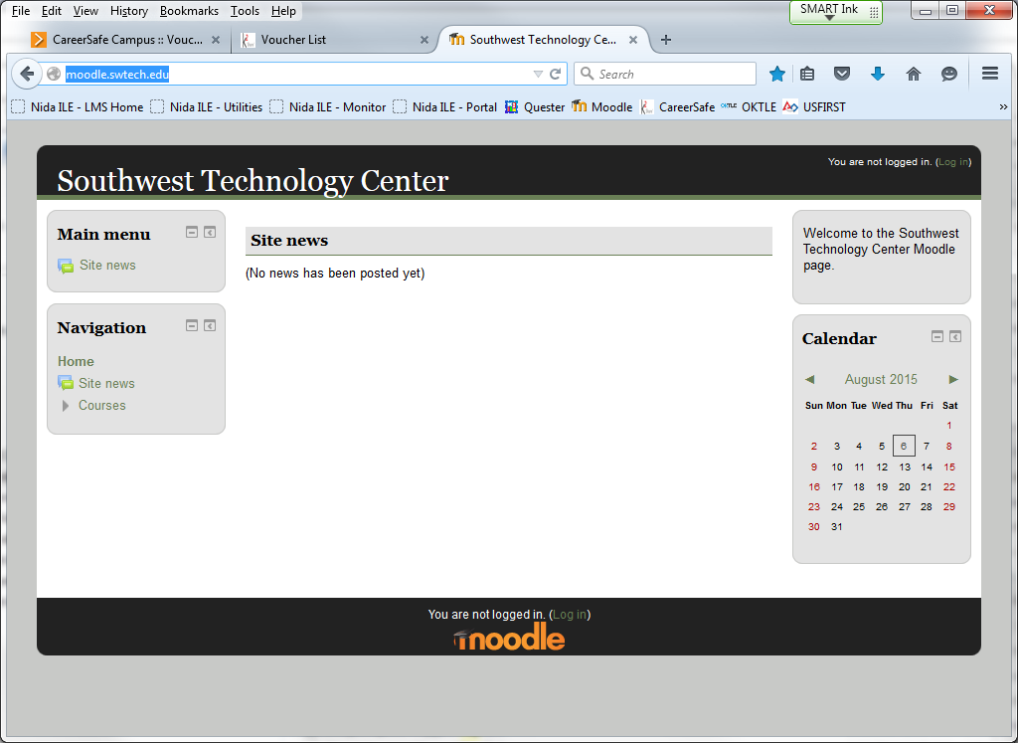
2.
1.
http://moodle.swtech.edu
  - Go to SWTC’s Moodle site at http://moodle.swtech.edu
  - Click on "Log in"
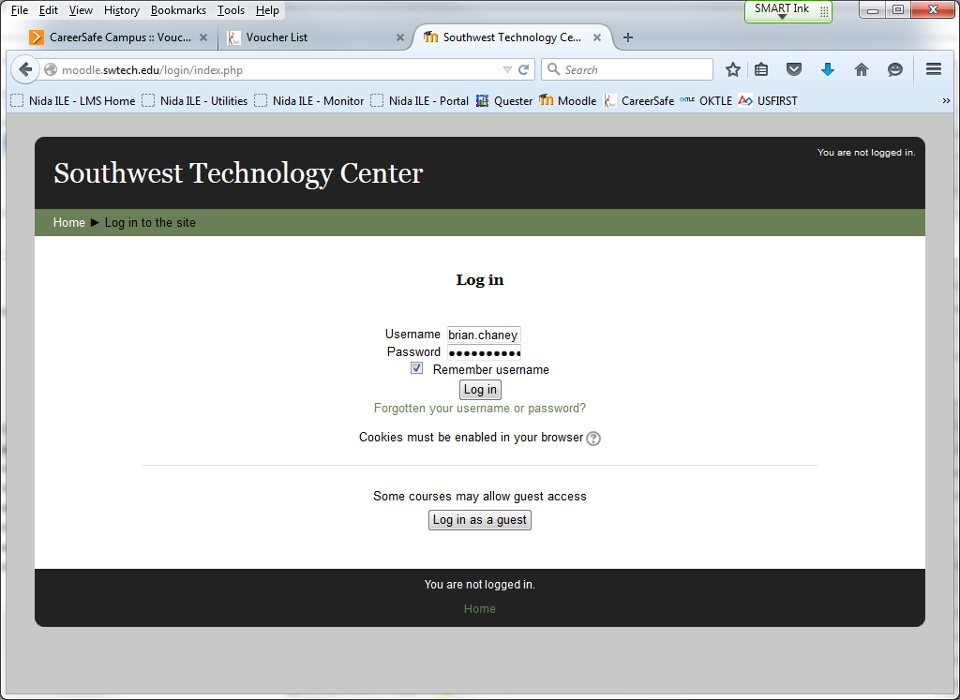
3.
  - If you do not have a username and password, click the “Log in as a guest” button.

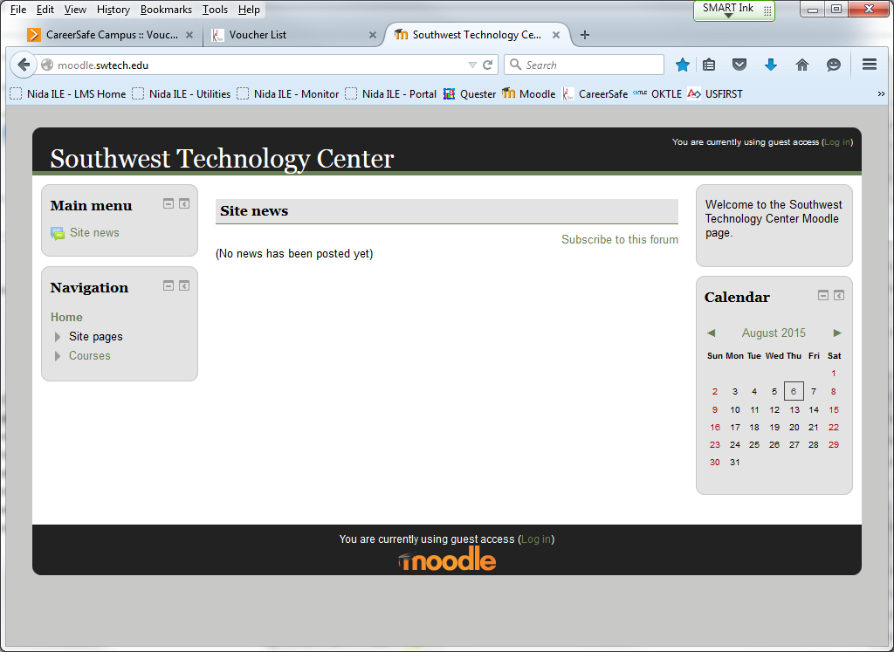
4.
  - Click “Courses.”

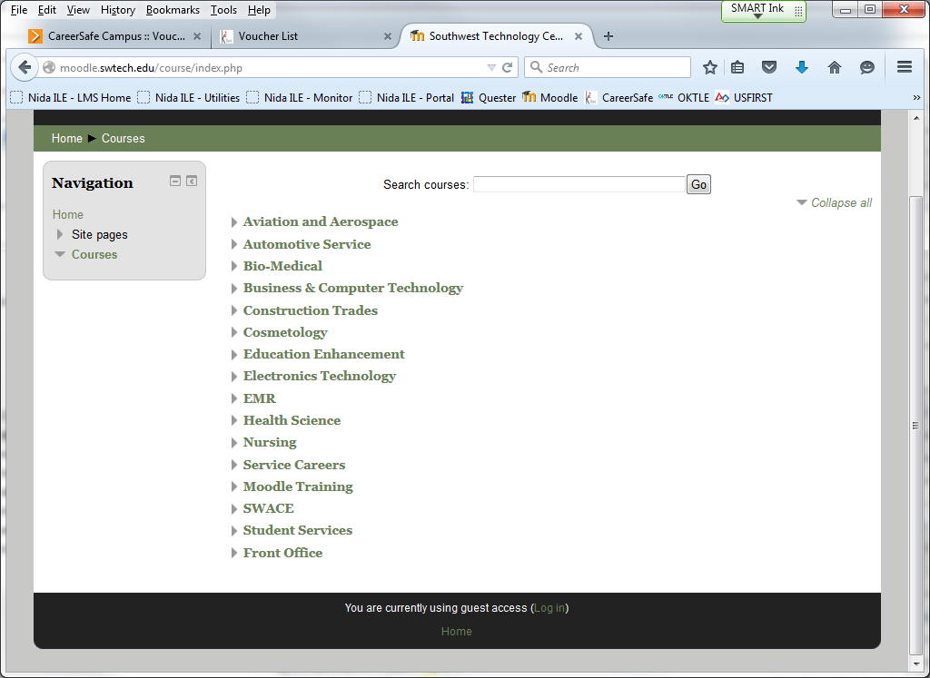
5.
  - Click “Electronics Technology.”

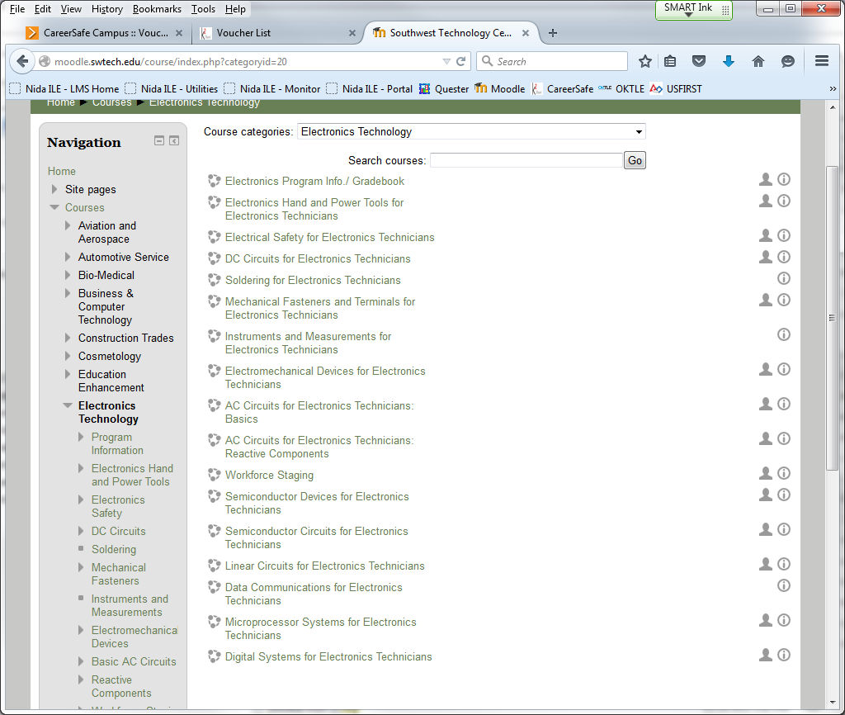
6.
7.

These are the courses in the Electronics Technology Program.
  - For General information, click on the “Electronics Program Info./ Gradebook” link.
  - For CareerSafe® study information, click on the “Electrical Safety for Electronics Technicians” link.

