Student Login Directions:
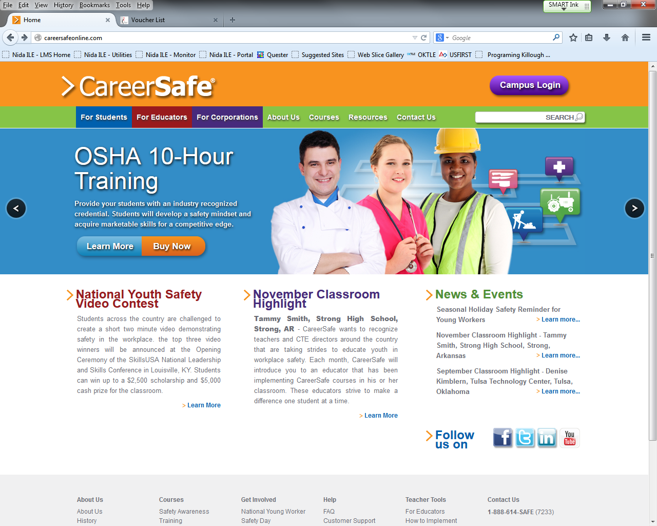
1.
www.careersafeonline.com
2.
- Navigate to www.careersafeonline.com
- Click on Campus Login.
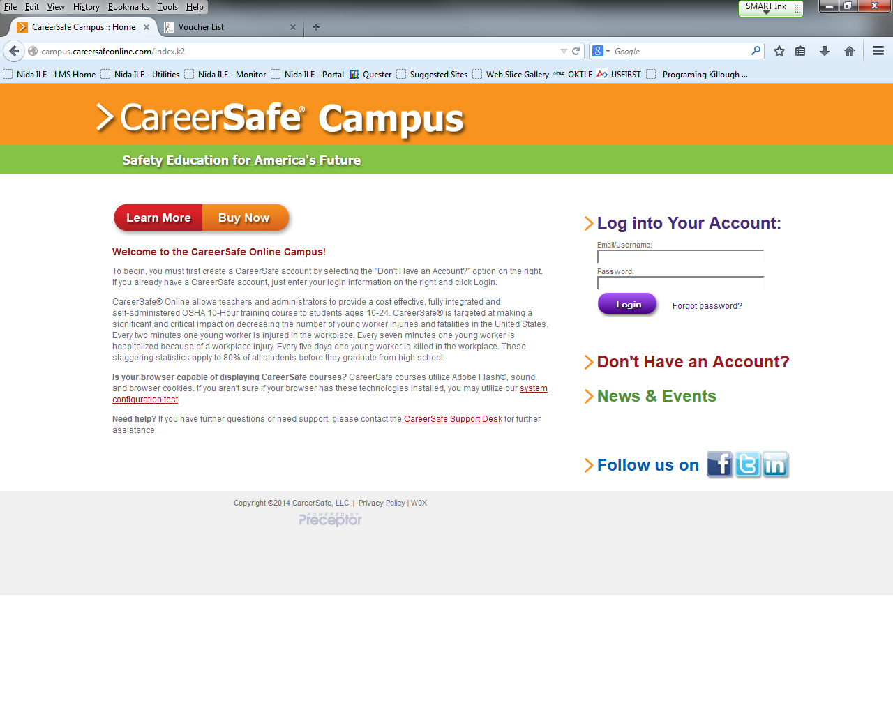
3.
- Enter email address and password in the appropriate fields, then click Login

If you have any questions about your subscription or using CareerSafe® Online, please e-mail our Support Services team at support@careersafeonline.com.

