Student Log-on Directions for NIDA-ILE

***NOTE: you need to use Internet Explorer as you internet browser because NIDA-ILE uses active X controls.***
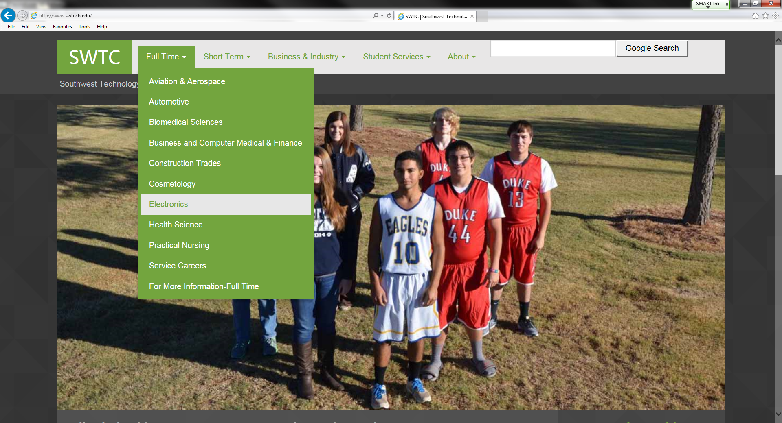
2.
1.
www.swtech.edu
  - Go to SWTC’s website at www.swtech.edu
  - Click on "Full Time" and “Electronics” on the drop down menu.
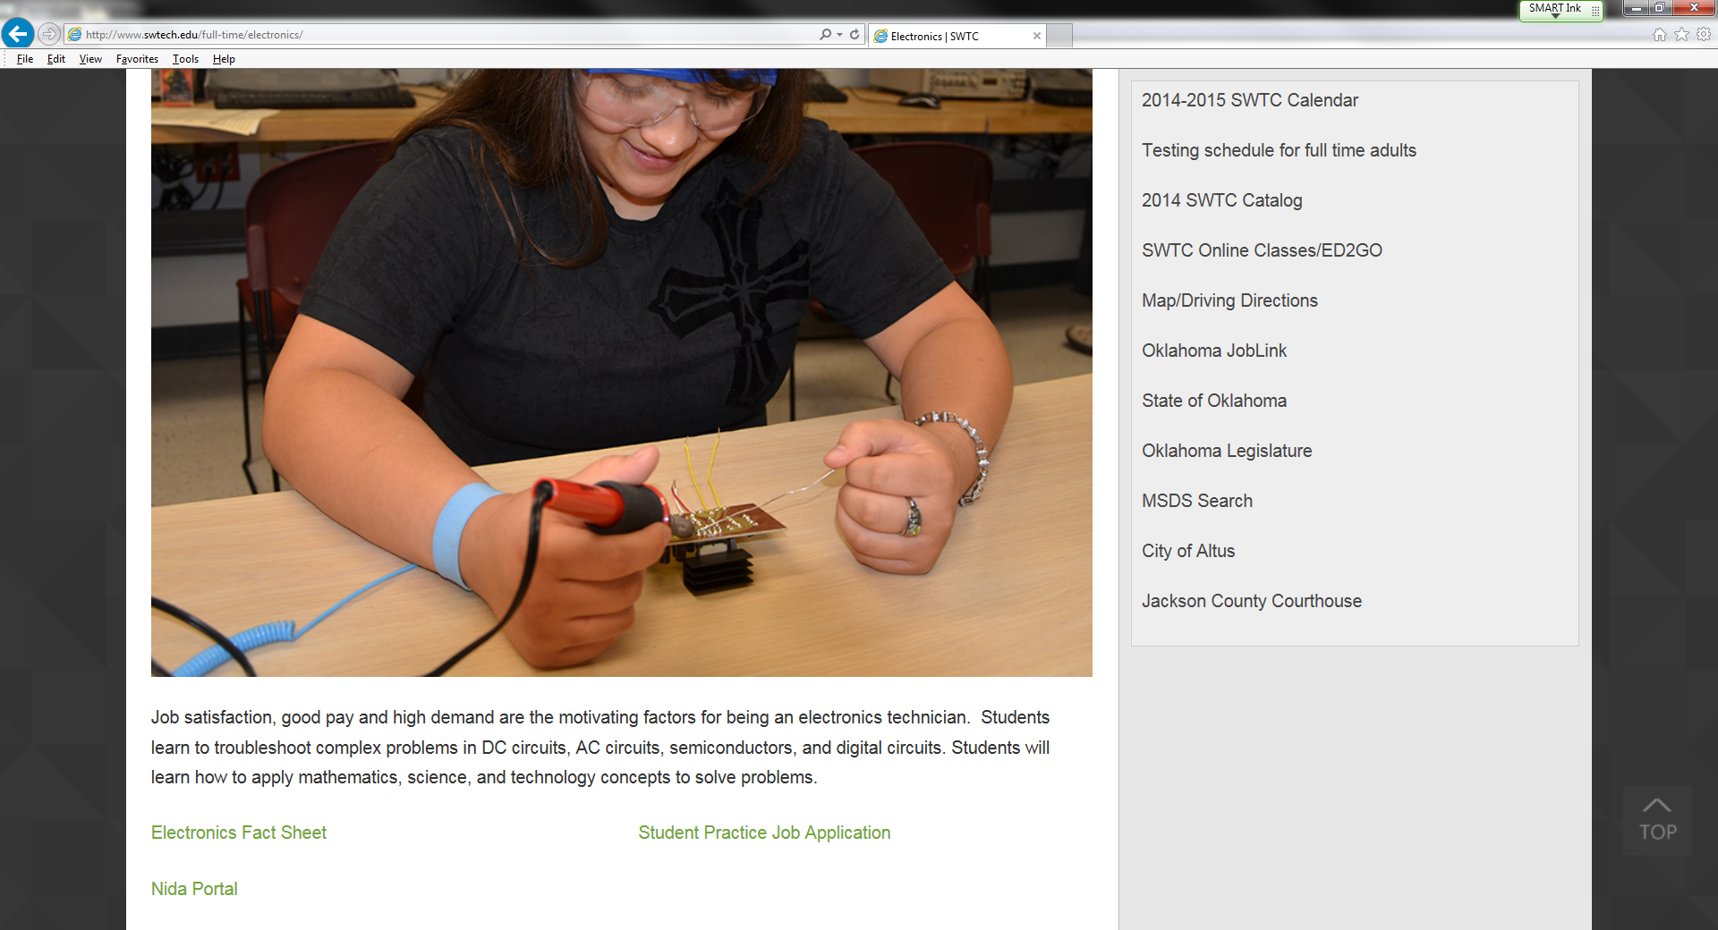
3.
  - Click the “Nida Portal” link.

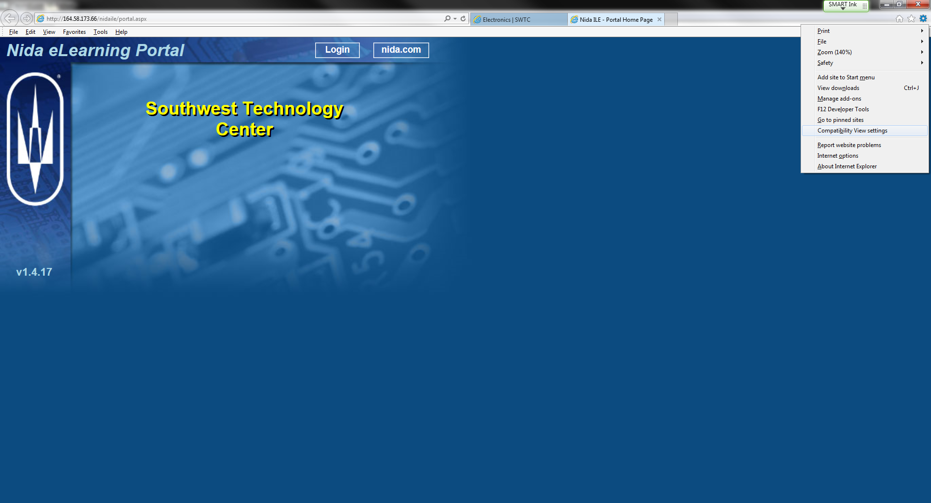
4.
  - Click gear in the top right hand corner and select “Compatibility view settings” from the pull-down menu.

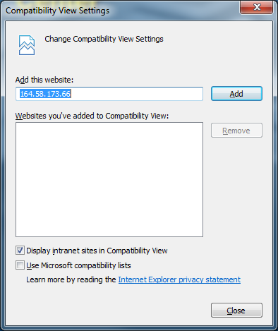
6.
5.
  - Address 164.58.173.66 should be in the Add this website box. Click “Add.”
  - This will add “164.58.173.66” into the “Websites you’ve added to Compatiblity View” box.
***This will ensure that all Flash object and Active X controls will work properly.***

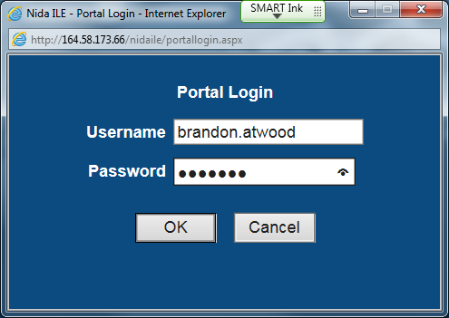
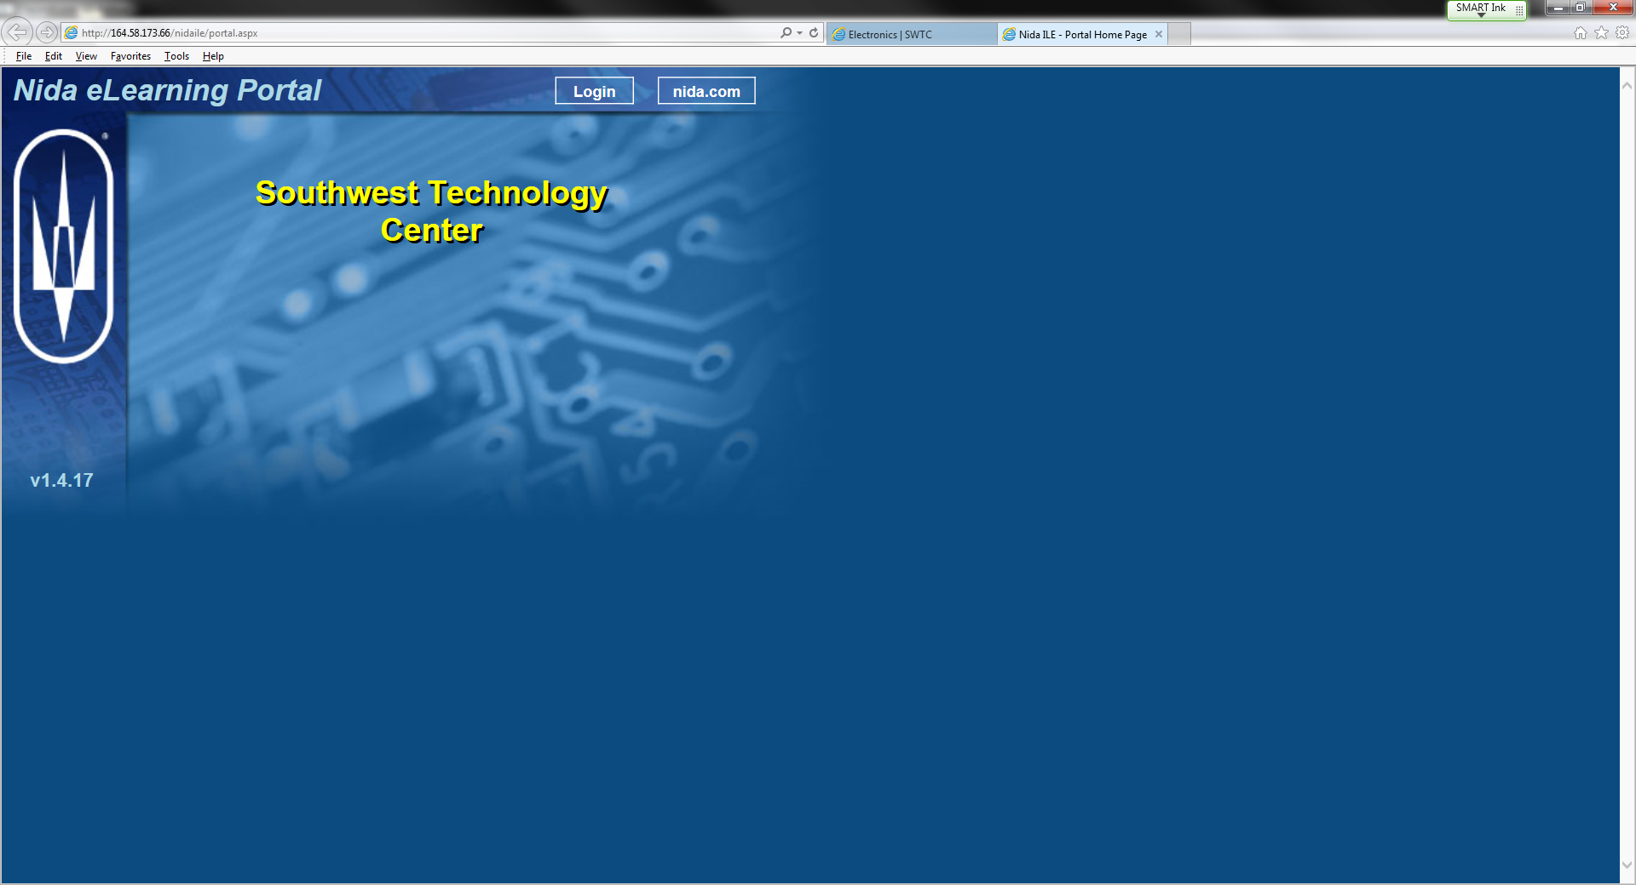
9.
8.
7.

  - Click on the “Login” button.
  - A pop-up box will appear asking for your Username and Password. Your username will be your firstname.lastname and you Password will be the one you created and turned in to the instructor. The password needs to be at least 6 digits of letters and/or numbers. NOTE: NO SPECIAL CHARACTERS.
  - Click the “OK” button

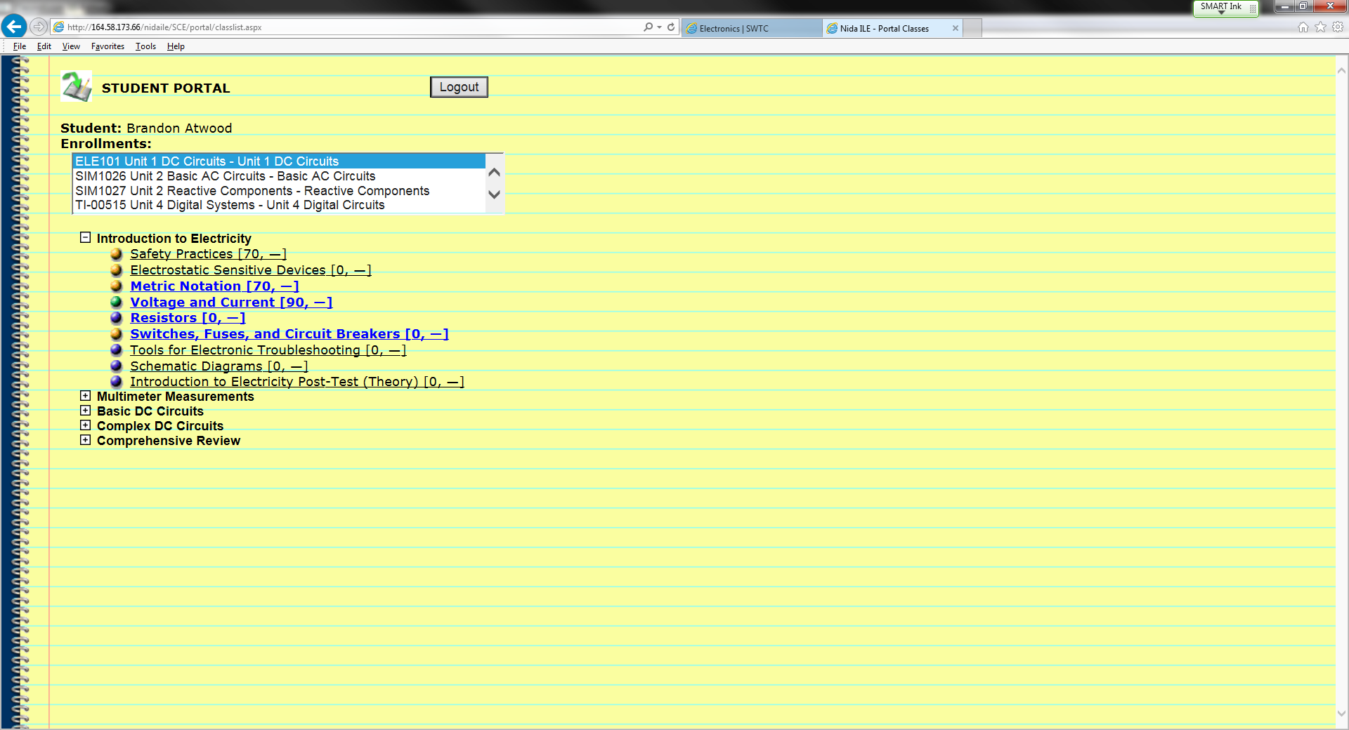
11.
12.
10.
This is the Student Portal screen. You have successfully logged on.
  - Select you course from the menu
  - Select Block
  - Select Lesson

