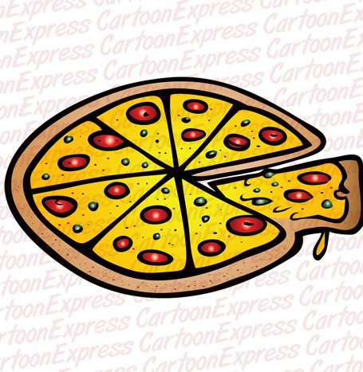
Name:
Date:
A Slice of Me

- Create a ‘pizza slice’ of your interests and personality to share with the class for the pizza slice bulletin board
  - Include on the Pizza Slice:
    - Name: Visible on front of slice so all can see
    - Pictures: School appropriate pictures that show your interests and likes
    - Words: School appropriate, cut out, typed, or written words or quotes that reflect your interests and likes
    - *NAME & DATE MUST BE ON THE BACK OF THE PIZZA SLICE TO RECEIVE A GRADE*
  - Presentation:
    - Present your pizza slice to the class in a short 2-3 min presentation
    - Hand teacher your rubric with name on it
    - Speak clearly and loud enough so all can hear
      - Write your name on the board
      - Talk about your interests and likes by showing the class your pictures and words on your pizza slice
      - Ask class if there are any comments or questions
      - Hang up your pizza slice on the bulletin board

Name:
Date:
A Slice of Me

A Slice of Me Rubric:
Area | Notes | Grade
Components: Name, date, class, on time |  | /5
Interests and Likes: School appropriate pictures and words |  | /5
Creativity: Colorful, unique, imaginative, and fun |  | /5
Presentation: name, talked about interests to class, spoke clearly and loudly |  | /5
 |  | TOTAL: /20

