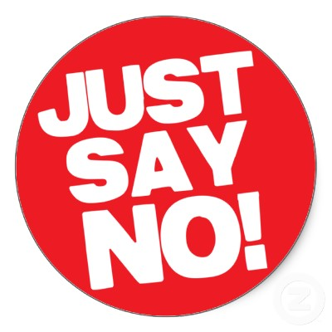
REFUSAL SKILLS STUDY GUIDE
Name:__________________________
Period:______

- ____________________ has the power to resist, but ________________ doesn’t sincerely want to.

- The goals of refusal
  - _______________________________________
  - _______________________________________
  - _______________________________________

- Steps for refusal
  - ________________________________________________________
  - ________________________________________________________
  - ________________________________________________________
  - ________________________________________________________
  - ________________________________________________________

- What to do under pressure
  - ________________________________________________________
  - ________________________________________________________
  - ________________________________________________________
  - ________________________________________________________
  - ________________________________________________________

