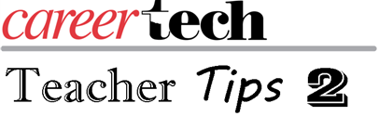
Welcome to a new school year!
Teacher Tips 2 will be a semimonthly feature that will be emailed to second-year teachers, as well as, other experienced teachers to keep them informed of events sponsored by CareerTech for continuing teachers. Your divisions will also keep you informed of opportunities for specific training.
Twice a month there will be a quick and timely tip that may be useful in your teaching practice. Among the topics that we will look at this year are the following:
- Beginning with the end in mind.
- Things not to do as an effective teacher.
- Making student work authentic.
- Effective effort rubrics.
- Improving instruction with feedback.
- Powerful ways to end the school year.
While most of the topics have a direct correlation to the essentials we discussed previously in Teacher Tips, we will look at how you can go beyond the basics.
The teacher tips will be archived on ctYou, http://ctyou.org, along with additional information. If you have not logged into CareerTech’s learning management system, follow the link above and create a user name and password. I have attached instructions for creating an account and finding the Teacher Tips 2 page.
Finally, there are opportunities for new CTE instructors to get additional training. The First is the CareerTech Professional Development Teacher Academy for all CareerTech teachers. This special opportunity will allow teachers to gain knowledge in new strategies and best practices in education.
- CT Teacher Academy: Moore Norman Technology Center - South Penn Campus, 13301 S. Pennsylvania Ave, Oklahoma City, OK 73170 , Sept. 27, 8:30 a.m. to 4 p.m.
- https://www.eventbrite.com/e/september-27th-ct-teacher-academy-891-tickets-43999015239

