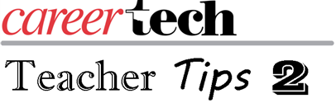
Last time we talked about starting a routine for yourself of smiling. I would also like to start the year by asking you to remember to begin with the end in mind. You have completed a year and know what the end looks like so we can plan with purpose throughout the year.
While we know that getting to know students is ongoing from the beginning to the end of each year, take some time to document things about the students and their work so that you can look back on it with them and see how far they have come in a year. You can do this in many different ways: take pictures, collect work or record video. Because we are teaching CTE classes, one of my favorites is to use a story pole. This is an actual pole or a specific spot where you take a picture every day throughout the year or duration of projects. The pole can be located in your room or at a site such as an ag barn. At the end of the year, you can look back with the students and see how their projects progressed and how much they have grown.
The second way to keep the end in mind is to remember that sense of community that your students had at the end of last year. How can we purposefully work at getting to know your students and help them get to know each other earlier in the year?
There are many ways to learn more about your students and to help them get to know each other. You can use them throughout the year to learn specific things about students. The ice breakers below show you specific things:
- What are their learning styles?
- How do they work together in groups?
While some teachers like to use ice breakers to start the year, others like to use learning style inventories. The results can be very useful for you in planning how you present material to your students.
- What’s your learning style?
- Learning Style Inventory
- Multiple Intelligences Self-Assessment
These activities take time, but they can be worthwhile if you keep and use the information you gain. I hope you have some way to capture what happens during the activities. It is even nice to summarize the activity with the students and point out the positive things you see from each one of them.
Coming Professional Development events: Teacher Academy.
Have the last three Teacher Tips 2 helped in starting your year off in a positive direction? [Click an answer]
Yes No

