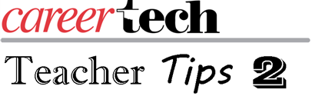
As I start to write this tip, I know I am writing it to myself 20-plus years ago. I have always had a hard time remembering names of students. While I was very good at getting to know my students, I always had a hard time connecting the knowledge of student to his or her name so let me give you some tips and even new tricks to remembering and pronouncing students names.
While many teacher are good using, “Hey, you,” to get students’ attention until they remember their name, that only works for a short time. The main secret to remembering names is to take the same enthusiasm you have for your CTE course and apply it to learning student names. Everyone has a good memory for things that interest and connect with them.
Here are a few effective methods to internalize students’ names.
- Assignments: Make several short assignments that just need to be recorded in your grade book as done and then handed back, allowing you to connect names and faces.
- Photo seating chart: Using whatever method you want, create pictures of students with their names so that you can get names, faces and location in room together.
- Using identifiers: Identifying items that only you use to help connect names to students, such as Bill has a backpack, Susie has long hair, Fernando has a wallet chain.
- Rhymes: Creating rhymes or lines to form songs to aid in name and visual memory.
- Small Groups: I usually paired student up so I would learn both names at the same time. You can do this with groups of three or four also, but avoid placing them in groups to do group work all the time.
- Greeting: Standing at your door, greet all your students each day and call them by name, and don’t be afraid to ask students for help when you get stuck.
- Say it back: When a student tells you his/her name, make sure you say it back and that you have pronounced it correctly. If it is difficult, write it down phonetically to help you pronounce it correctly.
Part of giving affirmation to the students is to let them know you know them. The best way is to know them by name. https://www.pronouncenames.com/ is a web site that will also help you pronounce student names.

