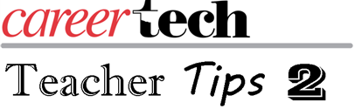
Happy Thanksgiving! Remember, all the Teacher Tips 2 are available online at ctyou.org . If you have not logged into CareerTech’s learning management system, follow the link above and create a user name and password. Follow the bread crumb trail to locate the course:

Home ► My courses ► PROFESSIONAL DEVELOPMENT ► Teacher Tips - N. Brubaker

I am also looking at what you would like to see as topics for the second half of the year. Please feel free to send me ideas at nathan.brubaker@careertech.ok.gov.

There is one more Teacher Academy meeting Jan. 30. If you have not registered you can still do so at Teacher Academy or follow the link below:
https://www.eventbrite.com/e/january-30th-ct-teacher-academy-891-tickets-46147343948.

I want to leave you with this thought for your students:

10 Things That Require Zero Talent

1. Being on time.

2. Work ethics.

3. Effort.

4. Body language.

5. Energy.

6. Attitude.

7. Passion.

8. Being coachable.

9. Doing extra.

10. Being prepared.

