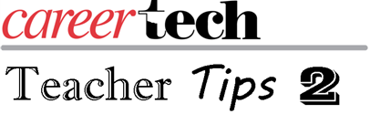
We have reached a time of year where we have covered a lot of content and the question arises: How should I assess the students to know if they have learned what I have taught? This is also the time where we get the age-old question from students, “Why are we learning this?”
Because we are CTE teachers, our challenge is always to make the students’ learning real. Most of the time we can accomplish this with a challenge to the students that makes them use their knowledge to create or solve a problem. With most CTE classes, this involves a product, a process or both. It can be assessed, but not necessarily graded, using a Single-point rubric.
This rubric allows several things to happen that will show the students’ knowledge of material covered. First, the class can create and modify the criteria of the challenge. Second, the students can work in groups to determine what needs to be worked on. Third, what will the outcome be like if you get it correct?
I have attached a modified single-point rubric for following the design process. When finished, the students can assess each other either by doing a walk-around and looking at different solutions or by listening to other group presentations. The students can even assess the effort of the group members using an Effective Effort Rubric (see attached). While none of the student assessment is graded, it is very good feedback for the students in future efforts or challenges.
As the instructor, you can also assess and give feedback or a grade if needed; you also need to have some sort of debriefing. This gives the students and you, as the teacher, the opportunity to offer feedback on the process, the products, the group dynamics and the criteria, allowing you to improve on your process also. You can also guide the debrief using questions that allow the students to think about the material covered and the process of the challenge.
While this might take a little time, it can create connections with the material you covered and make the leap to the next material covered quicker, as well as the leap to the real world of work.

