I Do WE Do YOU Do Model
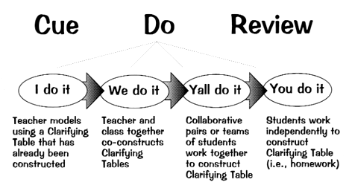
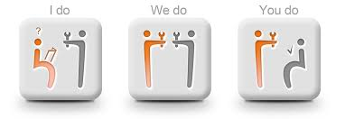
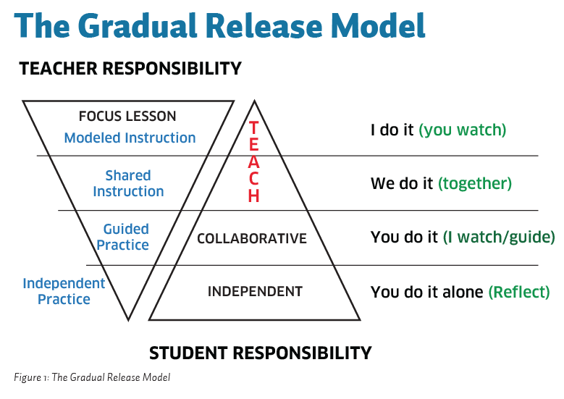

http://www.evidencebasedteaching.org.au/the-i-do-we-do-you-do-model-explained/

