http://ctyou.org
- Following the link above will take you to the Page below.
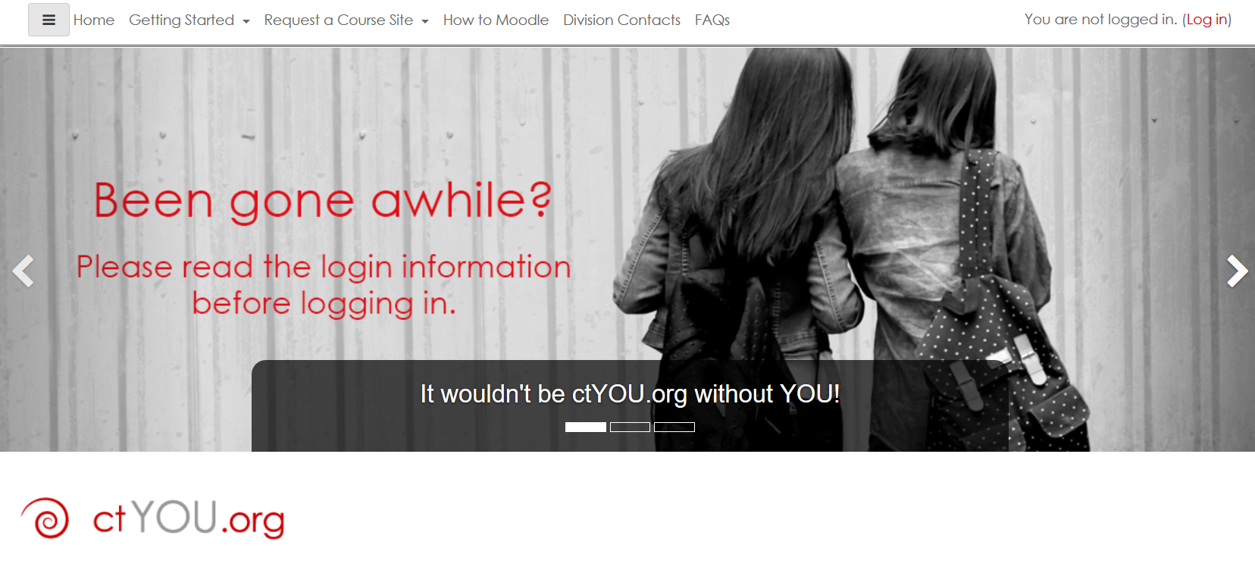
- Scroll down and select Professional Development.
- That will take you to the following page.
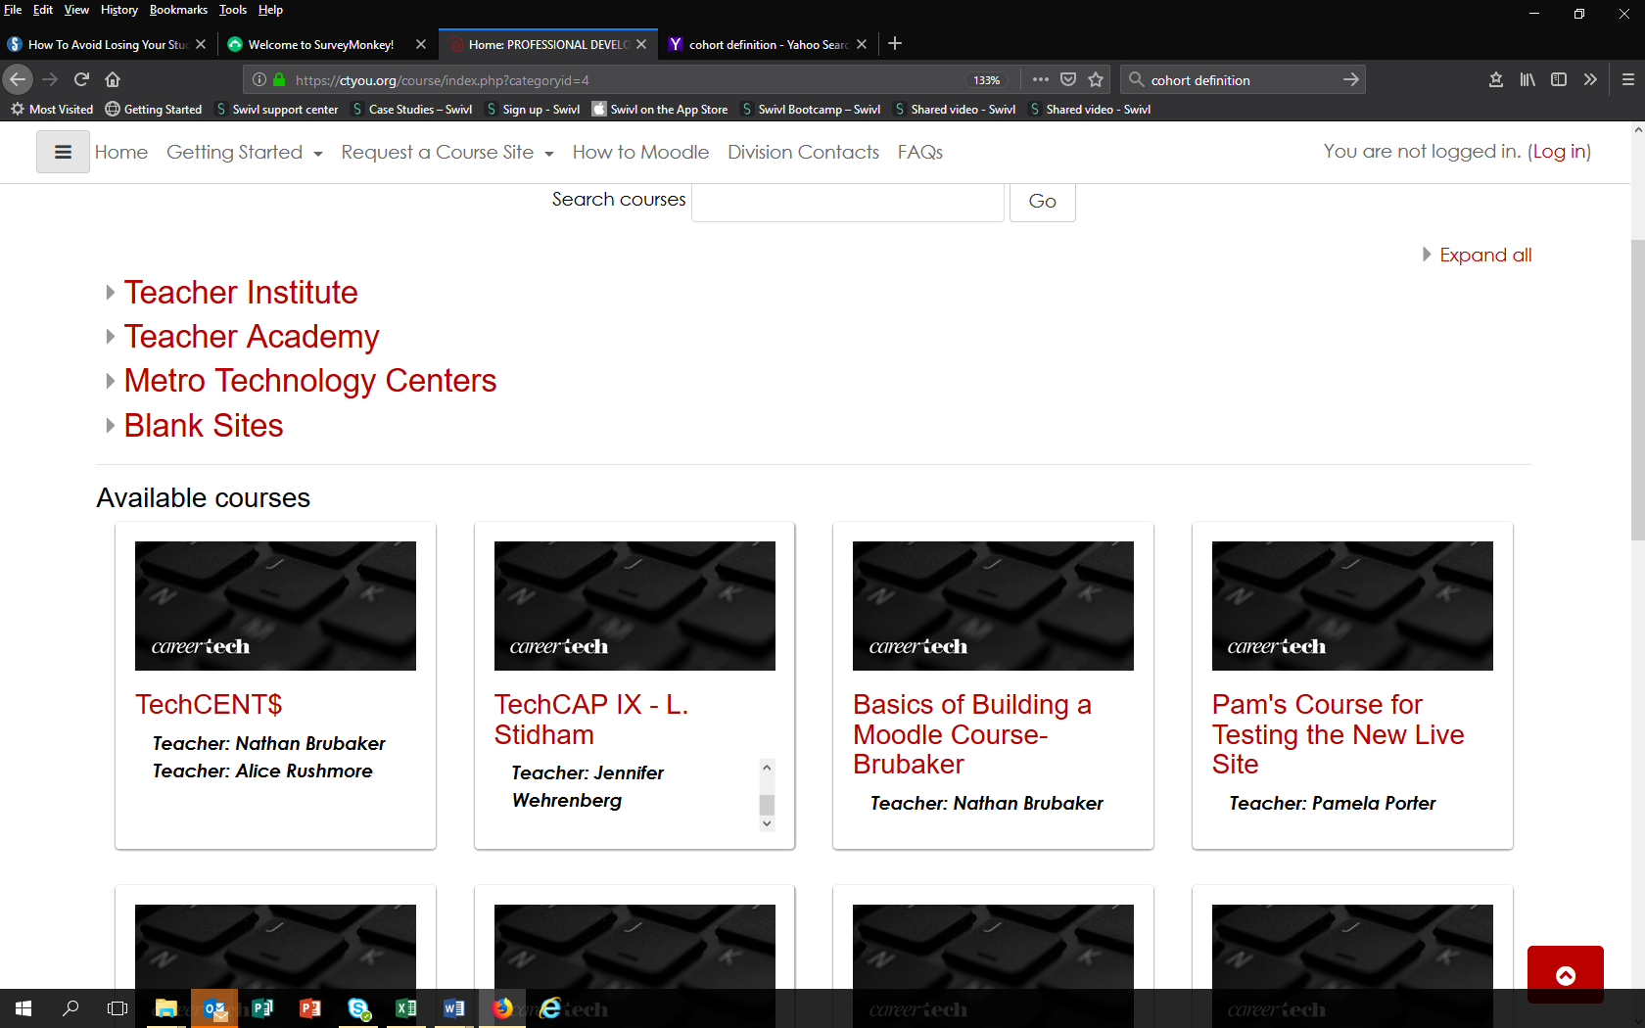
- Select the Continuing TechCENT$.
- That will take you to the Log in page. You will have a choice you can create an account or Log in as a guest without an account.
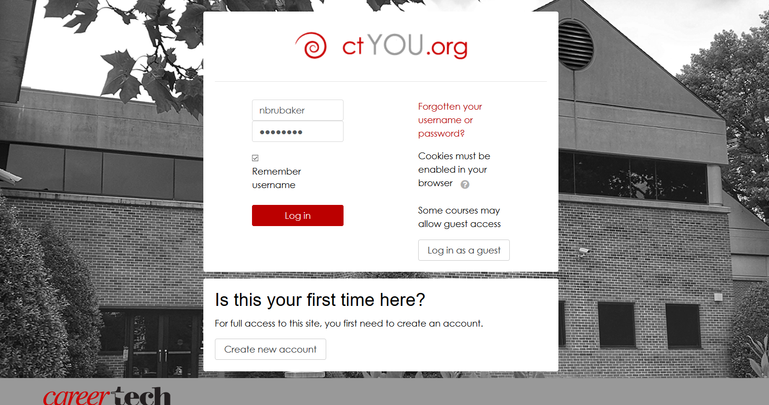
Either way this will take you to the Site agreement [If you create an account, Username: firstname.lastname].
- Read through and select yes at the bottom.
- This will take you directly to the CT TechCENT$ Page.
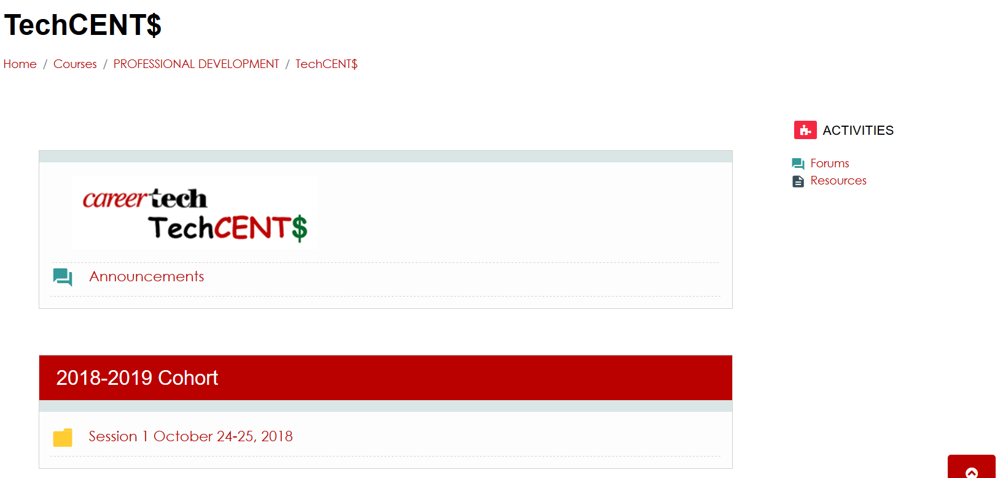
- Use and enjoy!
- If you have questions about the content or want something added contact:
Nathan Brubaker
careertech
nathan.brubaker@careertech.ok.gov
Leadership & Professional Development Specialist
Oklahoma Department of Career and Technology Education
Off: 405.743.5113
Cell: 405.642.1933

