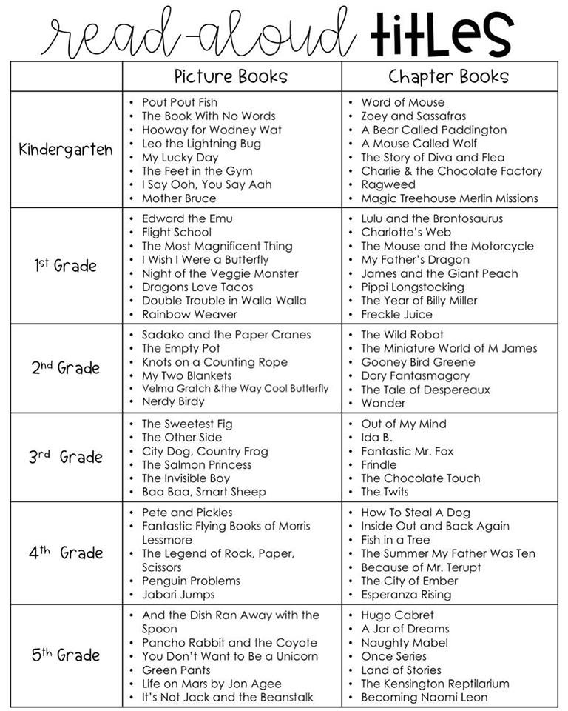

Essential workers have always played an important role, but current times call for extra appreciation of their hard work and dedication. To help your kids learn more about these essential careers, check out these 15 fun and educational books about the heroes all around you!

**A Hero Lives in My Family: A Story for Kids of First Responders**

**[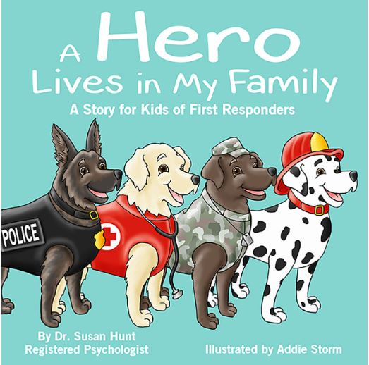](https://www.amazon.com/Hero-Lives-My-Family-Responders-ebook/dp/B013RJE74K/ref=pd_sim_351_3/131-4476135-8764007?_encoding=UTF8&pd_rd_i=B013RJE74K&pd_rd_r=84a97dbf-7216-4655-88d5-f36da20612cb&pd_rd_w=m2yfJ&pd_rd_wg=W6kEI&pf_rd_p=9fec2710-b93d-4b3e-b3ca-e55dc1c5909a&pf_rd_r=WSBVBSK26V5QXWYT993N&psc=1&refRID=WSBVBSK26V5QXWYT993N)**

**For Ages 2-8**

Kids will get to know some of the heroes they see in their very own household and discover how their parents help to serve and protect the whole community. This book will help your child to understand more about the importance of helping others and the different emotions that they may feel as a son or daughter of a first responder. View on Amazon

**I Want to Be a Doctor**

**[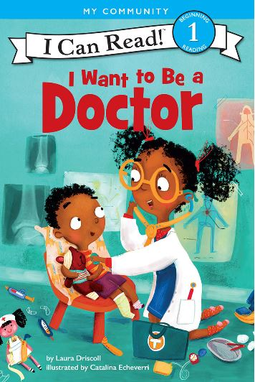](https://www.amazon.com/Want-Doctor-Can-Read-Level-ebook/dp/B072HFRNZZ/ref=zg_bs_318469011_22?_encoding=UTF8&psc=1&refRID=0Q8A3EXQP1DHYPACT2DN)**

**For Ages 4-8**

Does your child dream of becoming a doctor when they grow up? In the story, readers will follow one character who gets to meet all kinds of different doctors after injuring his foot. It's a perfect way for kids to explore the profession in a fun and engaging way. [View on Amazon](https://www.amazon.com/Want-Doctor-Can-Read-Level-ebook/dp/B072HFRNZZ/ref=zg_bs_318469011_22?_encoding=UTF8&psc=1&refRID=0Q8A3EXQP1DHYPACT2DN)

**I'm a Mail Carrier**

[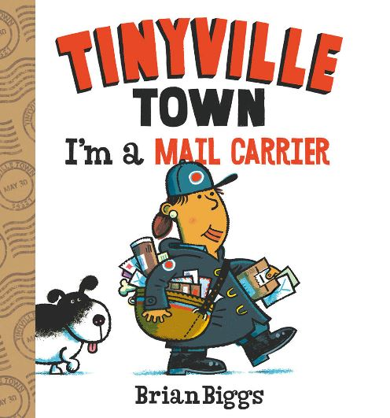](https://www.amazon.com/Mail-Carrier-Tinyville-Town-Book/dp/1419728334/ref=sr_1_3?dchild=1&keywords=mail+carriers+book&qid=1588862680&sr=8-3)

**For Ages 2-8**

Mail carrier Rita takes readers through her daily duties as she delivers mail and important packages all around town. No matter what the weather, it's critical for Rita to make sure that everyone receives their mail on time. This book is ideal for young children in preschool or kindergarten, and is a great way to show them one of the many valued essential workers in their lives. [View on Amazon](https://www.amazon.com/Mail-Carrier-Tinyville-Town-Book/dp/1419728334/ref=sr_1_3?dchild=1&keywords=mail+carriers+book&qid=1588862680&sr=8-3)

**Before We Eat: From Farm to Table**

[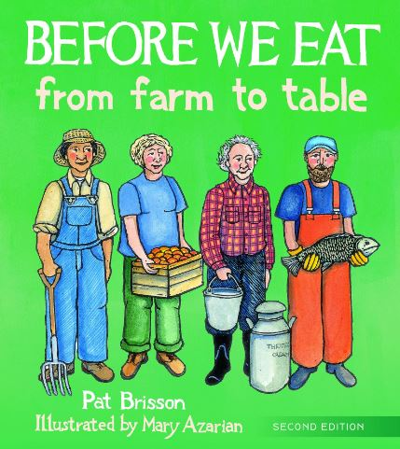](https://www.amazon.com/Before-We-Eat-Farm-Table/dp/0884486524/ref=zg_bs_3208_13?_encoding=UTF8&psc=1&refRID=XB3BDJYV9FBQKGYWBT99)

**For Ages 2-12**

We all enjoy the delicious foods we eat during meals or in between as tasty snacks, and this book helps to tell the full story about where all of those amazing foods come from, and who is responsible for producing them. [View on Amazon](https://www.amazon.com/Before-We-Eat-Farm-Table/dp/0884486524/ref=zg_bs_3208_13?_encoding=UTF8&psc=1&refRID=XB3BDJYV9FBQKGYWBT99)

**Police: Hurrying! Helping! Saving!**

**[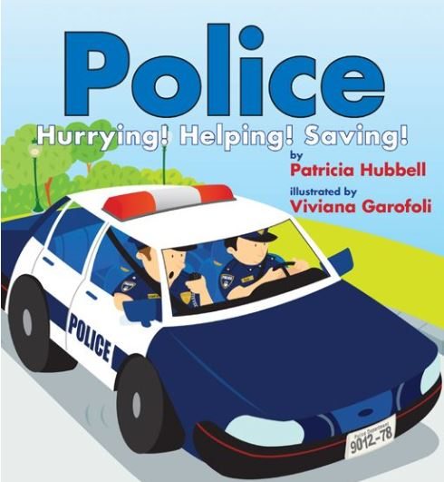](https://www.amazon.com/Police-Hurrying-Helping-Patricia-Hubbell-ebook/dp/B008RDG894/ref=zg_bs_318469011_23?_encoding=UTF8&psc=1&refRID=0Q8A3EXQP1DHYPACT2DN)**

**For Ages 3-6**

Children can learn more about how the police protect us by reading through this informative book featuring brightly colored images to keep them actively engaged throughout all of the calls the officers respond to in their workday. [View on Amazon](https://www.amazon.com/Police-Hurrying-Helping-Patricia-Hubbell-ebook/dp/B008RDG894/ref=zg_bs_318469011_23?_encoding=UTF8&psc=1&refRID=0Q8A3EXQP1DHYPACT2DN)

**Breaking Cat News: Cats Reporting on the News that Matters to Cats**

**[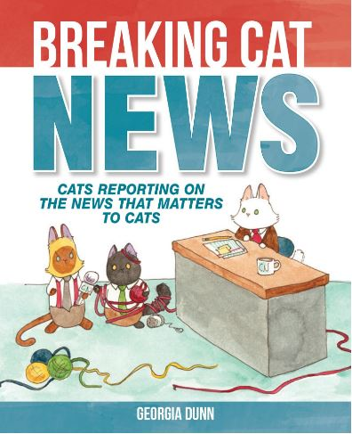](https://www.amazon.com/Breaking-Cat-News-Reporting-Matters-ebook/dp/B0170ZKBB0/ref=pd_sim_351_1/131-4476135-8764007?_encoding=UTF8&pd_rd_i=B0170ZKBB0&pd_rd_r=de1e1547-1dd7-43f0-a484-2ccd4bac82a7&pd_rd_w=zleMM&pd_rd_wg=m5Cko&pf_rd_p=9fec2710-b93d-4b3e-b3ca-e55dc1c5909a&pf_rd_r=WW9W351PZ007SBC8X1JK&psc=1&refRID=WW9W351PZ007SBC8X1JK)**

**For Ages 9-12**

This silly story features the profession of newscasters and news anchors in a light and funny way by telling it from the perspective of a few fluffy cats. Their wild headlines will certainly capture your young reader's attention to get them interested in this media-driven career.

[View on Amazon](https://www.amazon.com/Breaking-Cat-News-Reporting-Matters-ebook/dp/B0170ZKBB0/ref=pd_sim_351_1/131-4476135-8764007?_encoding=UTF8&pd_rd_i=B0170ZKBB0&pd_rd_r=de1e1547-1dd7-43f0-a484-2ccd4bac82a7&pd_rd_w=zleMM&pd_rd_wg=m5Cko&pf_rd_p=9fec2710-b93d-4b3e-b3ca-e55dc1c5909a&pf_rd_r=WW9W351PZ007SBC8X1JK&psc=1&refRID=WW9W351PZ007SBC8X1JK)

**My Mommy is a Nurse**

[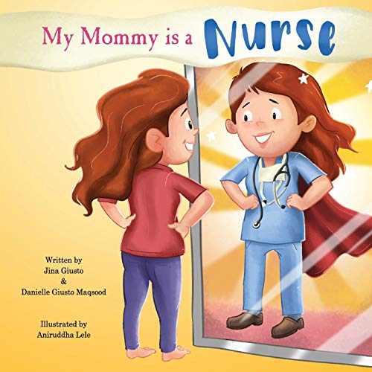](https://www.amazon.com/My-Mommy-Nurse-Jina-Giusto-ebook/dp/B07RM7NVCN/ref=pd_sim_351_3/131-4476135-8764007?_encoding=UTF8&pd_rd_i=B07RM7NVCN&pd_rd_r=8e1d9c30-15b5-44da-ab7e-1ec3b712fb27&pd_rd_w=SwcWN&pd_rd_wg=7cfGi&pf_rd_p=9fec2710-b93d-4b3e-b3ca-e55dc1c5909a&pf_rd_r=AJNK21Z689VE225GBAZ7&psc=1&refRID=AJNK21Z689VE225GBAZ7)

**For Ages 2-8**

Are you a nurse or healthcare worker? This book is a perfect way to show your child more about what you do everyday while at work. It can be difficult for kids to realize why their parents are away from home so often, but *My Mommy is a Nurse* will give them a glimpse into the incredible work you do to help heal others.

[View on Amazon](https://www.amazon.com/My-Mommy-Nurse-Jina-Giusto-ebook/dp/B07RM7NVCN/ref=pd_sim_351_3/131-4476135-8764007?_encoding=UTF8&pd_rd_i=B07RM7NVCN&pd_rd_r=8e1d9c30-15b5-44da-ab7e-1ec3b712fb27&pd_rd_w=SwcWN&pd_rd_wg=7cfGi&pf_rd_p=9fec2710-b93d-4b3e-b3ca-e55dc1c5909a&pf_rd_r=AJNK21Z689VE225GBAZ7&psc=1&refRID=AJNK21Z689VE225GBAZ7)

**Big Joe's Trailer Truck**

**[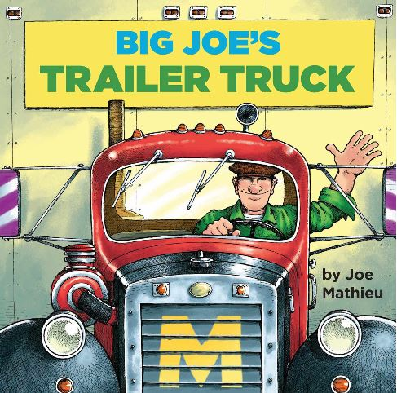](https://www.amazon.com/Big-Joes-Trailer-Truck-Pictureback-ebook/dp/B00MKZ9BA8/ref=zg_bs_318469011_78?_encoding=UTF8&psc=1&refRID=G7CAA2JF4V4VX1YSP703)**

**For Ages 3-7**

Are your kids curious about where all of their things come from? They may think it comes from the store, but this book will show them the entire process and how truck drivers are crucial to getting us the food and supplies we need each day.

[View on Amazon](https://www.amazon.com/Big-Joes-Trailer-Truck-Pictureback-ebook/dp/B00MKZ9BA8/ref=zg_bs_318469011_78?_encoding=UTF8&psc=1&refRID=G7CAA2JF4V4VX1YSP703)

**Momma's Boots**

[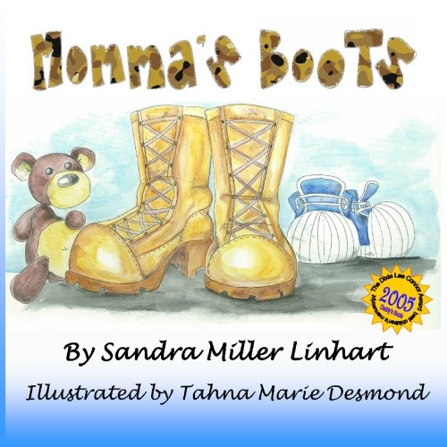](https://www.amazon.com/Mommas-Boots-Sandra-Miller-Linhart/dp/0984512713/ref=pd_sbs_14_21?_encoding=UTF8&pd_rd_i=0984512713&pd_rd_r=c4a7aec4-aa67-451a-8069-d3d9abb63fc5&pd_rd_w=AkHcJ&pd_rd_wg=Et96P&pf_rd_p=d13bb895-21d3-4e96-94a7-553aaae51224&pf_rd_r=420AW3M6M229GSV0T215&psc=1&refRID=420AW3M6M229GSV0T215)

**For Ages 4-9**

This book celebrates the many heroes we have fighting for us in all military branches, and helps to answer some of the most common questions that children with mothers in the military often have such as where their mom goes after putting on her combat boots, and if other mothers have special boots for their job too.

[View on Amazon](https://www.amazon.com/Mommas-Boots-Sandra-Miller-Linhart/dp/0984512713/ref=pd_sbs_14_21?_encoding=UTF8&pd_rd_i=0984512713&pd_rd_r=c4a7aec4-aa67-451a-8069-d3d9abb63fc5&pd_rd_w=AkHcJ&pd_rd_wg=Et96P&pf_rd_p=d13bb895-21d3-4e96-94a7-553aaae51224&pf_rd_r=420AW3M6M229GSV0T215&psc=1&refRID=420AW3M6M229GSV0T215)

**National Geographic Readers: Helpers in Your Neighborhood**

**[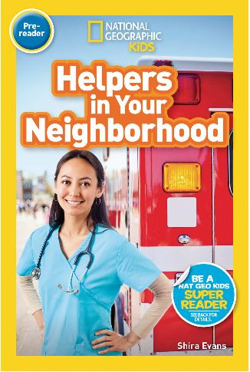](https://www.amazon.com/National-Geographic-Readers-Neighborhood-Pre-reader-ebook/dp/B07BJLD975/ref=pd_sim_351_5/131-4476135-8764007?_encoding=UTF8&pd_rd_i=B07BJLD975&pd_rd_r=49fb85f4-24c7-4d0d-8b30-dab1c045b668&pd_rd_w=TUBRi&pd_rd_wg=mPtff&pf_rd_p=9fec2710-b93d-4b3e-b3ca-e55dc1c5909a&pf_rd_r=NAB6HKHCN5Z1T7S4Z4ZA&psc=1&refRID=NAB6HKHCN5Z1T7S4Z4ZA)**

**For Ages 2-5**

Introduce your children to all of the heroes around them by sitting down to read *Helpers in Your Neighborhood* together. With a vocabulary tree at the start of the book, kids begin to build connections between the words they read throughout this text, and then have the opportunity to complete a wrap-up activity at the end. [View on Amazon](https://www.amazon.com/National-Geographic-Readers-Neighborhood-Pre-reader-ebook/dp/B07BJLD975/ref=pd_sim_351_5/131-4476135-8764007?_encoding=UTF8&pd_rd_i=B07BJLD975&pd_rd_r=49fb85f4-24c7-4d0d-8b30-dab1c045b668&pd_rd_w=TUBRi&pd_rd_wg=mPtff&pf_rd_p=9fec2710-b93d-4b3e-b3ca-e55dc1c5909a&pf_rd_r=NAB6HKHCN5Z1T7S4Z4ZA&psc=1&refRID=NAB6HKHCN5Z1T7S4Z4ZA)

**Grandma Drove the Garbage Truck**

**[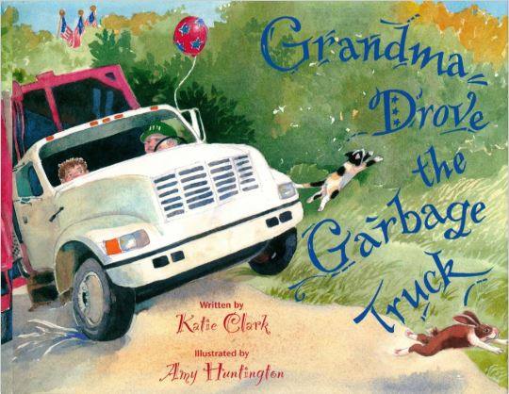](https://www.amazon.com/Grandma-Drove-Garbage-Truck-Katie-ebook/dp/B019L08UYM/ref=pd_sim_351_5/131-4476135-8764007?_encoding=UTF8&pd_rd_i=B019L08UYM&pd_rd_r=c7eeb496-4c62-47e6-af8f-76c59517bf86&pd_rd_w=TZWnS&pd_rd_wg=6dJ5U&pf_rd_p=9fec2710-b93d-4b3e-b3ca-e55dc1c5909a&pf_rd_r=VB5XTPYWZ2V14FH1N5V1&psc=1&refRID=VB5XTPYWZ2V14FH1N5V1)**

**For Ages 4-6**

A funny and highly engaging read, your kids will love *Grandma Drove the Garbage Truck*. While laughing at the character's crazy adventures, readers will also learn about the vital needs that sanitation workers fulfill during their long workday.

[View on Amazon](https://www.amazon.com/Grandma-Drove-Garbage-Truck-Katie-ebook/dp/B019L08UYM/ref=pd_sim_351_5/131-4476135-8764007?_encoding=UTF8&pd_rd_i=B019L08UYM&pd_rd_r=c7eeb496-4c62-47e6-af8f-76c59517bf86&pd_rd_w=TZWnS&pd_rd_wg=6dJ5U&pf_rd_p=9fec2710-b93d-4b3e-b3ca-e55dc1c5909a&pf_rd_r=VB5XTPYWZ2V14FH1N5V1&psc=1&refRID=VB5XTPYWZ2V14FH1N5V1)

**Whose Hands Are These? A Community Helper Guessing Book**

**[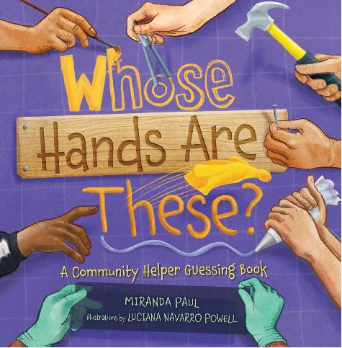](https://www.amazon.com/Whose-Hands-Are-These-Community-ebook/dp/B01BV2WJJA/ref=pd_sim_351_10?_encoding=UTF8&pd_rd_i=B01BV2WJJA&pd_rd_r=d4e4c572-0a7c-4837-9228-4ca63ccf3c43&pd_rd_w=mwXFM&pd_rd_wg=Xm3xy&pf_rd_p=9fec2710-b93d-4b3e-b3ca-e55dc1c5909a&pf_rd_r=6H673EE9B5X83AYDQS43&psc=1&refRID=6H673EE9B5X83AYDQS43)**

**For Ages 4-9**

Keep your child's full attention as they put together important clues while reading through this book that highlights many of the heroes and helpers that all communities rely on.

[View on Amazon](https://www.amazon.com/Whose-Hands-Are-These-Community-ebook/dp/B01BV2WJJA/ref=pd_sim_351_10?_encoding=UTF8&pd_rd_i=B01BV2WJJA&pd_rd_r=d4e4c572-0a7c-4837-9228-4ca63ccf3c43&pd_rd_w=mwXFM&pd_rd_wg=Xm3xy&pf_rd_p=9fec2710-b93d-4b3e-b3ca-e55dc1c5909a&pf_rd_r=6H673EE9B5X83AYDQS43&psc=1&refRID=6H673EE9B5X83AYDQS43)

**Work, Dogs, Work: A Highway Tail**

**[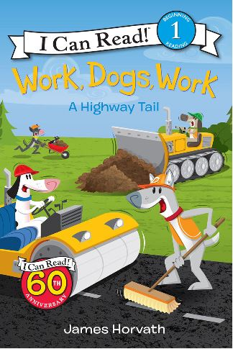](https://www.amazon.com/Work-Dogs-Highway-Tail-Level-ebook/dp/B01JFYB1K4/ref=pd_sim_351_27?_encoding=UTF8&pd_rd_i=B01JFYB1K4&pd_rd_r=d4e4c572-0a7c-4837-9228-4ca63ccf3c43&pd_rd_w=mwXFM&pd_rd_wg=Xm3xy&pf_rd_p=9fec2710-b93d-4b3e-b3ca-e55dc1c5909a&pf_rd_r=6H673EE9B5X83AYDQS43&psc=1&refRID=6H673EE9B5X83AYDQS43)**

**For Ages 4-8**

Kids can follow these playful pups through their day as they work to build a new brand new road. In the book, readers will learn about the unique roles included on a construction crew while developing their reading and speech abilities.

[View on Amazon](https://www.amazon.com/Work-Dogs-Highway-Tail-Level-ebook/dp/B01JFYB1K4/ref=pd_sim_351_27?_encoding=UTF8&pd_rd_i=B01JFYB1K4&pd_rd_r=d4e4c572-0a7c-4837-9228-4ca63ccf3c43&pd_rd_w=mwXFM&pd_rd_wg=Xm3xy&pf_rd_p=9fec2710-b93d-4b3e-b3ca-e55dc1c5909a&pf_rd_r=6H673EE9B5X83AYDQS43&psc=1&refRID=6H673EE9B5X83AYDQS43)

**Ada Twist, Scientist**

[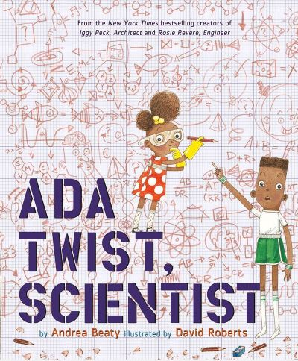](https://www.amazon.com/Ada-Twist-Scientist-Andrea-Beaty/dp/1419721372)

**For Ages 6-11**

Scientists are crucial for moving all of us forward in the world and developing innovative solutions to daily issues. Kids who are natural problem-solvers are sure to love this bestselling story on STEM careers.

[View on Amazon](https://www.amazon.com/Ada-Twist-Scientist-Andrea-Beaty/dp/1419721372)

**Richard Scarry's What Do People Do All Day?**

[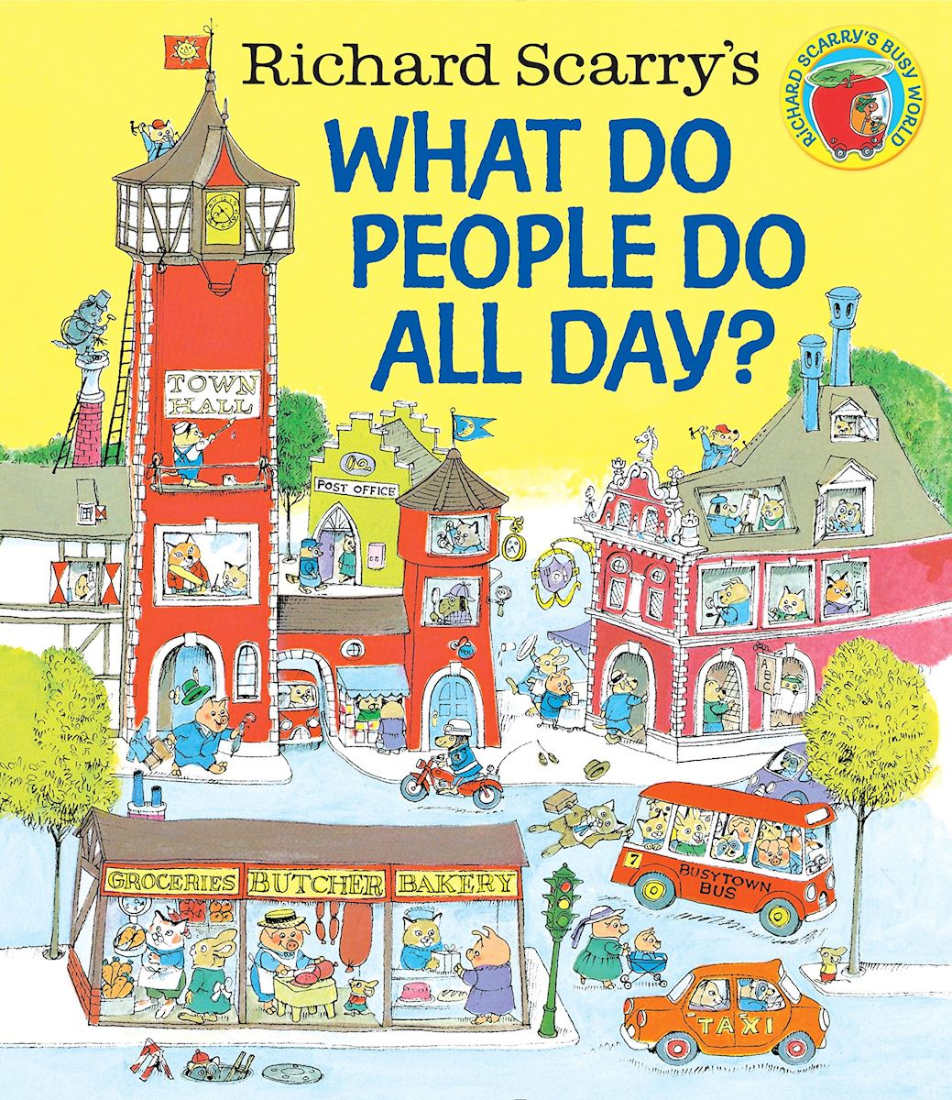](https://www.amazon.com/Richard-Scarrys-What-People-World/dp/0553520598/ref=pd_lpo_14_img_1/131-4476135-8764007?_encoding=UTF8&pd_rd_i=0553520598&pd_rd_r=f52585f3-1b49-4477-ae6e-b661851e04ff&pd_rd_w=ceS9t&pd_rd_wg=PqxOj&pf_rd_p=7b36d496-f366-4631-94d3-61b87b52511b&pf_rd_r=37XM856EPMDVH8J6CEX2&psc=1&refRID=37XM856EPMDVH8J6CEX2)

**For Ages 6-11**

Many parents probably remember reading this classic themselves as children, and it's a great story to pass on to your own kids to give them a sense of the large variety of jobs within one community that come together to keep it running smoothly.

[View on Amazon](https://www.amazon.com/Richard-Scarrys-What-People-World/dp/0553520598/ref=pd_lpo_14_img_1/131-4476135-8764007?_encoding=UTF8&pd_rd_i=0553520598&pd_rd_r=f52585f3-1b49-4477-ae6e-b661851e04ff&pd_rd_w=ceS9t&pd_rd_wg=PqxOj&pf_rd_p=7b36d496-f366-4631-94d3-61b87b52511b&pf_rd_r=37XM856EPMDVH8J6CEX2&psc=1&refRID=37XM856EPMDVH8J6CEX2)