Grade 3 Planet R Questions
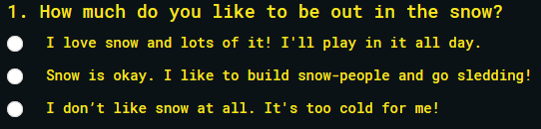
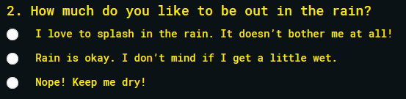
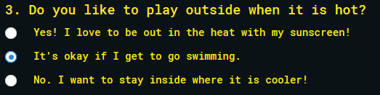
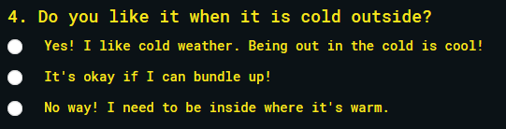
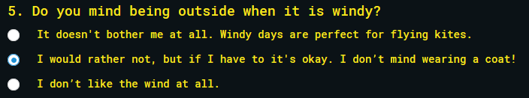
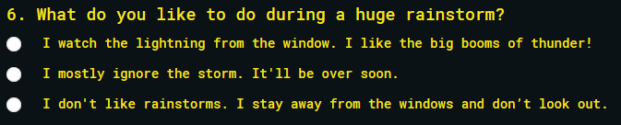
Planet I Questions
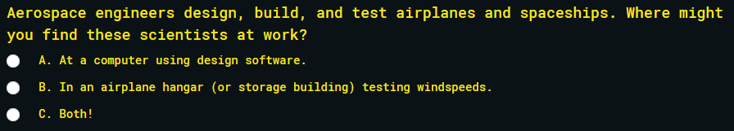
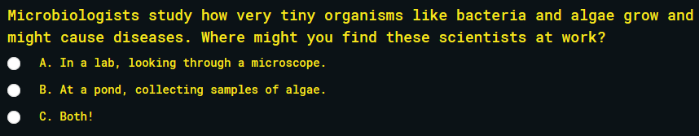
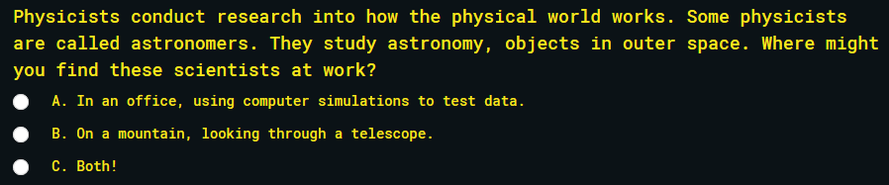
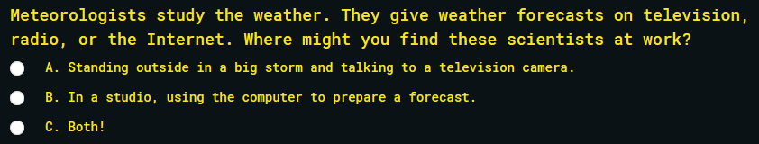
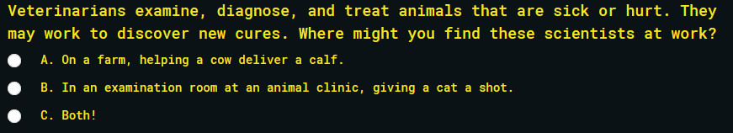
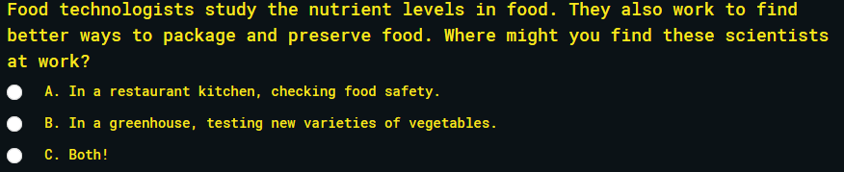
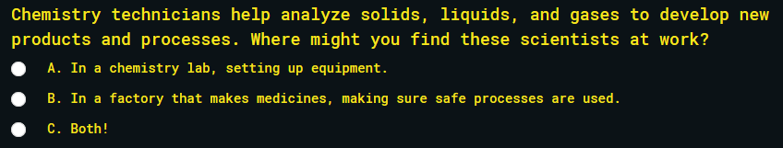
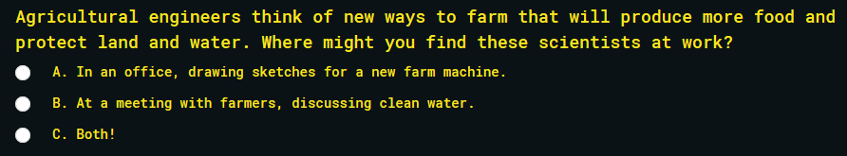
Planet A Questions
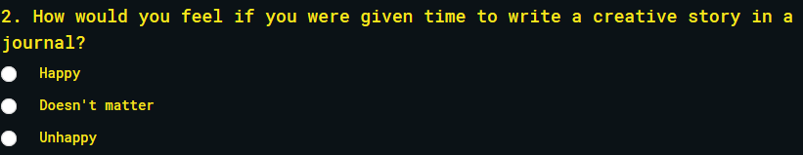
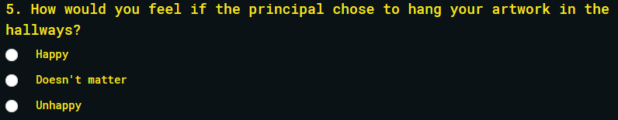
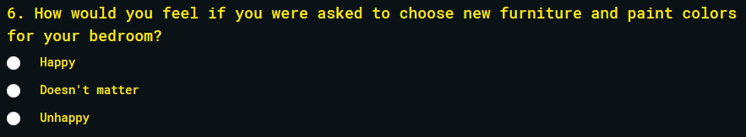
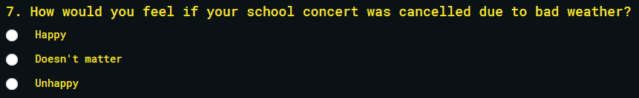
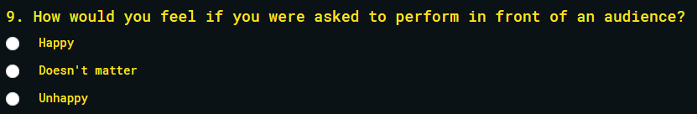
Planet S Questions
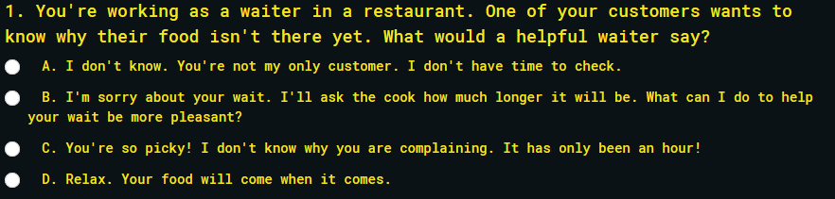
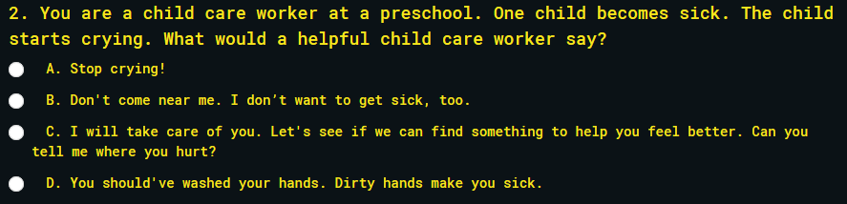
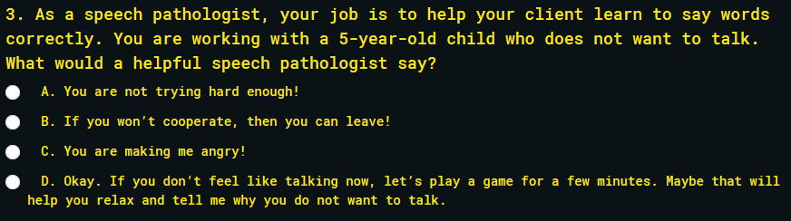
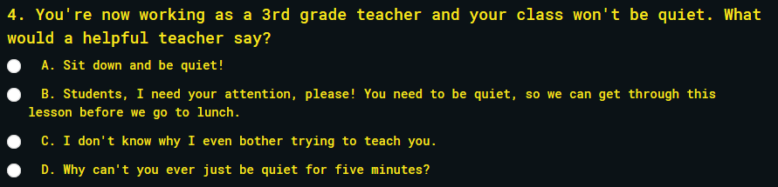
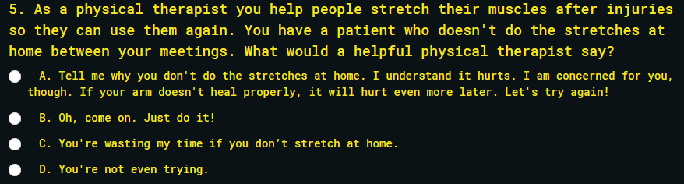
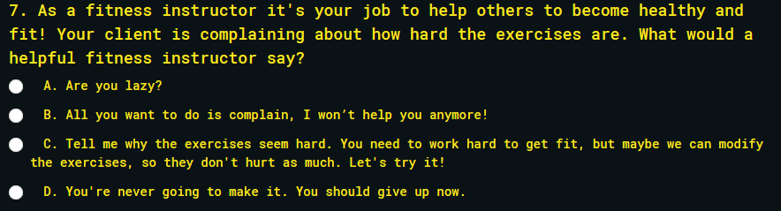
Planet E Questions
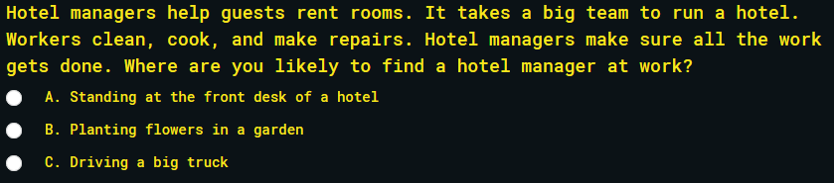
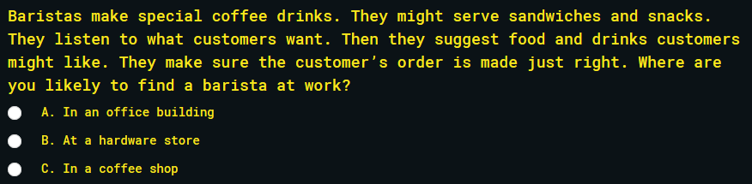
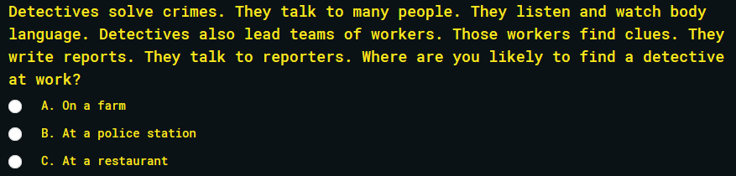
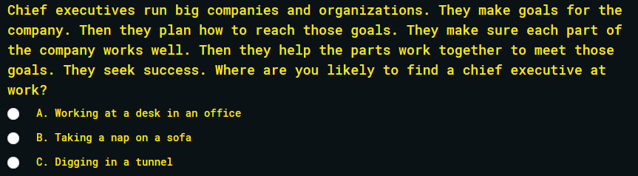
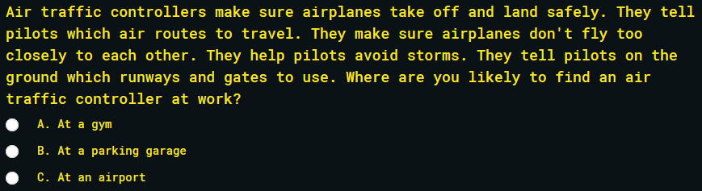
Planet C Questions
