**Planet R Questions**

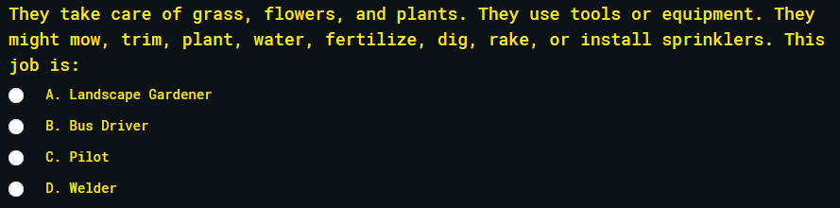

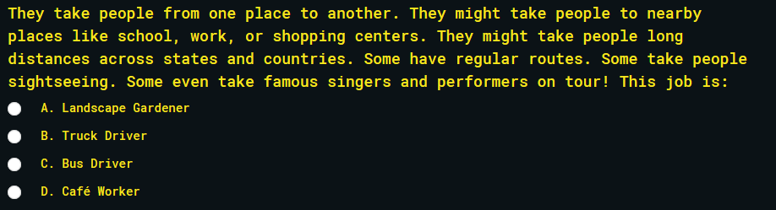

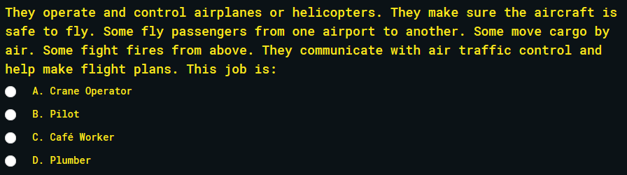

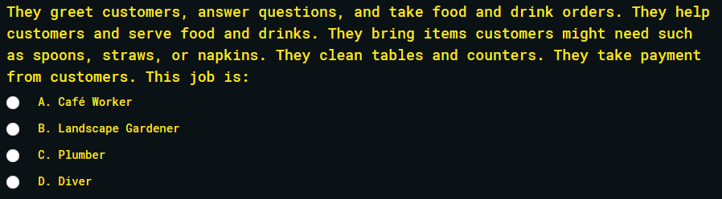

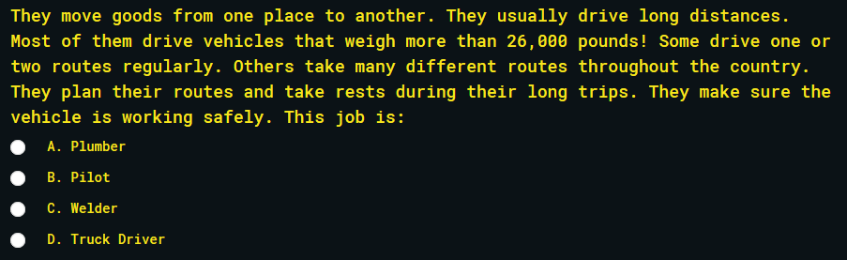

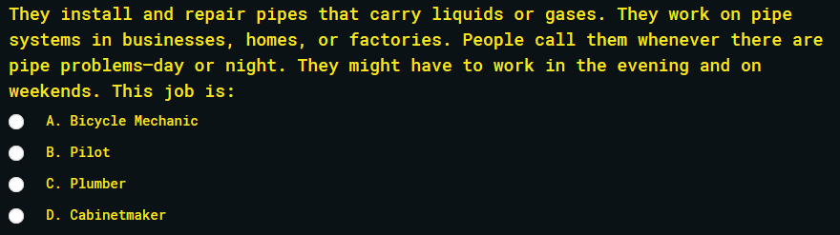

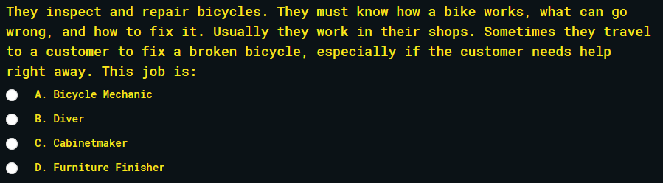

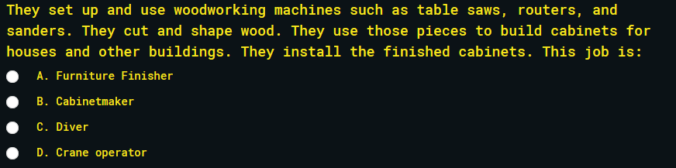

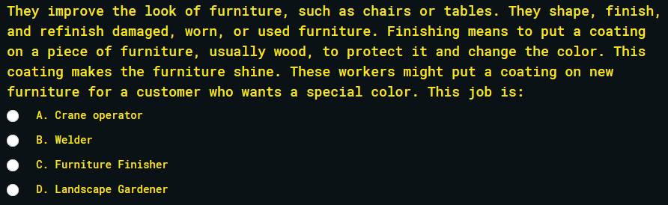

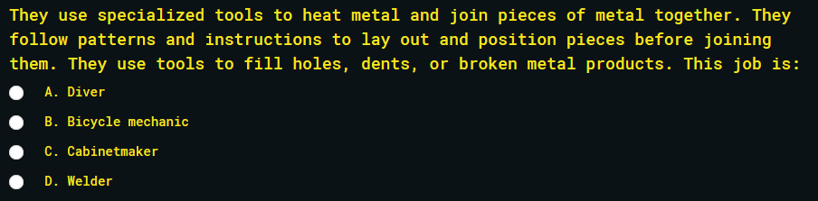

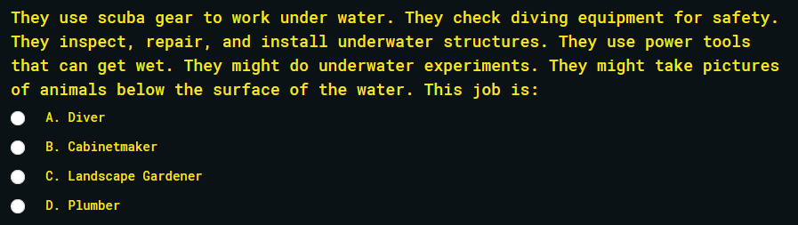

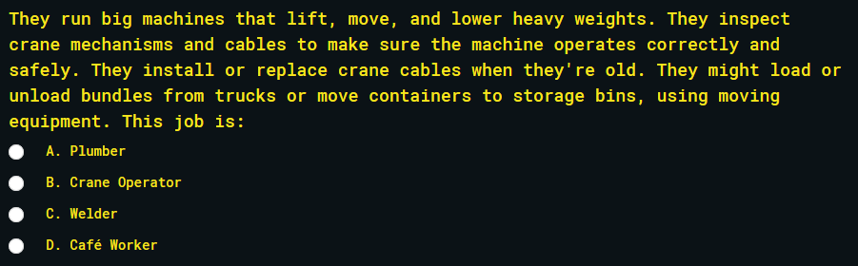

**I Planet Questions**

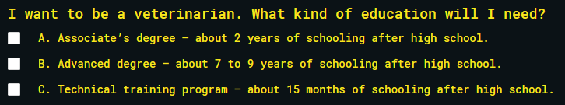

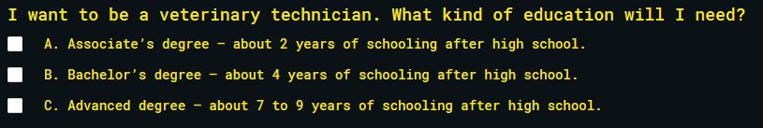

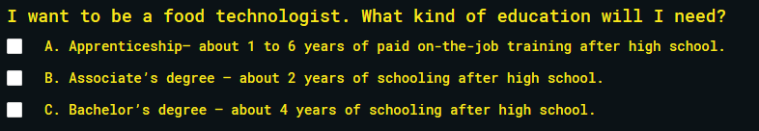

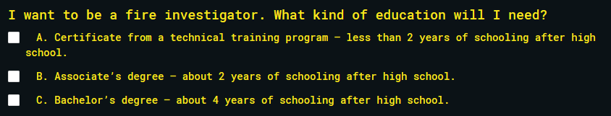

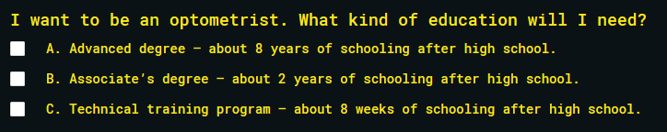

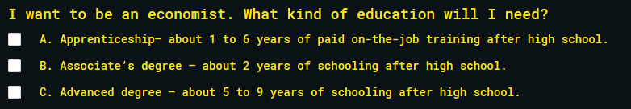

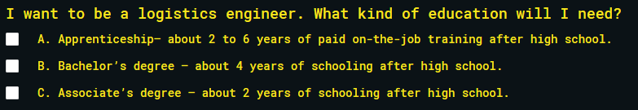

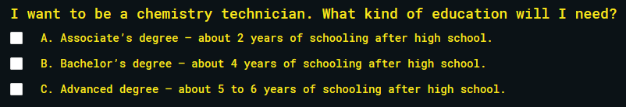

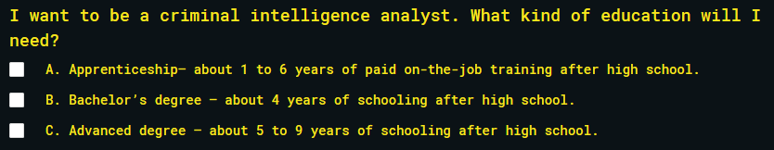

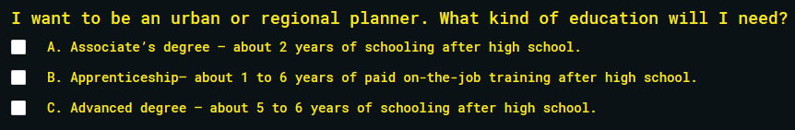

**Planet A Questions**

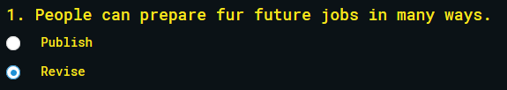

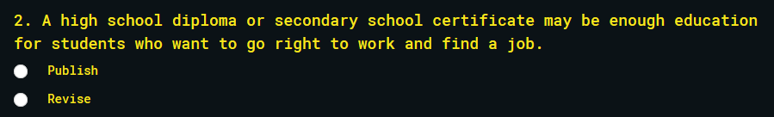

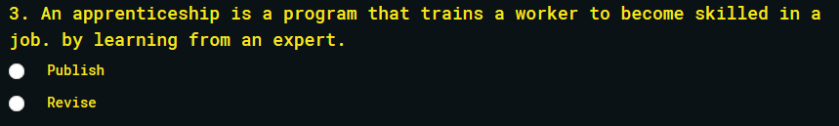

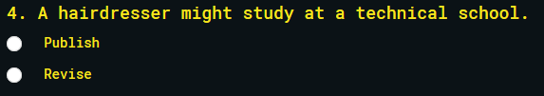

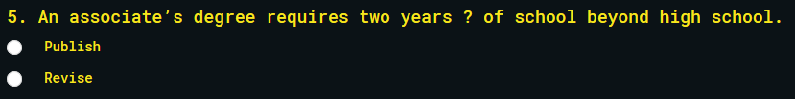

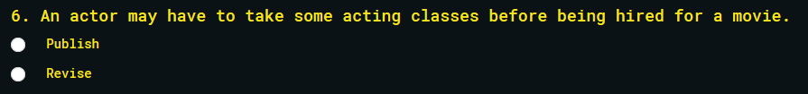

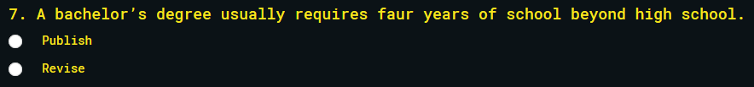

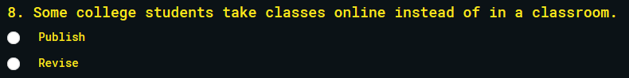

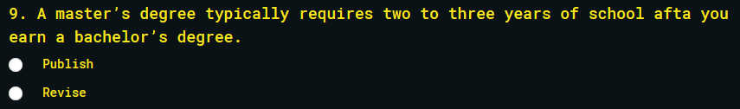

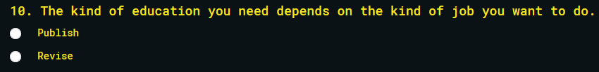

**Planet S Questions**

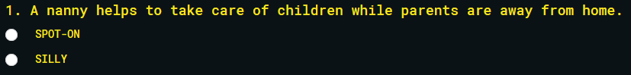

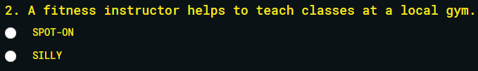

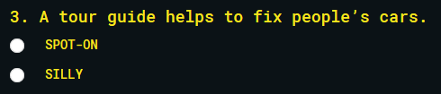

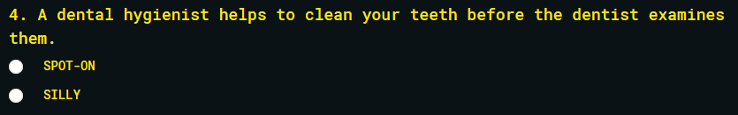

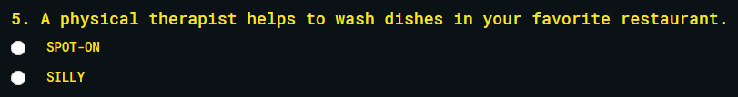

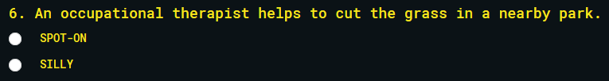

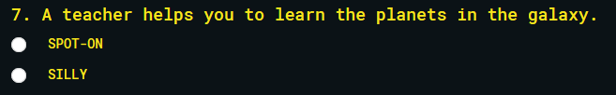

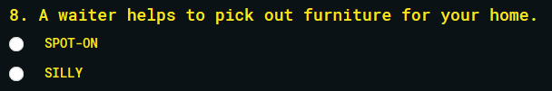

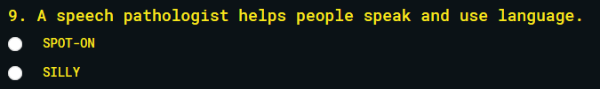

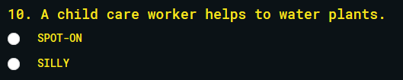

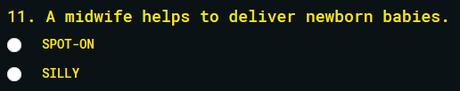

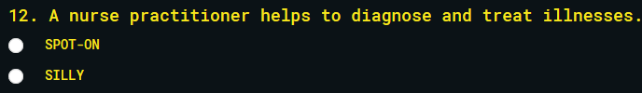

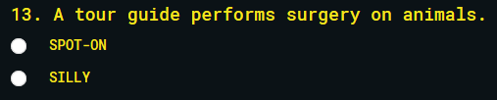

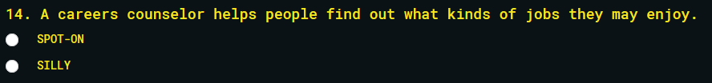

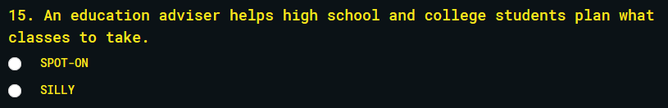

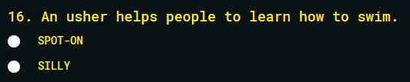

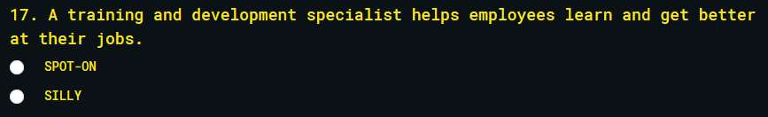

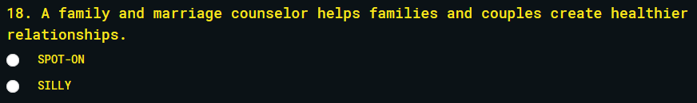

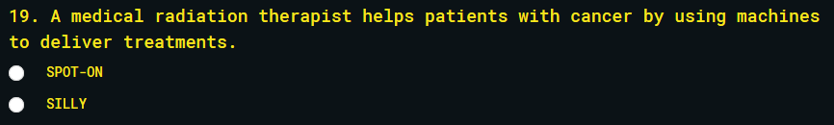

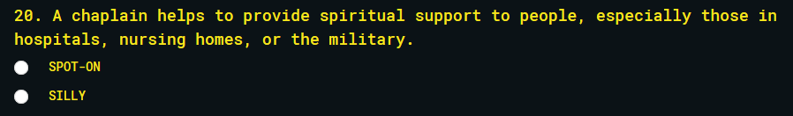

**Planet E Questions**



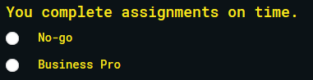

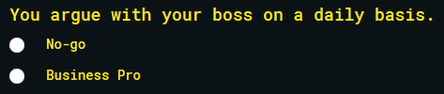





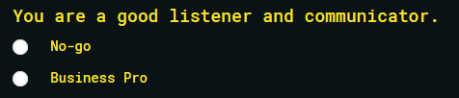



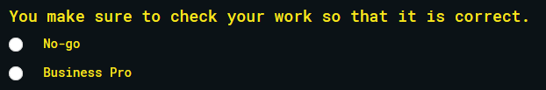





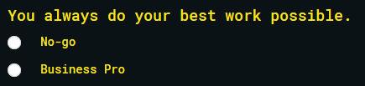

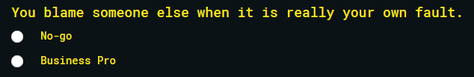

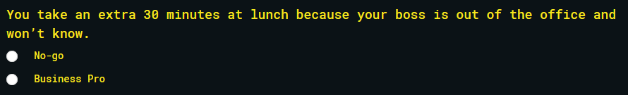



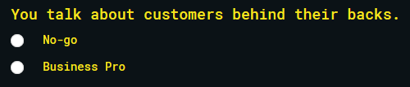

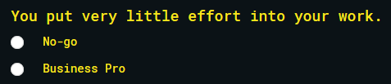



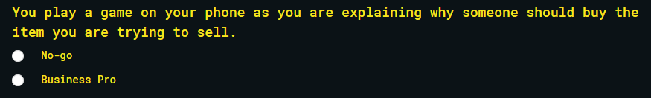





**Planet C Questions**

