Planet R Questions
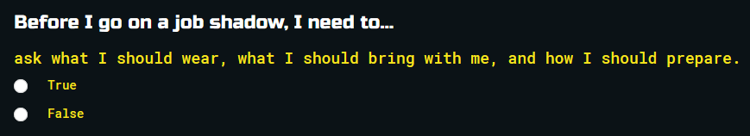
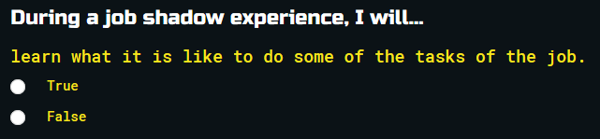
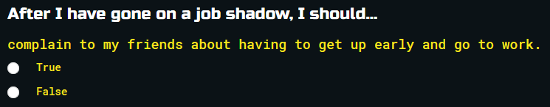
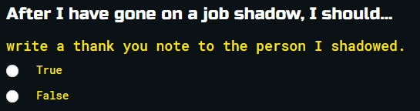
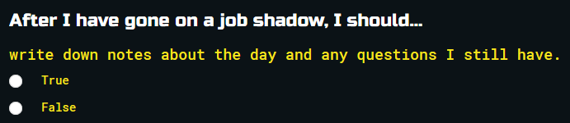
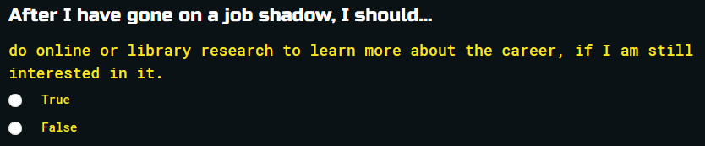
Planet R Survey
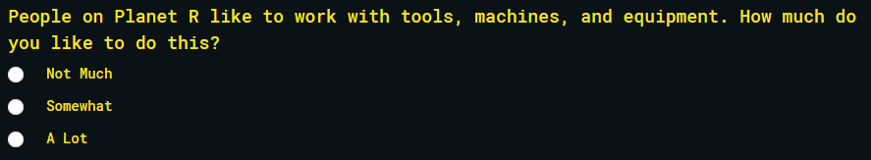
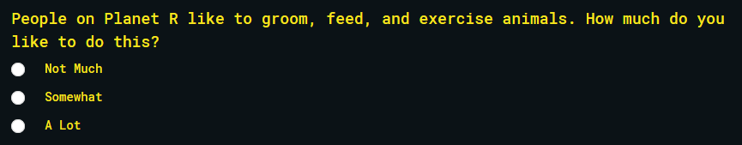
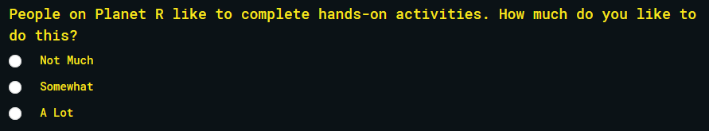
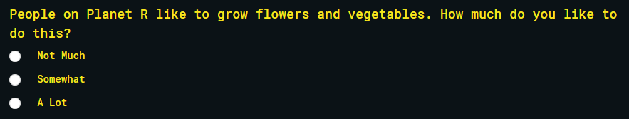
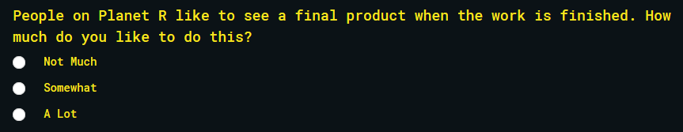
Planet I Question
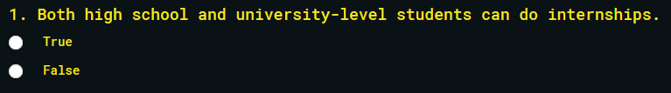
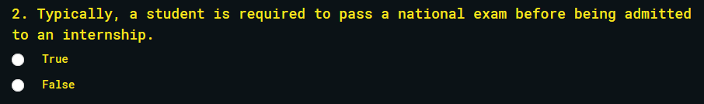
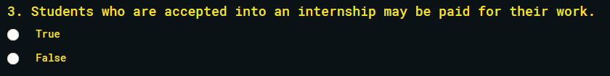
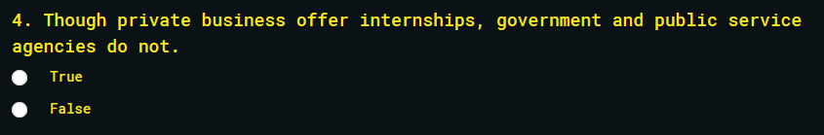
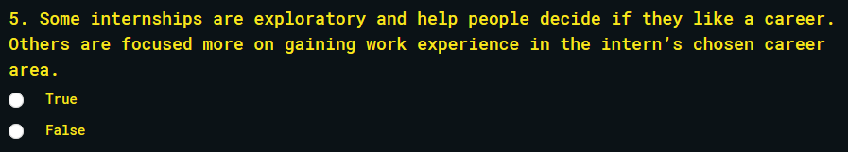
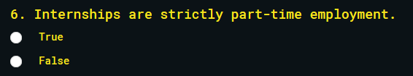
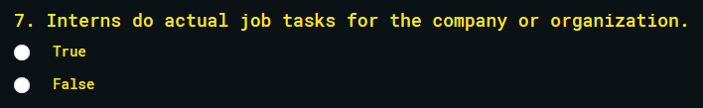
Planet I Survey
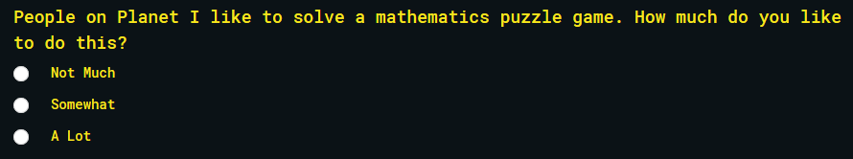
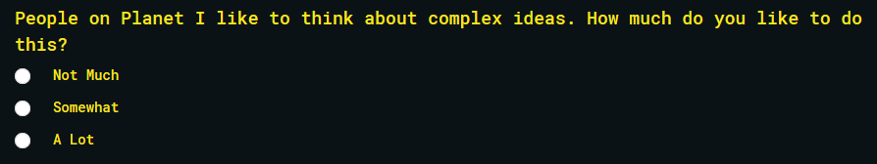
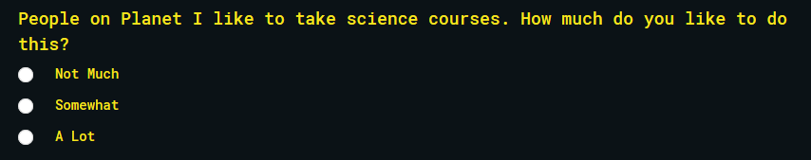
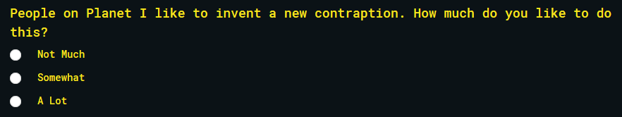
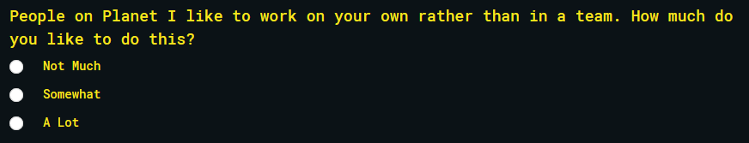
Planet A Questions
Planet A Survey
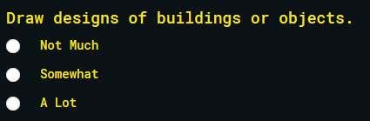
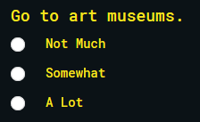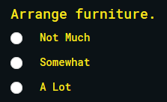
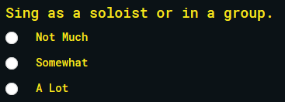
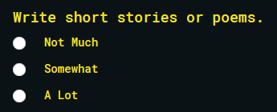
Planet S Questions
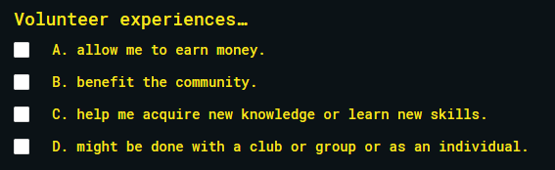
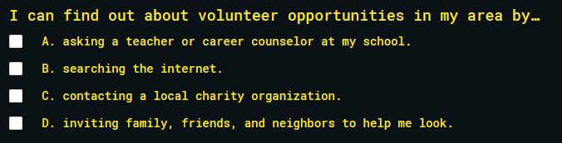
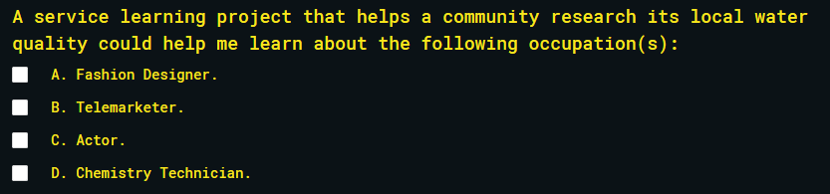
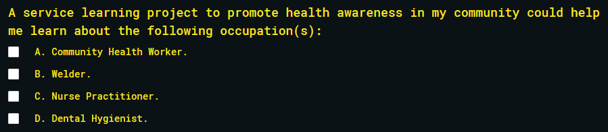
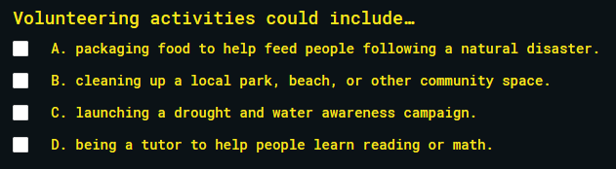
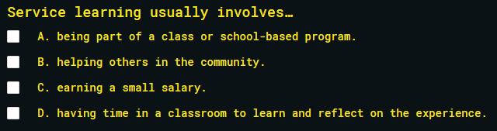
Planet S Survey
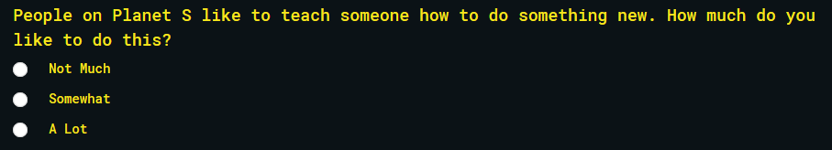
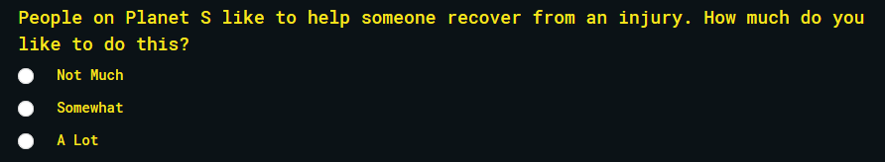
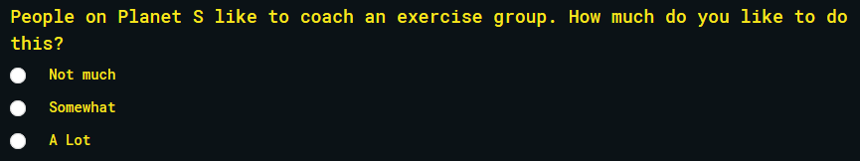
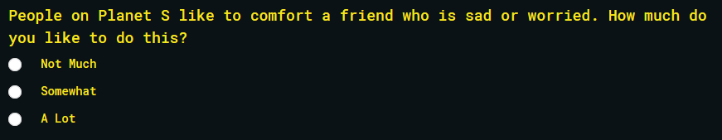
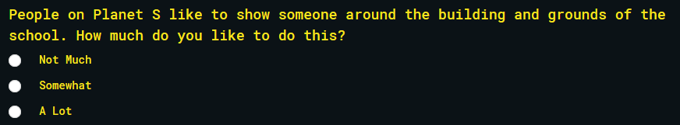
Planet E Questions
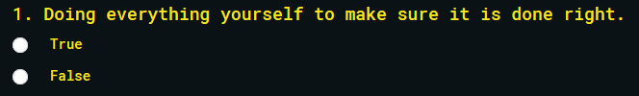
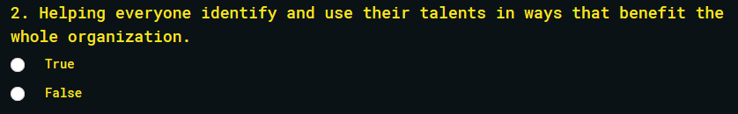
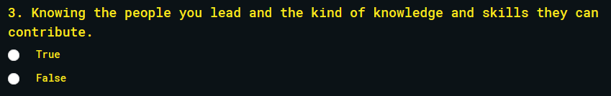
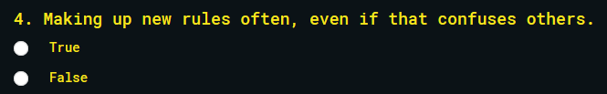
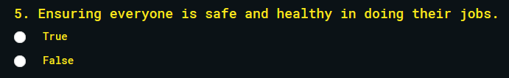
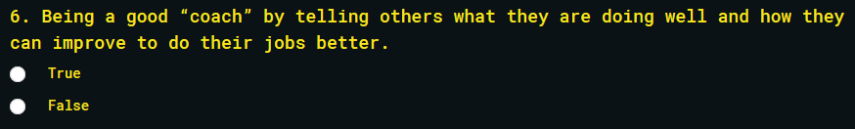
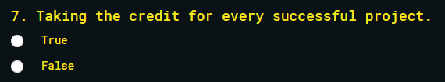
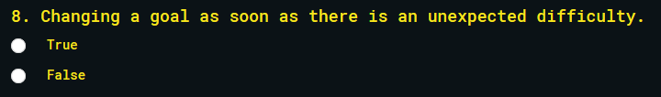
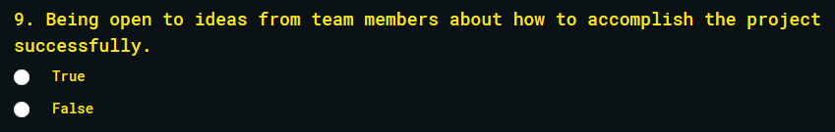
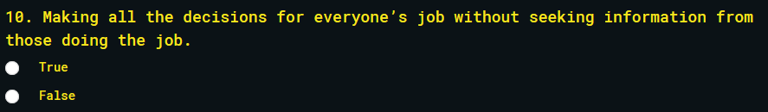
Planet E Survey
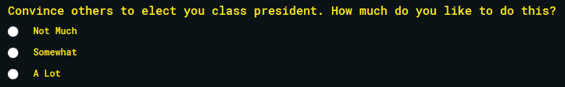
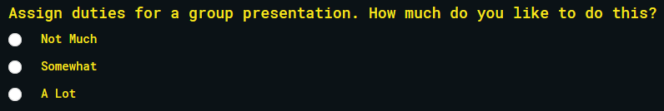
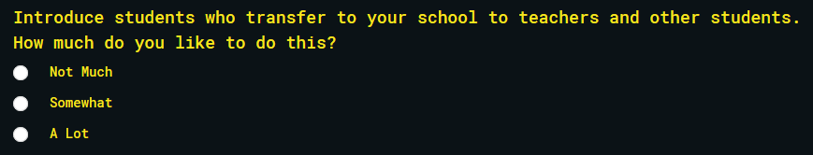
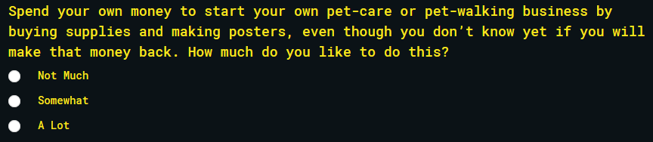
Planet C Questions
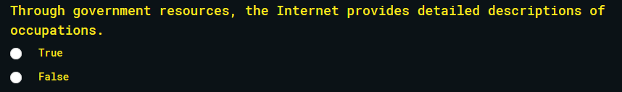
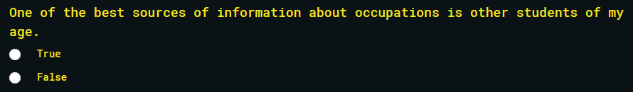
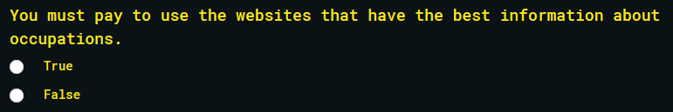
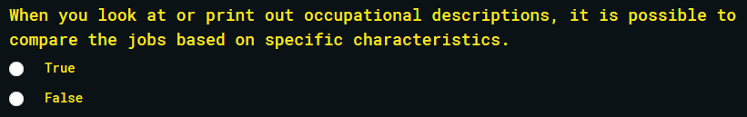
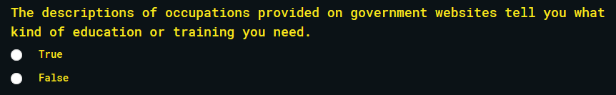
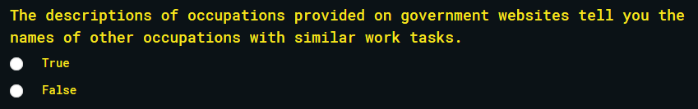
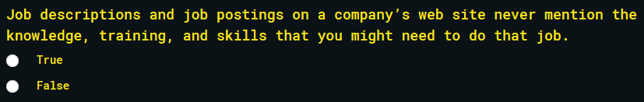
Planet C Survey
