You Never Get Another Chance to Make a First Impression
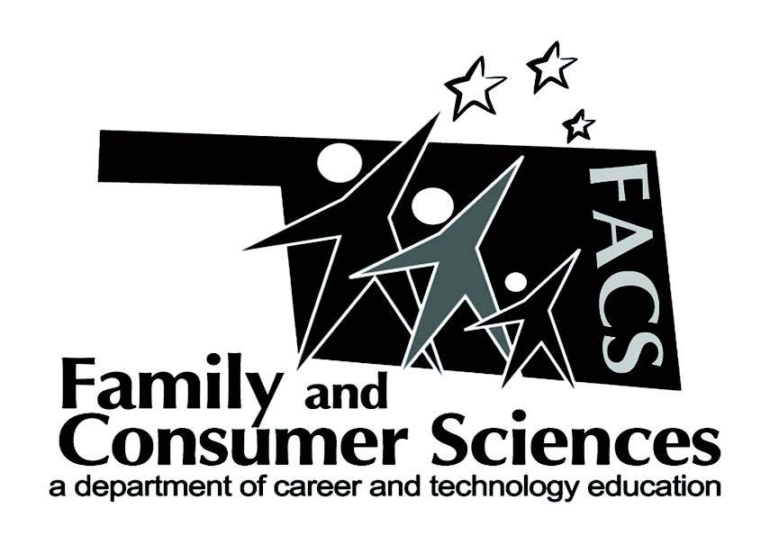

Lesson Plan Title:
Jobs, Careers, Fashion
Subject Area:
Recommended course(s):
Surviving and Thriving and Clothing

Aligned to NASAFACS Standards:
 | 1.2.7 |  | Analyze factors that contribute to maintaining safe and healthy school, work and community environments.
16.3.5 |  |  |  | Generate design that takes into consideration ecological, environmental, sociological, psychological, technical, and economic trends and issues.

Objectives:
- Discuss the importance of dressing appropriately for an interview
- Identify various workplaces and wardrobes that are worn to an interview
- Analyze various types of dress for the workplace
- Discuss jewelry, tattoos, piercings, accessories, etc.

Materials needed:  Croquis – male and female  Copy paper – 8 1/2x11  Colored pencils  Lead pencil  Thin point black sharpie – for tracing outfit and body  when done sketching and coloring outfit | Resources:  Tools for Sketching - article  http://www.threadsmagazine.com/item/3719/meet-the-threads-croquis-family-your-tool-for-fashion-sketching  What is a Fashion Croquis – video  https://www.youtube.com/watch?v=KvRvt9CapCs

Lesson Summary/Outline:
One never gets another chance to make a first impression. The purpose of this lesson is to allow students to visually see various examples of clothing and to determine the standard of dress for an interview. In the end, the students will be given a company and they will have to research dress code and design an outfit appropriate for the interview.

Motivator/Opening:
Write on the board: “If you had a job interview tomorrow, what outfit would you wear?” Discuss their comments….

Activities:  - Find 10 pics out of a magazines (male and female) that are both business professional and causal. View the following outfit choices and discuss whether they are appropriate for an interview, a day on the job, both, or none of the above. Justify the opinions.  - Discuss the standard for business dress for women is blue or black, closed toed shoes, conservative makeup, jewelry, and hair. For men, it is black or blue suits with button-up shirt and tie. An interview is one standard higher; it is the best-dressed outfit that fits the above definition. Many students will want to argue that it is dependent on WHERE they are to work; it is true that some companies have a more casual dress policy.  - This is a great time to bring up the importance of researching the company before the interview takes place.  - Discuss business casual dress. Discuss how businesses vary what that concept is, and how many are straying away from any type of “dress down” day because it is so confusing for employees. Again, research becomes crucial.  - Discussion regarding tattoos (business standards it for tattoos to be hidden from sight), jewelry and piercings (conservative jewelry, piercing of the ears are usually acceptable, but not others)  - Research and design an acceptable outfit to an interview | Assignments:  Give every student a company to research and find out what would be appropriate to wear to a job interview –  Examples – Anthropology, Acme Brick, CarMax, Charles Schwab  After researching, design an interview outfit that would be appropriate for the purpose of interviewing for the job site. Remember one would need to wear clothes that reflect the image of the business that one is applying for employment. They would need to use a croquis sketch design and color it. Then go back and ink it out with black sharpie.

Evaluation:
After the sketches are complete, have the students report about their company and dress code. Then explain the outfit that designed and how it would be appropriate to wear.

Submitted by:
Karin Davis
Contact info:
Karin.davis@tulsatech.edu

