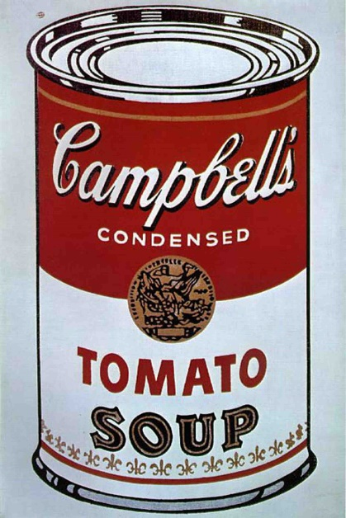

Group Name: ________________________________________

Members: ______________________________________________________

_______________________________________________________________

**Campbell’s Soup** Careers Activity

NSSA – July 11/12, 2019 ODCTE - CAC

**NSSA**

|  |  |
| --- | --- |
| JOB/CAREER | CLUSTER |
|  |  |
|  |  |
|  |  |
|  |  |
|  |  |
|  |  |
|  |  |
|  |  |
|  |  |
|  |  |
|  |  |
|  |  |
|  |  |
|  |  |
|  |  |
|  |  |
|  |  |
|  |  |
|  |  |
|  |  |
|  |  |
|  |  |
|  |  |
|  |  |
|  |  |
|  |  |
|  |  |

Suggestions:

SETUP

1. Work in small groups.
2. Set a time limit – 10 minutes or less is best!
3. Ask the question – “How many different jobs can you name that played a part in getting this can of soup to the table?

FOLLOW-UP Activities

1. Which team had the most jobs listed? (named jobs, specific, correct)
2. Sort the jobs by Holland’s Codes, Career Clusters, Job Families, etc. (You choose based upon age/experience/interest!)
   1. Holland’s Codes Graphic below
   2. Link to Oklahoma Career Clusters <https://www.okcareertech.org/educators/career-clusters>
3. Which of your jobs can be found in OKLAHOMA?
4. Which jobs require training/education beyond high school?
5. Where can I get training/education for this job?
6. Interview someone who has one of the jobs.

Campbell’s Soup Careers Activity

* Career Awareness
* Career Clusters/Connections
* Ice Breaker
* Divergent Thinking
* Adaptable for Elementary - Adult

* This activity was shared and used at New Student Services Academy at ODCTE in Stillwater – July 2019. I have used the activity with different audiences at different locations for years but I did NOT create the activity! These notes, graphics, and suggestions were developed for sharing with others involved in Career Awareness education and support. Graphics were taken from the KUDER website and ODCTE. Please feel free to use and share… and if YOU come up with other ideas to go with the activity PLEASE share back? ☺ Cari Lousch – CAC Manager/ODCTE

