OKCareerGuide.org
- Follow the link above or just type in okcareerguide.org and it will take you to the page below.
- You will need to go to the middle of the screen and either log in or create an account. If you scroll down to the bottom of the page and you can see descriptions of the different accounts. The very bottom has training and tutorials along with additional resources.
- Basically there will be 3 kinds of accounts:
  - Student
  - Adult
  - Educator
- As an instructor, you will want to create one in each. However, I found that I needed a different email for each account.
- I will walk through the student account and describe the process for all three at the same time.
- First select the student button then the Create an Account button. When you do this you will see the following window come up.
- Once you select middle or high school student, you can start creating account.
- You will need select a grade level [Navigator the student account covers grades 6-12]
  - Then select a graduation year .
- Then start typing in your school [it should start populating after 3 letters] if you do not find you school contact Erica Harris @405.809.3612.

- Next select the green Nest Step button at the bottom and the page will get longer to reveal the next step.
- Pryor to having students create accounts you will need to find out if they have an email or a cell phone that they can text. If not then you may want to help them save their password and unser name. [NOTE: make sure that your students check the box allowing you to send them messages.
- Next select the green Nest Step button.
- This is where things will change depending on if you are a Student/Adult or Educator.
- First, I recommend that you use student before your username and password.
  - Likewise, when you do adult use adult before your username and password. Then when you do the Educator, you can use your regular username and password.
When you do the educator setup you will also have to have a code and a password that is assigned to you. [Contact Erica Harris @405.809.3612 for code and Password]
  - I recommend the question about birth city for most students.
- Next select the green Nest Step button.
- Fill out step 4 as you wish and it should get you started.
- Make sure you have written down all the usernames and passwords!!
- The student version [Navigator] opens and looks like the page below for a sixth grader and will have more options as the grade levels get higher.
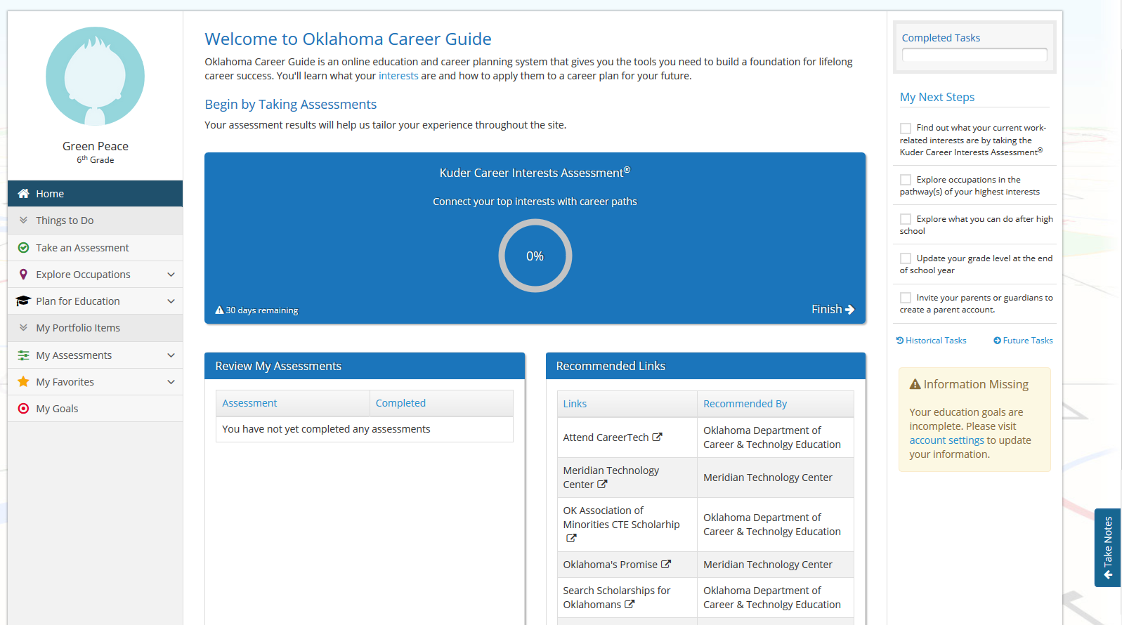
- The Adult version [Journey] looks like page below.
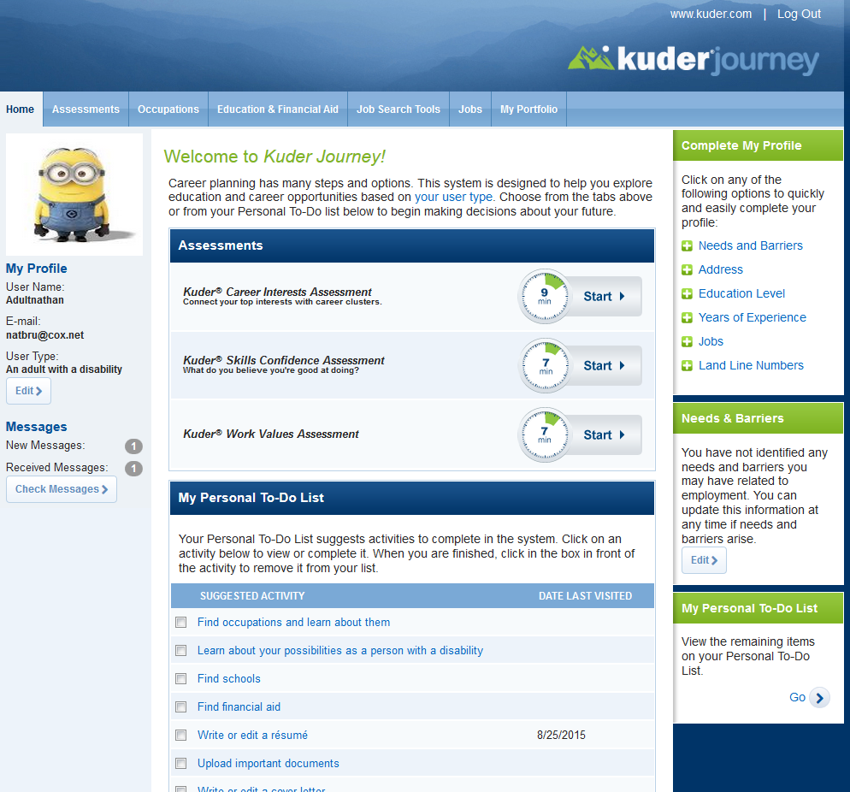
- The Educator version looks like below.
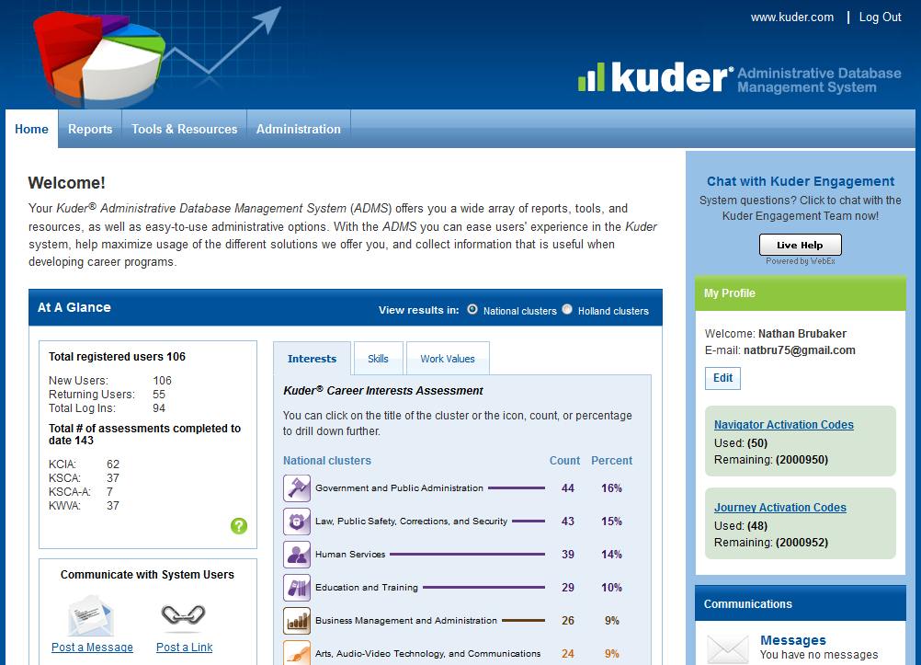
- If you select the Tools & Resources tab at the top you get a page that looks like:
- Under Curriculum Resources select Lesson Plans.
  - This will give you a great place to start in your CTE class and you can show other teachers the lesson plans for their class.
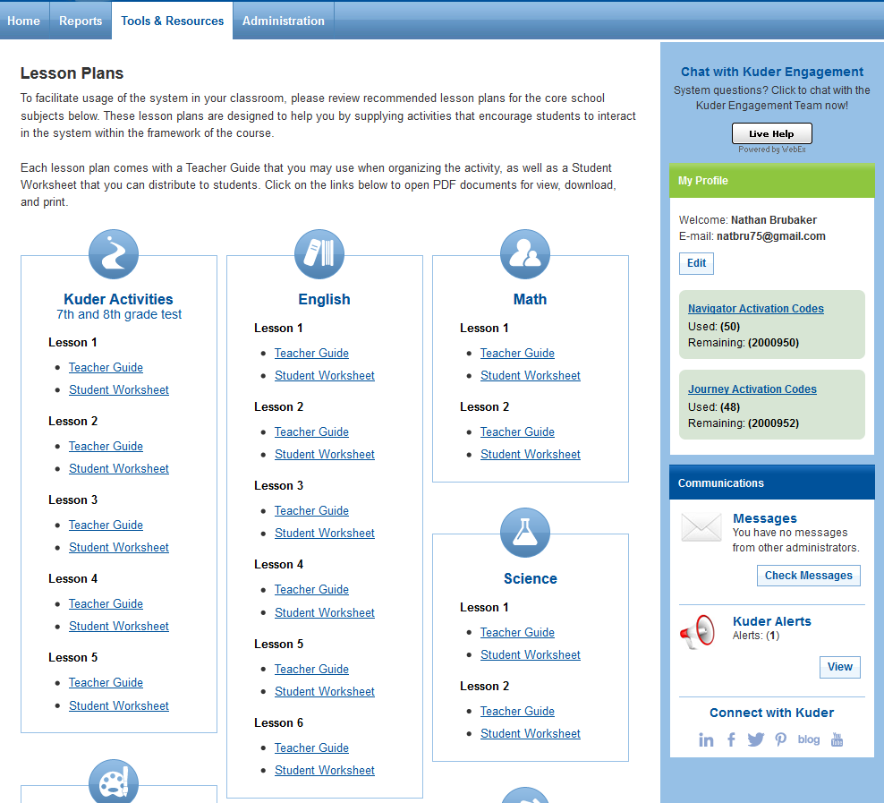
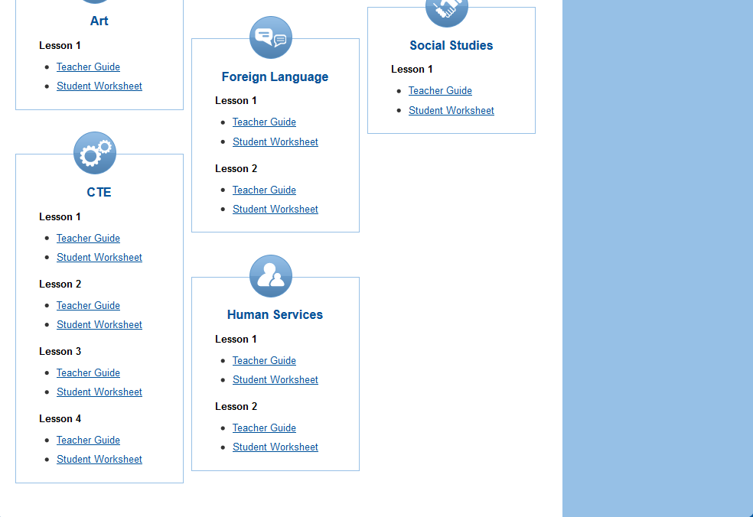
- Training is available @
https://www.okcareertech.org/educators/career-and-academic-connections/career-information/website-documents/OKCareerGuideCustomizedTrainingRequestForm.pdf
sign up today for training in your area or request training for your school by calling Erica Harris @405.809.3612.

6th grade Assignment
Total time 50 minute class period
Take interest assessment [10 minutes]
- How many occupations are on your list suggested by assessment results? ____________
- List any occupations that are non-traditional Gender Opportunity occupations.
________________________________________________________________________________________________________________________________________________________________________________________________________________________________________________________________________________________________________________________
- List any occupations that are national Bright Outlook occupations.
________________________________________________________________________________________________________________________________________________________________________________________________________________________________________________________________________________________________________________________
- List any occupations that support the National Green Economy.
________________________________________________________________________________________________________________________________________________________________________________________________________________________________________________________________________________________________________________________
- Out of all the occupations listed, choose your top five you might consider and list below
- ______________________________________
- ______________________________________
- ______________________________________
- ______________________________________
- ______________________________________

- Choose one of the Occupations from your list and watch the video. Then list the following information
- National Annual Salary Range _____________________
- Entry-Level Education _____________________
- Number of Jobs in 2014 _____________________
- Expected Job Openings (2014-2024) _____________________
- National Outlook (2014-2024) _____________________
- Oklahoma Median Yearly Salary _____________________
- Oklahoma Median Hourly Salary _____________________
Optional activity [depending on size of class could be another 50 minutes]
Have students read task and working conditions and orally present the occupation and tell about five things they found interesting from the reading. That information could also be added to the worksheet above

Additional Activity [depending on size of class could be another 50 minutes]
Have students print out Occupation details to take home to parents and ask them what they think about the occupation and sign it. They would report to the class about what their parents or guardians might know about the occupation.

Additional Activity [Could be added to the above assignment]
Have student cluck on the Pathway and list all the occupations that fall under the pathway besides the one that they chose.

Additional Activity
Have students start clicking on the star next to occupations they like.

Additional Activity
In the next steps at the right of the page have student click on Explore what you can do after high school.

Additional CTE activity [this would use the worksheet above]
- The CTE teacher would go to the Occupations suggested by National Career Clusters and Pathways.
- Following the list of pathways for each cluster, they will make a list of occupations related to their CTE class.
- Students either are assigned occupations or choose occupations then use worksheet to gather information and present to class.
- If students are, in a STEM exploratory class, they might just complete the work sheet for each area they explore and it be included into the assignments for that area.

7th grade assignments
Total time 50 minute class period
Take Skills Confidence assessment [10 minutes]

- List the top five career pathways that were generated for you and a short description of each:
  - ________________________ - ________________________________________ __________________________________________________________________
  - ________________________ - ________________________________________ __________________________________________________________________
  - ________________________ - ________________________________________ __________________________________________________________________
  - ________________________ - ________________________________________ __________________________________________________________________
  - ________________________ - ________________________________________ __________________________________________________________________

- Star any career pathways that interest you.

- Located just under the Print Report link it says, “View by National Career Cluster Ranking”. Click on this and list your top 5 national career clusters:
  - ____________________________________
  - ____________________________________
  - ____________________________________
  - ____________________________________
  - ____________________________________
Look at the bottom of the list, what is there? ___________________________________ Is it really something you have no interest? Explain: ________________________________________________________________________

- Click on the second tab of the results [Occupations to Explore] and choose three occupations you like and star them. List your choices below.
  - ____________________________________
  - ____________________________________
  - ____________________________________

- Click on the third tab of the results [Sample Ed Plans], choose an education plan that aligns with one of your stared occupations, and list it below.
  - __________________________________________________________________

- Click on the Sample Ed Plan that you listed above and it will open and be titled in green. Find the Plan of Study (PDF) and click on it. List below the math and CTE courses you will have to take in high school.
  - Math: ____________________________________________________________
  - CTE: ______________________________________________________________

- Optional activity would be to print out Plan of Study to take home and show parents.

- Click on the fourth tab [Majors to Explore] and explore the Education Levels drop down box. Going through each level and applying filters write below how many majors are possible with the education level.
  - Less than high school graduation _____
  - High school graduation or equivalent _____
  - Less than two-year postsecondary certificate or program _____
  - Two or three year associate degree _____
  - Bachelor’s Degree _____
  - Doctorate or professional degree _____
- Choosing the education level that you plan to achieve star three majors and list them below.
  - _____________________________________
  - _____________________________________
  - _____________________________________

Optional activity [depending on size of class could be another 50 minutes]
Have students choose one of their top career pathways and give class information about it and explain how they may like to pursue a career in this area.

Additional Activity [depending on size of class could be another 50 minutes]
Have students print out Pathway details to take home to parents and ask them what they think about the pathways and sign it. They would report to the class about what their parents or guardians might know about the pathways.

Additional Activity
Have students start clicking on the star next to pathways they like.

Additional Activity
In the next steps at the right of the page have student click on Explore occupations in the pathways of your highest interests.

Additional CTE activity [this would use the worksheet above]
- The CTE teacher would go to the Occupations suggested by National Career Clusters and Pathways.
- Following the list of pathways for each cluster, they will make a list of occupations related to their CTE class.
- Students either are assigned pathways or choose pathways then use worksheet to gather information and present to class.
- If students are, in a STEM exploratory class, they might just complete the work sheet for each area they explore and it be included into the assignments for that area.

8th grade assignments

- Re do your Skill Confidence Assessment
- On the right side of the screen, click on the second My Next Steps. List the top five Career pathways
  - ______________________________________________
  - ______________________________________________
  - ______________________________________________
  - ______________________________________________
  - ______________________________________________
- Discuss how the Interest compare to the skills in each pathway.
________________________________________________________________________________________________________________________________________________________________________________________________________________________________________________________________________________________________________________________________________________________________________
- Click on View By: Top Career Pathways and list the top five career clusters.
  - _____________________________________________
  - _____________________________________________
  - _____________________________________________
  - _____________________________________________
  - _____________________________________________
- Once again, compare the interest to the skills in each cluster.
________________________________________________________________________________________________________________________________________________________________________________________________________________________________________________________________________________________________________________________________________________________________________
- Looking at clusters and pathways click on at least one stars of each that you find interesting. List them below: ________________________________________________
________________________________________________________________________________________________________________________________________________
- Looking again at My Next Steps click on the fourth one down called review sample plans of study. Based on the star items you listed above, choose a national career cluster and print out a plan of study. [decide if you want to collect or send home to parents or both]

Create or Edit an Education Plan
To be done with teacher or counselor

- On the right side of the screen, click on the fifth My Next Steps. [This can be done as a class, or individualy as teacher as advisors, or by the counselor.]
- If started in 7th grade can be edited or add additional years
- When finished preview the plan, print the plan and submit for approval.

Additional lessons
Review plans for after high school

- On the Options after High School page are five different directions click on the learn more about for each and based on your assessments it will show you pathways available at that level of training. List the top 5 pathways available [if there are any] for each level of training.
  - Get a Job After Graduation: _________________________________________________
  - Military Training: _________________________________________________________
  - On-the-Job Training or Apprenticeship: ________________________________________
  - Community College or Technical School: _______________________________________
  - Four-Year College or University: _____________________________________________

