Sewing 101: The French Seam

This is used most often when sewing clothes if you don't have a serger. The raw edges of the fabric are encased so that there is no fraying. Grab some scrap fabric and try it out (it's fun!) Here goes:
We are going to sew these two pieces of fabric together:
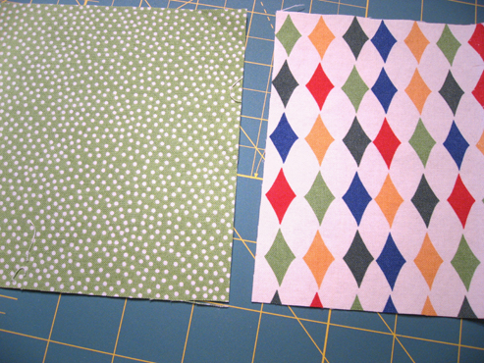
This is the part that feels strange. Line up your fabric with WRONG sides together and sew a 3/8" seam:
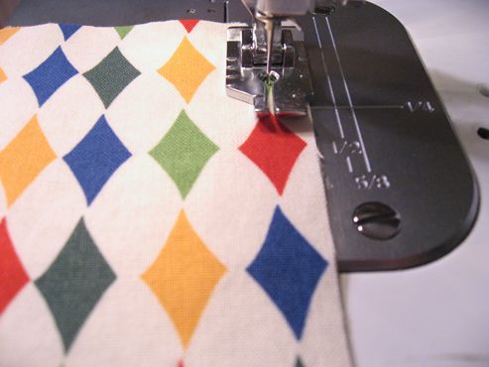
Measuring 1/8" out from the sewn line, trim off the seam allowance.
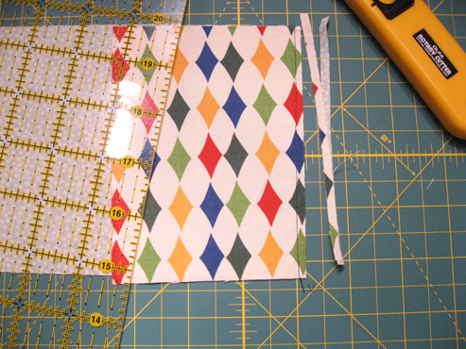
Fold the fabric on the seam so that right sides are together and iron it down.
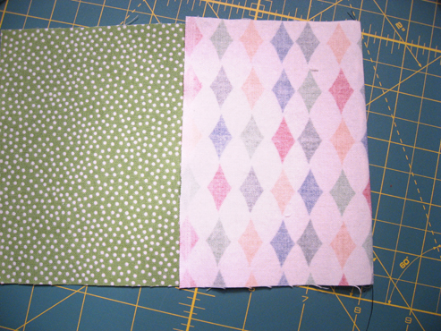

Stitch another seam at 1/4" (this part feels normal again, because right sides are together--whew!).
When you open it up, it looks like this:
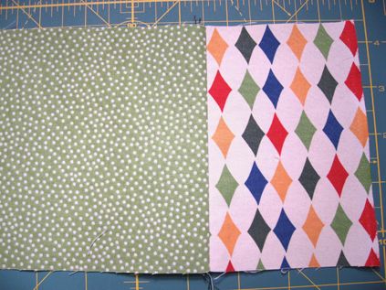
And from the back, it looks like this--see, no raw edges!

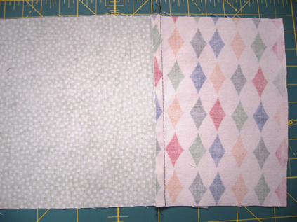
Why all the precise measurements? To get a perfect 5/8" seam, of course!

<<http://stardustshoes.blogspot.com/2007/08/sewing-101-french-seam.html>>

List 3 ways that you would use or have used the French seam:
________________________________________________________________________________________________________________________________________________________________________________________________________________________

Follow instructions and attach your sample here:

