Understanding Workplace Ethics

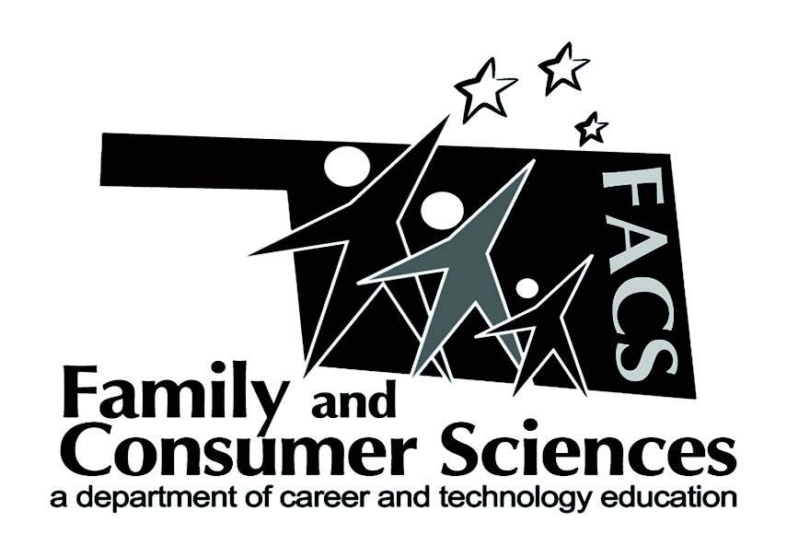

**Lesson Plan Title:**

Career Orientation

**Subject Area:**

**Recommended course(s):**

Career Orientation, Hospitality and Tourism

**Aligned to NASAFACS Standards:**

|  |  |
| --- | --- |
| 1.2.2 | Demonstrate job seeking and job keeping skills. |
| 1.2.8 | Demonstrate work ethics and professionalism. |

**Objectives:**

After studying this section, you will be able to:

* Explain why ethics are important in the workplace
* Describe ways to behave ethically in the workplace

|  |  |
| --- | --- |
| **Materials needed:**  You will need a pencil, calculator, 2-3 recent newspapers, construction paper, tape or glue, scissors. | **Resources:** |

**Lesson Summary/Outline:**

In summary, students will gain a better perspective on why unethical behavior, even things they think are small, are impactful to themselves and those who they work with.

**Motivator/Opening:**

To introduce the chapter, teacher will lead students in a discussion of examples of unethical behavior in the workplace.

|  |  |
| --- | --- |
| **Activities:**  Methods/Procedures or Steps   1. Intro – teacher will ask students to define ethics in the workplace setting. Teacher will write all of their definitions on the white board. 2. Teacher will then ask students to discuss whether it is important to be ethical in the workplace. What are the expectations that employers have of their employees? If they were the employer, what would they expect? 3. Worksheet: Teacher will give students the “Pizza Place” worksheet. Students will take turns reading aloud the scenario found in the worksheet. Students will then calculate the financial loss to the employer each time the employees give away Pizza and soda. 4. Ethics in the News: Students will select an article from a recent newspaper about an employee who has been unethical. They will read the story and highlight what the employee did wrong and highlight the consequence. 5. Think. Pair. Share. - Students will break into small groups to share their article and discuss what the employee should have done to be more ethical. 6. Closure: Teacher will ask students to share the impact unethical behavior might have on the employee, employer, the employee’s co-workers, family and friends.   Reference Materials Used: Several recent newspapers and Pizza Place worksheet  Closure: To wrap up the lesson, students will be asked to reflect on the consequences of unethical behavior. | **Assignments:**  Ethics in the News and Pizza Place worksheet |

**Evaluation:**

Teacher will collect the highlighted news article and Pizza Place worksheet to evaluate student understanding as well as getting one idea from each student during closure.

**Notes:**

**Submitted by:**

**Jennifer Johnson**

**Contact info:**

**Wyandotte High School**

**(918) 678-2222**

For a bell ringer, place 2-3 workplace ethics scenarios on the Smartboard and ask students to share what they would do in those various situations.