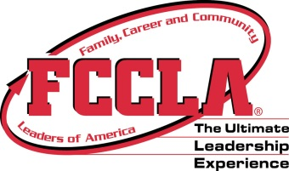
Leadership Luau
District Leadership Conference
October 4, 2016
Registration Deadline: September 16, 2016
Location: Putnam City North High School

- Roll Call Poster
  - Bring a poster decorated for the conference.
  - The poster should be standard size (22”x 28”).
  - It should incorporate the theme “Leadership Luau”
- Community Service Project
  - Miles of Smiles!
  - 8,800 toothbrushes equal one mile and that’s our goal!
  - Bring toothbrushes, toothpaste, floss
Dress Code
Chapter t-shirt and jeans

Competitions
- Chapter T-shirt Competition – provide one t-shirt to be judged! First, second, and third place will be recognized. *shirts will be tossed into crowd and not given back*
- Limbo/Lip Sync/Dance Battle – students can sign up on the day of conference to compete in fun competitions!

Send Payment to: Mrs. Nancy Osterman, South District III FCCLA Treasurer
Yukon High School
215 West Danforth, Edmond, OK 73003
Phone: (405)354 - 6692
Email: nancy.osterman@yukonps.com

Questions: Miss Brittani Parker, South District III FCCLA Counselor
Putnam City North High School
Phone: (405) 722-4220 ext. 2659
Email: brittanip@putnamcityschools.org

Miss Whitney Miller, South District III FCCLA Teacher Counselor
Mustang High School
Phone: (405) – 376-2461 Email: millerw@mustangps.org

