Three Year Electronic Subscription
Safe Dates On Demand (3 Year)
Online Price: $175.00
https://www.hazelden.org/store/item/38103?Safe-Dates-2nd-Edition
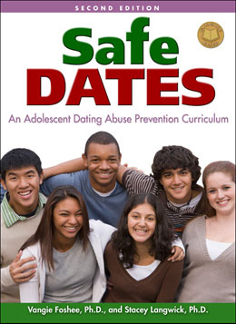
According to the Centers for Disease Control and Prevention, every year, 1 in 4 adolescents experience verbal, physical, emotional, or sexual abuse from a dating partner.
It is imperative to stop dating violence before it ever starts. Safe Dates, second edition, can help with that. This evidence-based program helps teens recognize the difference between caring, supportive relationships and controlling, manipulative, or abusive relationships. It is during the critical pre-teen and teen years that young people begin to learn the skills needed to create and foster positive relationships. With Safe Dates, young people are given the tools needed to build these skills.
Highly engaging and interactive, Safe Dates reflects the issues faced by today's teens. The curriculum includes:
- Updated statistics and facts
- Information on dating abuse through technology
- All handouts and parent resources on CD-ROM
- New Families for Safe Dates program to get families talking about healthy dating relationships and dating abuse
Safe Dates has been designated as a Model Program by the Substance Abuse and Mental Health Services Administration, and was selected for the National Registry of Evidence-based Programs and Practices (NREPP), receiving high ratings on all criteria.

Download a sample lesson.

Hazelden's grant writing toolkits have been specifically designed to help you find the funding you need to purchase our best-selling evidence-based programs. Please email us at training@hazeldenbettyford.org to receive support in completing a grant application. Our team will be happy to provide resources about our products and programs that will help you prepare a strong grant application.

