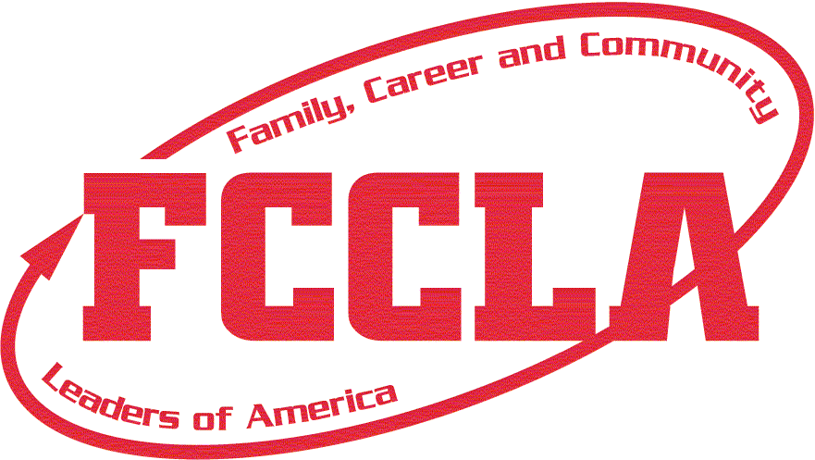
FCCLA Timeline

July
- If possible, go to your school before Summer Conference to “scope out” your classroom and find out what is there and what you need.
- Call Gail Taylor, Oklahoma FCCLA Secretary/Bookkeeper, and get your Chapter ID. Write this down! You’ll use it for logging into the FCCLA portal
- Meet your financial secretary, transportation director, and activities director. Find out what the process is to open financial requests and request transportation.
- Meet with your administrators to learn about the overnight and out of state travel policies. Your district might require School Board approval, which requires paperwork and planning ahead.
- Open purchase orders/financial requests for LEAD Conference, Chapter Affiliation, and chapter t-shirts.
- Design a chapter t-shirt.
- Find out if any fundraising materials were ordered by the former adviser. discuss fundraising policies with administration.
- Join the Family, Career and Community Leaders of America (FCCLA) Advisers Facebook page. Join the OKFACSED Facebook page.
- Follow Oklahoma FCCLA on social media:
  - Facebook: Oklahoma FCCLA
  - Instagram: @okfccla
  - Twitter: @OKFCCLA

August
- Find out if FCCLA officers have been elected. If they have, host a virtual meeting with them and get to know them. Plan something FUN for them to do, even virtually, so as to establish a relationship. They’re your lifeline for FCCLA help!
- Register for Lead Conference (Chapter officer training)
- Fill out bus requests for district meeting, state convention, etc. Again, the earlier the better!
- Put all FCCLA dates on school calendar
- Create chapter calendar and point system
- Decide when you’ll have FCCLA meetings
- Create a fun membership recruitment plan. Offer incentives for students to join!
- Create a Remind, GroupMe, Band, Google Classroom, or some electronic platform to direct members to get all updates and correspondence. Have the access code on your syllabus and on your FCCLA membership form.

September
- Integrate FCCLA into your classroom. Use Competitive Events and FCCLA National Programs as class projects. Utilize the rubrics from Competitive Events to grade the class projects.
- Gather student information using the members affiliation information sheet and affiliate online in the FCCLA portal. Send state and national dues by October 10^{th.}
- Attend Lead Conference
- Request a State Officer to do a virtual visit with your classes. This promotes FCCLA and gets students excited to join. Request forms found on www.okfccla.net
- Take on one project that all your classes agree to use as their FCCLA project to help you get started. This could be a national program or a community service project.
- Start preparing for STAR Events
- Attend District Meeting
- Register for Take AIM Conference (optional - for new members, preferably grades 7-10)
- Assess your competitors and FCCLA red jackets in your chapter. Order more jackets if needed. Make sure all competitors are aware of official dress code.

October
- Take AIM Conference (October 8)
- Pay dues to National FCCLA (payment received in Reston, VA by October 10)
- Attend District Conference
- Continue working on STAR Events
- Register for National Fall Conference (NFC) – optional (cancelled 2020)
- Start raising money to attend National Leadership Conference

November
- Submit an article/pictures for the Oklahoma FCCLA Connection Magazine (November 1)
- Participate in district STAR Events
- Attend National Fall Conference (cancelled 2020)
- Begin promoting attending State Convention
- Make travel plans for Regional STAR Events (transportation, possible lodging)

December
- State and National Officer Applications due (December 15)
- Breathe and reflect on finishing a great semester!
- Register for Region STAR Events. Do so before you leave for winter break!

January
- State Officer Interviews (optional)
- Register for State Convention (early bird registration price)
- Fill out National Program applications (Due March 1)
- Keep working on STAR Events!
- Start planning chapter activities for State FCCLA Convention
- Make hotel reservations for State Convention, if necessary
- Make hotel and travel arrangements for State STAR Events, if necessary
- Make plans to celebrate

February
- Region STAR Events
- Participate in FCCLA Week activities
- Register for State STAR Events (Deadline is March 1)
- Host a meeting for members who could potentially attend National Leadership Conference. Create a payment plan, contact, fundraisers, and begin creating an itinerary.
- Attend FCS Day at the Capitol
- Get board approval to attend National Leadership Conference

March
- Last chance to register for State FCCLA Convention without a late processing assessment
- Keep practicing for STAR Events!
- Get materials ready to attend State FCCLA Convention (permission forms, schedules, etc.)
- Have a chapter meeting with members attending State Convention to go over schedule, dress code, code of conduct, etc.
- Fill out district officer application (Applications found at www.okfccla.net)
- Watch the State Officer candidate videos to determine for who your chapter will vote. Appoint your chapter Voting Delegates.

April
- Attend State Convention (April 1)
- Register for National Leadership Conference (optional)
- District officer elections by region
- Attend P.I. meetings
- Plan for end of year FCCLA activities (banquet, etc.)
- Elect local officers
- Register students for Summer Leadership Summit (optional)

May
- Get fundraisers approved for next year
- FCCLA Connection articles due (May 31)
- Breathe and enjoy your summer! You made it!

