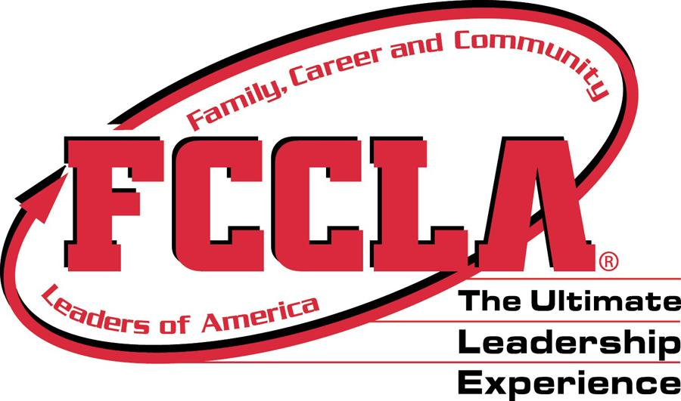

Check us out on www.fcclainc.org,
Facebook, Instagram, or
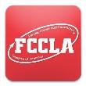FCCLA 365 app

FCCLA: What is it?
Family, Career and Community Leaders of America (FCCLA) is a dynamic and effective national student organization that helps young men and women become leaders and address important personal, family, work, and societal issues through Family and Consumer Sciences education, or as determined by the state department of education. FCCLA has more than 150,000 members and over 5,300 chapters from 48 state associations, Puerto Rico, and the Virgin Islands. The organization has involved more than ten million youth since its founding in 1945.
FCCLA: The Ultimate Leadership Experience is unique among youth organizations. It is the only career and technical in school student organization with the family as its central focus. Participation in national programs and chapter activities helps members become strong leaders in their families, careers, and communities.
FCCLA: A history Timeline
June 1945: Future Homemakers of America was founded at a convention in Chicago, Illinois.
July 1948: The first national convention was held in Kansas City, Missouri.
1966: Future Homemakers of America’s membership peaked at 607,175.
July 1973: The organization’s first male national officer, Toney Bingham, from Washington, DC, was elected.
December 1977: Rhode Island was the last of the 53 state associations (including the District of Columbia, Puerto Rico, and the Virgin Islands) to affiliate.
July 1980: The National Board of Directors approved the purchase of land on which to build a national headquarters and leadership center in Reston, Virginia.
July 1981: Monya Frazier from Florence, South Carolina, was elected the organization’s first black national president.
September 28, 1981: The official groundbreaking ceremony was held at the building site in Reston, Virginia.
July 1983: The national headquarters and leadership center was dedicated during the 1983 National Leadership Meeting in Washington, DC.
Fall 1983: A series of regional Cluster Meetings began.
Fall 1984: For the first time, one copy of Teen Times, the national magazine, was sent to every member.
Winter 1985: The Adviser newsletter was introduced for chapter advisers.
July 1986: Thomas Lucas from Milton, West Virginia, was elected the organization’s first male national president.
January 1994: The pilot program for middle level affiliations was approved to begin in September 1995.
July 1999: Voting delegates voted in favor of the proposed name change to Family, Career and Community Leaders of America.
September 2003: “The Ultimate Leadership Experience”, the tagline chosen by members, was used on all national materials.
September 2005: The first all four-color Teen Times was sent to all nationally affiliated members.
September 2009: The Family and Consumer Sciences Knowledge Bowl was introduced as a new competitive event.
July 2011: The FCCLA Leadership Academy was launched to provide national opportunities and recognition to any member seeking leadership development.
September 2011: Technology-based, online STAR Events and a new type of competitive event, called Skill Demonstration Events, were included in the newly named Competitive Events Guide.
July, 2014: 33 STAR Events were offered, including the new FCCLA Chapter Website, Applied Math for Culinary Management, and Sports Nutrition events. A record was set for the number of STAR Events participants (4,178 members) competing at the 2014 National Leadership Conference in San Antonio, TX.
July 2015: FCCLA hosted a “70 Years Strong” anniversary rally on Capitol Hill, drawing thousands of FCCLA members to advocate for strong Family and Consumer Sciences (FACS) education in schools.

Mission Statement
To promote personal growth and leadership development through Family and Consumer Sciences education. Focusing on the multiple roles of family member, wage earner, and community leader, members develop skills for life through character development, creative and critical thinking, interpersonal communication, practical knowledge, and career preparation.
Purposes
Colors
Red and White
FCCLA’s Official Uniform
Red blazer
- Black skirts, slacks, or sheath dress are to be worn with the official blazer
Tagline
The Ultimate Leadership Experience
Motto
Toward New Horizons
Flower
Red rose
1. To provide opportunities for personal development and preparation for adult life.
2. To strengthen the function of the family as a basic unit of society.
3. To encourage democracy through cooperative action in the home and community.
4. To encourage individual and group involvement in helping achieve global cooperation and harmony.
5. To promote greater understanding between youth and adults.
6. To provide opportunities for making decisions and for assuming responsibilities.
7. To prepare for the multiple roles of men and women in today’s society.
8. To promote Family and Consumer Sciences education and related occupations.

Creed
We are the Family, Career and Community Leaders of America. We face the future with warm courage and high hope.
For we have the clear consciousness of seeking old and precious values. For we are the builders of homes, Homes for America’s future, Homes where living will be the expression of everything that is good and fair, Homes where truth and love and security and faith will be realities, not dreams.
We are the Family, Career and Community Leaders of America. We face the future with warm courage and high hope.

National Programs
 | The FCCLA Career Connection program guides youth to link their options and skills for success in families, careers, and communities. Through individual, cooperative, and competitive activities, members discover their strengths, target career goals, and initiate a plan for achieving the lifestyle they desire.
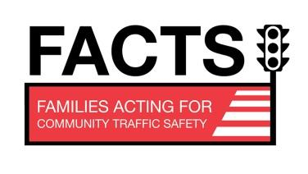 | FACTS is a national peer education program where members create projects that strive to save lives through personal, vehicle, and road safety.
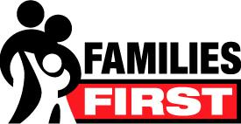 | The Families First national program is a peer education program through which youth gain a better understanding of how families work and learn skills to become strong family members.
 | Financial Fitness is a national peer education program involving youth teaching one another how to earn, spend, save, and protect money wisely.
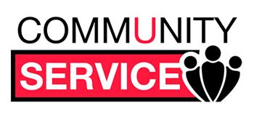 | The Leadership Service in Action program guides students to develop, plan, carry out, and evaluate projects that improve the quality of life in their communities.
 | Power of One helps students find and use their personal power. Members set their own goals, work to achieve them, and enjoy the results.
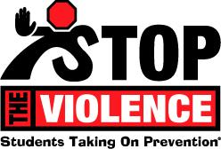 | FCCLA’s Students Taking On Prevention (STOP) the Violence program empowers youth with attitudes, skills, and resources in order to recognize, report, and reduce youth violence.
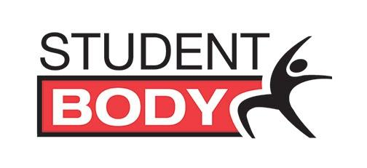 | The FCCLA Student Body national peer education program helps young people discover the Healthy You, the Fit You, the Real You, and the Resilient You.
 | FCCLA members are selected for scholarship opportunities to travel to Japan for four to six weeks and live with a Japanese host family. The opportunity to experience the day-to-day life of another country, and its people enhances students’ awareness of international issues
Skills
Demonstration
Events

Consumer Math Challenge
Culinary Chicken Fabrication*
Culinary Food Art *
Culinary Knife Skills
Culinary Math Challenge
Early Childhood Challenge
FCCLA Creed Speaking & Interpretation
FCCLA Knowledge Challenge
Fashion Sketch *
Hospitality, Tourism and Recreation Challenge
Impromptu Speaking
Interior Design Sketch*
Nutrition Challenge Science in FACS
Challenge Speak Out for FCCLA
Technology in Teaching *
Toys that Teach *

*These events are offered every other year.

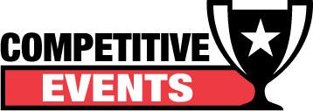

Competitive Events
FCCLA provides opportunities for members to gain recognition for their individual, team, and chapter activities. Members are encouraged to expand their knowledge and experiences in an area of their interests and build on foundational and specialized skills and abilities through the FCCLA/LifeSmarts Knowledge Bowl, Skill Demonstration Events, and STAR Events. While members strive for success, they learn the importance of education, the value of helping others, and the power of self-accomplishment.

Skills Demonstration Events
Skill Demonstration Events provide opportunities for members to demonstrate college and career-ready skills in Family and Consumer Sciences and related occupations. Challenge testing takes place online.
The remaining events take place at National Cluster Meetings. To compete in Skill Demonstration Events, members must be affiliated and select an event when registering for the National Cluster Meeting.
1st, 2nd, and 3rd place event winners will each receive a trophy during the Closing General Session of the National Cluster Meeting they are attending.

STAR Events
Students Taking Action with Recognition (STAR) Events are national competitive events in which members are recognized for proficiency and achievement in chapter and individual projects, leadership skills, and career preparation. Competitions take place at the local, regional/ district, state, and national levels. Participants may earn gold, silver, or bronze awards, and scholarship opportunities may also be available.
FOUNDATIONAL EVENts
• Career Investigation
• Entrepreneurship
• Environmental Ambassador
• Focus on Children
• Illustrated Talk
• Interpersonal Communications
• Job Interview
• Leadership
• Life Event Planning
• Nutrition and Wellness
• Parliamentary Procedure
• Recycle and Redesign

LEADERSHIP EVENTS
• Advocacy
• Chapter In Review Display and Portfolio
• Chapter Service Project Display and Portfolio
• National Programs in Action
• Promote and Publicize FCCLA!

CAREER PREPARATION
• Applied Math for Culinary Management
• Culinary Arts
• Early Childhood Education • Fashion Construction
• Fashion Design • Food Innovations • Hospitality, Tourism and Recreation
• Interior Design
• Sports Nutrition • Teach and Train

ONLINE STAR EVENTS
• Digital Stories For Change • FCCLA Chapter Website

FCCLA/Life Smarts
Knowledge Bowl
The FCCLA/LifeSmarts Knowledge Bowl is a three-level team competition that challenges students’ knowledge in six content areas:
• Personal Finance
• Consumer Rights & Responsibilities (to include Family, Career & Community Studies)
• Technology (to include Fashion & Housing Design)
• Health & Safety (to include Food Science & Nutrition and Early Childhood & Human Development)
• Environment (to include Hospitality, Tourism & Recreation)
• FCCLA Knowledge
Level I – Part 1 – TeamSmarts Quiz and Online Competition
Level I – Part 2 – National Cluster Meeting Competition
Level II – Online “Second Chance Round” Competition and National LifeSmarts Championship Qualifying Round Level III – National Leadership Conference Championship.
The FCCLA/LifeSmarts Knowledge Bowl is a partnership with the National Consumers League LifeSmarts program (www.LifeSmarts.org).
Understanding FCCLA
As a student of Family, Career, and Community Leaders of America (FCCLA), you will have the opportunity to join one of the most well-known and respected student organizations in the United States of America. It is important for you to learn more about FCCLA, so you can enjoy the many benefits that come from being a member.

Objective 1: Complete statement about FCCLA
FCCLA is a dynamic and effective national student organization that…..
- Is non-profit for public or private school students through grade 12
- Helps young men and women become leaders
- Addresses important personal, family, work, and societal issues through family and consumer science education
- Represents more than 150,000 students in 5,300 chapters in 53 state associations, including the District of Columbia, Puerto Rico, and the Virgin Islands
- Is sponsored by the US Department of Education through the Office of Vocational and Adult Education and the American Association of Family and Consumer Sciences
- Was founded on June 11, 1945 as Future Homemakers of America and renamed Family, Career, and Community Leaders of America in July 1999 to reflect the evolution into work and society

Objective 2: Identify three major levels of the FCCLA organizational structure
- National – all state associations
- State – all chapters in your state
- Local – your chapter (all FCCLA members of your school)

Objective 3: Identify types of FCCLA memberships
- Active – any student through grade 12 who is taking or has taken a course in family and consumer sciences and/or related occupations; only members are allowed to hold office, make motions, and vote.
- Alumni and Associates – former active members and other adults who support the organization and contribute to its growth
- Honorary – individuals who have made and continue to make outstanding contributions to the organization

If the Shoe Fits……
As leaders, we need to remember that people are like shoes. They come in many styles, sizes, shapes, and colors. What is your favorite? Which one are you most like?

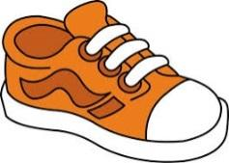 | Tennis Shoe:  Are you a comfortable, practical person who gets things done? Are you versatile, fits in most places, likes sports, usually has an active hobby? Are you flexible and adaptable, helps out when needed, likes people, and friendly.
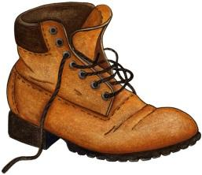 | Work Boot:  Are you a hard worker, can take getting dirty or accept a challenge? Are you ready to get going, sometimes impatient, doesn’t like to sit around in meetings? Work boots will do the unpleasant job if it needs doing and usually can do many things.
Dress Shoe:
Do you rise to the occasion and become a leader? Will you step out in front but know when to be a follower? Are you careful, a good manager, dependable, will get the job done in a quiet manner but speak out if you disagree?

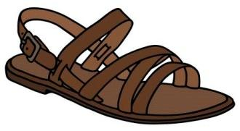 | Sandal:  Does carefree, fun, and friendly describe you? You may be late but makes up by being enthusiastic. Do you like nature; know how to relax and when to relax? Or, do you hurry up to get the job done in order to do other things? The sandal usually call on the tennis shoe or work boot for help, has a good time and is open to new ideas.
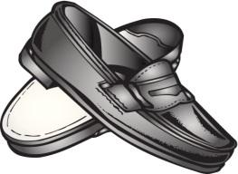 | Loafer:  Are you cool, calm, and comfortable? You do the job and then pursue your own interest. The loafer is a “do my own thing” kind of person.
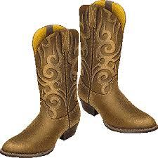 | Cowboy Boot:  Do you have special talents and abilities? Are you resourceful, energetic, and doesn’t worry about what others think? The cowboy boot is creative and stands up for their beliefs.
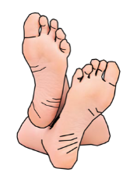 | Bare Feet:  Are you a nature person who enjoys the physical aspects of life? Do you want to get back to basics?
House Shoe:
Maybe you are comfortable, cozy, and warm. You make people feel relaxed and secure. Are you a people person who likes to talk confidentially?

Did you decide which shoe fits you best? It takes all kinds of leadership for a successful team. We need all kinds to be a successful chapter.

Objective 4: Identify the meanings of symbolism of FCCLA
An emblem/logo is an object or symbol used to identify as idea, group, or other objects; insignia. The emblem/logo shows that FCCLA is a dynamic, active organization bound for the future.
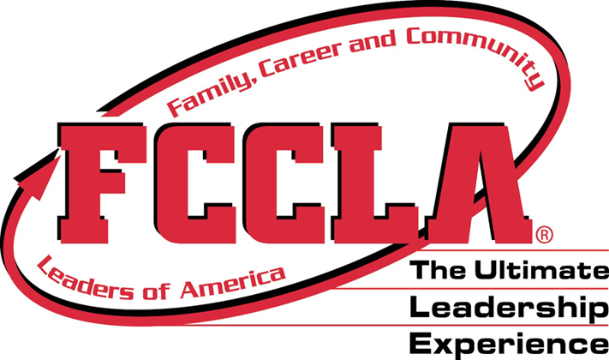
- The dominant collegiate lettering or font articulates a focus on education and student leadership.
- The red color of the emblem signifies strength
- The swooping arrow arch embodies an active organization that moves toward new arenas.

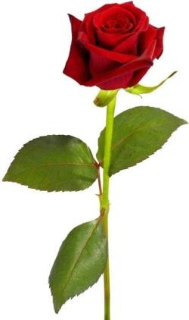
FCCLA flower is the rose. The red rose represents a desire for joy in everyday living. The beauty of the rose has made it a popular flower nationwide. It gives joy through its beauty and fragrance and it symbolizes the FCCLA members’ search for beauty in every day.

FCCLA colors are red and white.
- Red – suggests strength, courage, and determination
- White – symbolizes sincerity of purpose and integrity of action

A mission statement is a written declaration of an organization’s purpose. FCCLA’s mission statement is:
To promote personal growth and leadership development through Family and Consumer Sciences education. Focusing on the multiple roles of family member, wage earner, and community leader, members develop skills for life through character development, creative and critical thinking, interpersonal communication, practical knowledge, and career preparation.

A motto is a word or phrase expressing a rule of conduct of principle. FCCLA’s motto is: Toward New Horizons
A tagline is a branding slogan. FCCLA’s tagline is: The Ultimate Leadership Experience.

Objective 5: Understand the benefits of being an FCCLA member.
- Encourages participation in service projects
- Helps individuals learn to cooperate
- Helps individuals learn responsibility
- Helps individuals develop leadership qualities
- Helps individuals develop personal goals and values
- Increases knowledge about family and consumer sciences and related occupations
- Opens doors to new experiences
- Provides opportunities to make new friends

Objective 6: Recite the FCCLA Creed
A creed is a guiding principle or belief.

Family, Career, and Community Leaders of America Creed

We are the Family, Career and Community Leaders of America.
We face the future with warm courage and high hope.

For we have the clear consciousness of seeking old and precious values.
For we are the builders of homes,
Homes for America’s future,
Homes where living will be the expression of everything that is good and fair,
Homes where truth and love and security and faith will be realities, not dreams.

We are the Family, Career and Community Leaders of America.
We face the future with warm courage and high hope.

Participating in FCCLA --Westville Chapter

Here at Westville, our goal is to have active members. We want to build a strong FCCLA with members participating in various service and fundraising projects. We strive to take pride in our school and community by showing support for other students, groups, and community leaders. We may be a small school, but we are mighty!
Objective 1: Explain who can become a member
A member is a person who belongs to a group or organization.
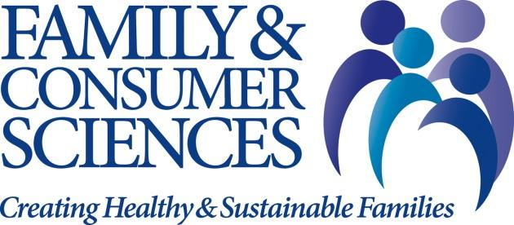
- Any student who is taking or has taken a Family and Consumer Science course is eligible to become an FCCLA member.
- Both young men and women in grades 7-12 can join
- Membership is gained by paying an annual dues amount.

Objective 2: Identify what membership dues are
Dues are a fee or charge for membership in an organization or group.
- Students pay dues each year to be a member of an FCCLA chapter.
- Dues paid are the sum of national, state, and local dues.
- Dues need to be paid by the third Friday in September to be eligible to compete in District STAR Events and attend District Leadership Conference.
- Dues are paid to the FCCLA Advisor, Chapter Treasurer, or Chapter Secretary.
- By paying dues, each member of FCCLA has the opportunity to participate in all national and state competitions and meetings.
- Dues can be earned by participating in the first fundraiser of the school year.

Objective 3: Define leadership and identify opportunities for leadership with FCCLA
Leadership is the position or function of a leader. It is the ability to guide or direct others.
- Members are encouraged to participate in chapter projects, including service and fundraising projects.
- Members can be elected to serve as a Chapter Officer.
  - Officers are leaders elected into position by members or delegates.
  - Westville has 6 high school and 5 junior high officers.
- Members can also interview and run for a District, State, or National Officer.
  - District Northeast 5 has five officers representing 20 schools.
  - State Officers are elected by chapter delegates at State Convention in the spring. Oklahoma has 10 State Officers making up the State Executive Council.
  - National Officers are elected by state delegates at National Leadership Conference in the summer. There are 10 National Officers and they make up the National Executive Council.
- Members have the opportunity to apply and be selected to serve on a chapter committee where they will assist officers with various tasks and responsibilities.
- FCCLA leaders should
  - Have a positive attitude
  - Work closely with everyone in the chapter to achieve their goals
  - Respect the opinions of others
  - Stay informed about what is going on within the organization
Objective 4: Understanding Westville FCCLA
- Westville Chapter members are expected to be good role models and abide by the school handbook policies.
- Westville is a part of Oklahoma’s Northeast Region and District Northeast 5.
- Westville Chapter has a point system where members can earn points for volunteer hours, donations, attending meetings, and participating in other school activities.
- FCCLA Coronation—
  - Girls that earn 300 points or more by December 1st are eligible for coronation.
  - Girls are voted on to represent their grade levels in FCCLA Royalty.
  - After Royalty is selected, girls will ask boys who are in FCCLA to escort them during the ceremony.
- Westville Chapter has many projects we do throughout the school year.
  - Service projects include, but are not limited to, Pink Out, teacher appreciation gifts, community holiday dinners, and baking desserts for local benefit dinners.
  - Fundraisers include, but are not limited to, cookie dough, Valentine’s gifts, candy bags, and bake sales.
- Chapter members have the opportunity to apply and be selected to serve as a committee member to assist officers in carrying out responsibilities.
  - Fundraising Committee assists with fundraising ideas and projects.
  - School Service Committee assists with any projects that help out the school, teachers, or another school group.
  - Membership Committee assists with recruiting, retaining, and recognizing chapter members.
  - Community Service Committee assists with any community service projects that FCCLA is involved in.
  - Public Relations Committee assists with taking pictures and changing out the bulletin board and display case.
- Committee members will be selected by the 2nd week in September.
- Westville Chapter Officers and their responsibilities include but are not limited to:
  - President (HS & JH)
    - Presides over all business meetings for the chapter
    - Guides planning for all chapter activities
    - Serves on the Fundraising Committee
  - Vice President (HS & JH)
    - Aides the president
    - Helps in planning activities
    - Fill in for president as needed
    - In charge of the School Service Committee
  - Treasurer (HS only)
    - Helps keep record of dues paid
    - Keeps record of all fundraising activities
    - In charge of Fundraising Committee
  - Secretary (HS & JH)
    - Keeps record of meetings and attendance
    - Keeps records of points system
    - In charge of the Membership Committee
  - Project Programmer (HS & JH)
    - Plans and promotes service projects
    - Organizes school wide activities including FCCLA Week and Pink Out.
    - In charge of Community Service Committee
  - Public Relations (HS & JH)
    - Maintains bulletin board and display case
    - Takes pictures of chapter activities
    - Administrator on chapter’s social media accounts
    - In charge of Public Relations Committee

