#32 – Why there’s always room for Jello in an inquiry project?
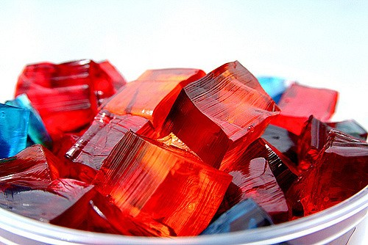

Are you looking for a demo or an inquiry project about enzymes? If so, consider Jello. Yes, what I’m proposing is a Jello inquiry project. First of all, Jello makes for a fun and cheap activity. And, the materials are easily accessible too. Furthermore, kids can relate to Jello. I mean, who hasn’t had a bowl of Jello or some Jello mixed in with some fruit cocktail when they were young? It’s part of our culture. And, even within the science classroom, there’s always room for Jello.

Jello mystery = Interesting Inquiry Project
Ever notice how there isn’t kiwi Jello? There’s Jello that comes in strawberry, orange, and lime, but why not kiwi?
Years ago, I thought I’d get into the hipster food craze by producing funky combinations of naturally made Jello with real chunks of fruit. I bought some gelatin, dissolved it in water and added some kiwi and placed it in the fridge.
Unfortunately, the Jello didn’t set – it was still in liquid form after being in the fridge overnight. So, I added another pack of gelatin (with the thinking that increasing concentration of gelatin would obviously result in the reaction I want). And, it also did not set. Why wasn’t the gelatin setting? This was the classic science discrepant event, and one that inspired me to create a jello inquiry project.
Below, we quickly discuss the reasons why jello won’t set in kiwi and provide a quick intro and some inquiry suggestions for your own Jello inquiry project. A quick guide / cheat sheet is available at the end for download.

Why won’t kiwi Jello set?
So why doesn’t Jello (or, to be more precise, gelatin) set in the presence of kiwi? Turns out, it’s because of the presence of naturally occurring digestive enzymes in kiwi.
Enzymes, of course, are biological catalysts that speed up the rate of a reaction without be used up itself. For digestive enzymes, these enzymes can break down one protein and then move onto another and another without being used up. The digestive enzymes in kiwi break down the proteins in gelatin, thereby preventing gelatin from setting. Thus, jello cannot set in the presence of kiwi because the enzymes digest all the gelatin. The same thing happens to jello in the presence of pineapple too.
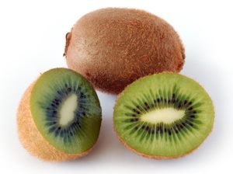
To get Jello to set in kiwi, we must stop the work of the digestive enzymes in the kiwi. We do this by destroying or altering the digestive enzymes in the kiwi. For example, one way to do this is to force bonds that hold the enzyme together apart (by adding heat). Or, we can disrupt the electrostatic attractive forces within the enzyme (for example, by changing the pH). By destroying the digestive enzymes in kiwi before adding the Jello, we make sure there is gelatin present for the Jello to set.
Our Jello inquiry project does not just ask how to stop the activity of digestive enzymes. Instead, we also want to determine what minimum treatment is necessary for edible, kiwi Jello to set. Potentially, there may be many things that can disrupt digestive enzymes (ex. Adding heavy metal ions), but the treatment may not result in an edible product.
Part 1: A Quick Jello Intro
To start the project, we must illustrate the problem. The following outlines a demo that can be done to show students how gelatin will not set in the presence of kiwi.

Materials
2 – 250mL beakers
1 – package of Knox gelatin
1 – Kiwi
2 – marbles

- Dissolve Knox gelatin according to the instructions into the 250mL beaker.
- Pour half of the dissolved gelatin into the other 250mL beaker. Add additional water to each beaker to make up to 200mL of water.
- Add 10 small pieces of sliced kiwi to one beaker. Leave the other beaker untouched.
- Place beakers in the fridge and leave overnight.
- Take both beakers out the next day. Place one marble in the beaker containing kiwi-gelatin and the other in the beaker containing only gelatin. What do you notice?

Note: the marble should sink in the first beaker because the gelatin has not set. However, the gelatin in the second beaker has set and the marble remains on the surface.

Part 2: Adding in a dash of Inquiry
Consider the factors that can be changed in order for to destroy or disable the digestive enzymes in the kiwi. Your students can choose one or two to study and determine the minimum treatment necessary to set jello with kiwi in it.

Changing temperature
What if kiwi were heated at higher temperatures before being added to gelatin? Students can heat kiwi at 70, 80, 90, and 100 degrees Celsius for a set amount of time and determine what minimum temperature will allow gelatin to set.
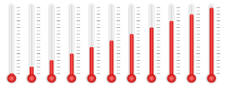

Changing heating time
What if kiwi were heated at lower temperatures but for longer periods of time? Perhaps, students can experiment with heating kiwi at 80 degrees for 5 minutes, 10 minutes, 20 minutes, and half an hour and note any changes.

Changing pH
What if kiwi was soaked in acidic or basic solution before being added to gelatin? One thing that can be done is soaking the kiwi in increasing concentrations of lemon juice to make it more acidic. Alternatively, kiwi can also be soaked in increasing concentrations of baking soda solution to make it more basic.
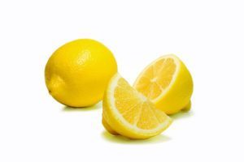

Dissolving salts or sugars
What if dissolved salts or sugars disrupted the covalent bonds in proteins? Students can test this idea by soaking kiwi in saturated salt or sugar solution and solutions of 40%, 60%, and 80% saturation before adding to gelatin.

Adding different alcohols
What if polar covalent liquids are strong enough to disrupt kiwi’s digestive enzymes? Students can test this hypothesis be soaking kiwi in alcohol of growing alcoholic concentrations (ie. from 5% to 40% alcohol) before adding to gelatin.

Wrap Up
An inquiry project doesn’t need to have an elaborate set up or even a super complicated procedure. Some of the best inquiry projects come as a result of noticing a different result to an everyday occurrence. Which is why the discrepancy with regards to jello and kiwi makes for such an interesting yet simple inquiry project. Jello is common enough for most anyone to access. Yet, the solution to our inquiry project can be approached from so many different angles. To download the handouts to this post, click on the link below. And, please share this post through social media if you enjoyed it or found it useful. Thanks!

Click Here to Download Jello Inquiry Project Handout

Until next time, keep it REAL!

