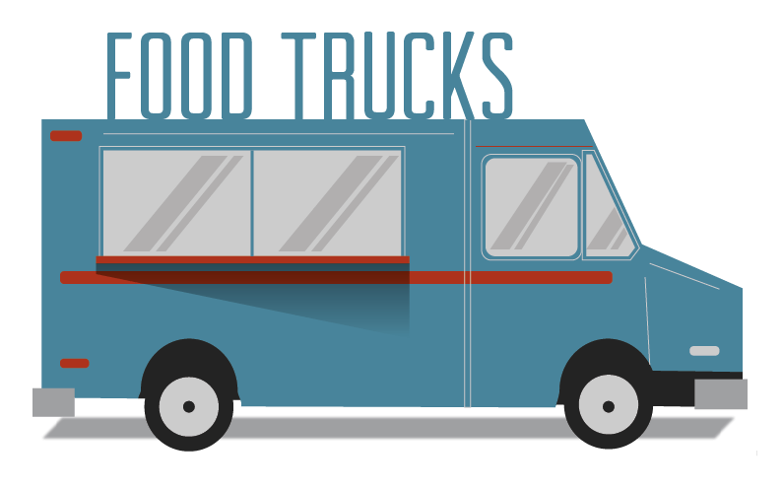
Health Science Food Truck Challenge

Student Challenge: Create a virtual food truck that will serve people with specific health issues who require a therapeutic diet.

Project Elements:
Step 1: Therapeutic diet
  - Your teacher will let you know if you may select a specific diet or if one will be assigned to you.
  - Options include but Low sodium diet Diabetic diet
are not limited to: Low calorie (weight loss) diet Gluten free diet
High fiber diet Renal diet
Bland diet Low fat/low cholesterol
Food allergen (no dairy, eggs, nuts) Lactose free diet
Step 2: Select a theme.
        - Your food truck must have a theme. Your theme can be a movie, TV show, musical group, travel destination, college, pastime, hobby, etc. Choose whatever theme you want.
        - All aspects of your project must fit your theme – from your truck design and food offerings to the names of your dishes. Your ideas must be cohesive, tell a story, and fit your theme.
Step 3: Plan your menu.
a. You will design and (virtually) prepare three dishes – a signature dish, a side dish, and a dessert.
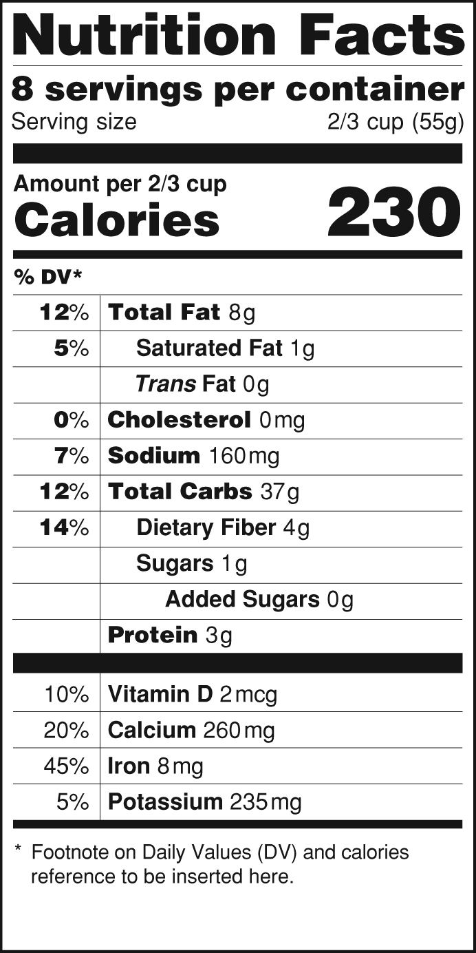
b. All three dishes must relate to your theme and follow the guidelines for your assigned therapeutic diet.
Step 4: Create nutrition labels.
a. Create a nutrition facts label for each of the items on your food truck following the FDA guidelines.
b. To do this, you will need to do the math. Determine the exact amount of each ingredient in each dish and add up the amount for each nutrient.
Step 5: Design your truck.
- Your truck should illustrate your theme and include the names of your products, the specific type of diet supported by your dishes, and a short description of the population your truck is designed to serve.

Step 6: Present (oral presentation) your food truck as directed by your teacher.
  - You should be prepared to explain your dishes, how they support your therapeutic diet, and at least one disease or disorder indicated for that type of diet.

Nutrition Labels Summary

Theme
Diet
Dishes (Names) | Signature: |  | Side: |  | Dessert:
Ingredients  (per serving) | Nutrient/g/mg | %DV | Nutrient/g/mg | %DV | Nutrient/g/mg | %DV
 | Total fat ____  Saturated fat ___  Trans fat ___  Cholesterol ___  Sodium ____  Total Carbs ___  Dietary fiber ___  Sugars ___  Added sugars __  Protein ___  Vitamin D ___  Calcium ___  Iron ___  Potassium ___ |  | Total fat ____  Saturated fat ___  Trans fat ___  Cholesterol ___  Sodium ____  Total Carbs ___  Dietary fiber ___  Sugars ___  Added sugars __  Protein ___  Vitamin D ___  Calcium ___  Iron ___  Potassium ___ |  | Total fat ____  Saturated fat ___  Trans fat ___  Cholesterol ___  Sodium ____  Total Carbs ___  Dietary fiber ___  Sugars ___  Added sugars __  Protein ___  Vitamin D ___  Calcium ___  Iron ___  Potassium ___
 | Calories |  | Calories |  | Calories
On a separate worksheet, list all the ingredients for each dish and the amount (grams) per serving. Then figure out the total nutritional values for an individual serving for each of your dishes. Any values that are one or less can be disregarded.

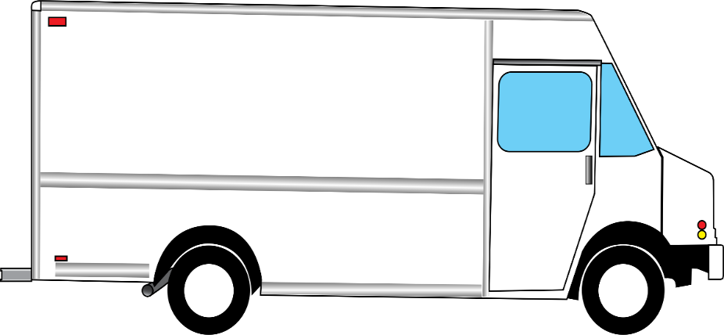
You can Google “Food truck template” or draw a truck of their own design.

