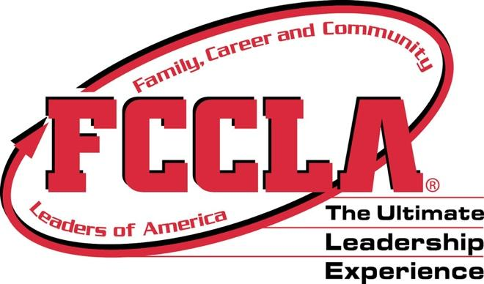
Seiling High School
Ultimate Leader Handbook 2023-24

Name: _____________________________________
Class Hour: _______________________________

