Work-Based Learning Playbook
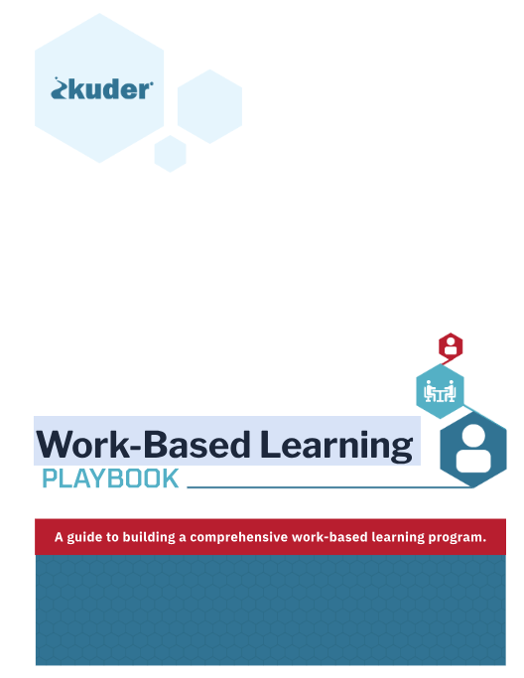
Kuder WBL Playbook (adobe.com)
https://indd.adobe.com/view/c895210f-6c08-4f0c-a9c0-f8c58f322d06

