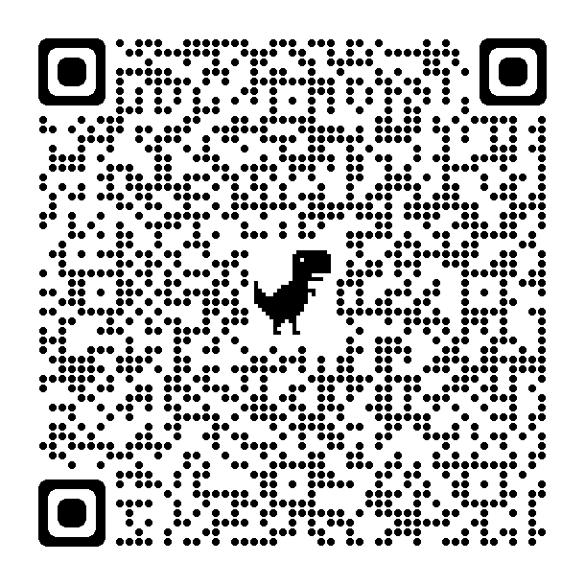

Anatomy of a Recipe: [https://docs.google.com/document/d/1atVy2MPE0wcaWjBSko-ZrRdGONghDjBmAyuD9tH2UuQ/edit?usp=sharing](https://urldefense.com/v3/__https:/docs.google.com/document/d/1atVy2MPE0wcaWjBSko-ZrRdGONghDjBmAyuD9tH2UuQ/edit?usp=sharing__;!!NZFi6Pppv9YRQw!rCTywON1E0yddQFVbV3qaFEPQObtavRuK7VfKRxe7e55RYgWAjHT_lF272j_2-s2F1XKzNrJQgHj93Wuv7g0-NdalHfMiRzajyW9Av40Ng$)

One Big Chocolate Chip Cookie: [https://docs.google.com/document/d/1QZvjw6OgTzjpicLZxhGPbEaW1sivMyl6ADv2FCsGEzo/edit?usp=sharing](https://urldefense.com/v3/__https:/docs.google.com/document/d/1QZvjw6OgTzjpicLZxhGPbEaW1sivMyl6ADv2FCsGEzo/edit?usp=sharing__;!!NZFi6Pppv9YRQw!rCTywON1E0yddQFVbV3qaFEPQObtavRuK7VfKRxe7e55RYgWAjHT_lF272j_2-s2F1XKzNrJQgHj93Wuv7g0-NdalHfMiRzajyX25mouVQ$)