FCCLA Creed

We are the Family, Career and Community Leaders of America.
We face the future with warm courage and high hope.

For we have the clear consciousness of seeking old and precious values.
For we are the builders of homes,
Homes for America's future,
Homes where living will be the expression of everything that is good and fair,
Homes where truth and love and security and faith will be realities, not dreams.

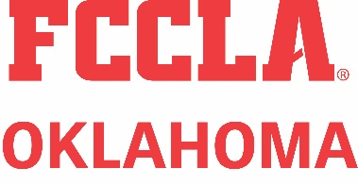
We are the Family, Career and Community Leaders of America. We face the future with warm courage and high hope.

