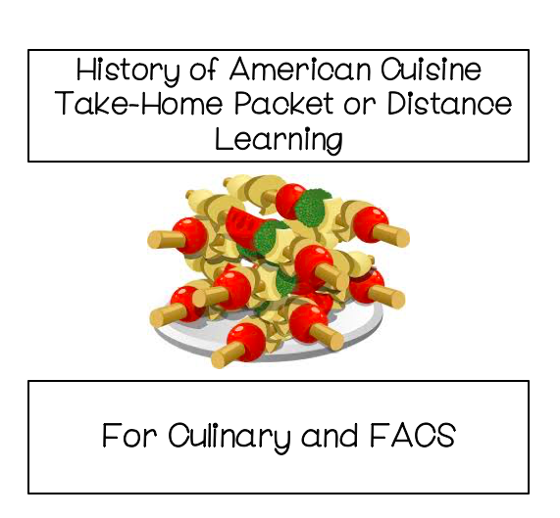

**Name: _________________________**

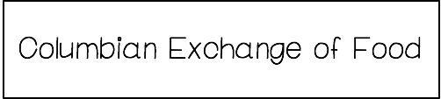

During the 15th and 16th centuries the “Old World” of Europe, Asia and Africa and the “New World” of the Americas made contact and exchanged many goods. Once European explorers discovered the Americas the transfer of food, animals, people and diseases began between the two parts of the world.

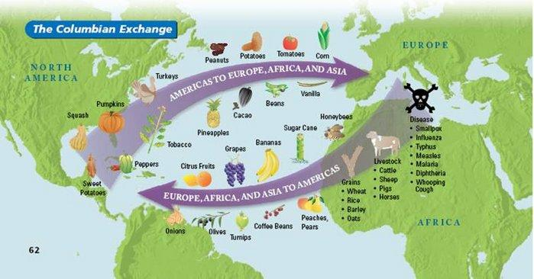

**America to Europe and Asia**

Many foods and animals from the Americas made their way to Europe, Africa and Asia. Crops such as potatoes, maize, and tomatoes originated in America. Today potatoes and tomatoes are a staple in European cuisine. Imagine that Italy did not have tomatoes until the 1500s! Other crops introduced to the New World from America were beans, vanilla, cacao, squash, peanuts and many more.

**Europe to America**

Europe introduced many fruits to the New World including bananas and grapes. Additionally, wheat, rice, coffee, lettuce were among other crops brought over. Animals were also introduced to the Americas including chicken, horses, sheep, pigs and cows. The Native Americans did not have horses until the Spanish arrived in the 1500s!

**How it Changed the World**

The Columbian Exchange shaped civilization as we know it. Today, Brazil in South America is the leading producer of coffee in the world even though coffee was not introduced to the New World until the 1500s. Similarly, tomatoes are one of the most used ingredients in Italian dishes and potatoes, a historically traditional Irish dish was not native to Ireland! Beef, which is considered an iconic American food was not introduced to the New World until the Columbian Exchange.

The exchange of foods enriched diets and diversified dishes across the globe. Imagine a world in which we had not exchanged these foods.

**Questions**

1. What 2 parts of the world interacted during the Columbian Exchange?
2. Using the map above, write your favorite food from the New World and the Old World.
3. List 2 items that came from the Old World to the New World.
4. List 2 items that went from the New World to the Old World.
5. Research the Columbian Exchange and list 5 more foods/animals that came from both sides of the world below.

**Came from Old World Came from New World**

|  |  |
| --- | --- |
|  |  |

1. Name a recipe that you enjoy that would not be possible without an item from the New World.



**Using the map below and the internet to research a region or state of the United States and their culinary influences. Answer the questions below.**

