Broken Arrow High School

FCCLA Chapter

Spring Activities

Desinya Garza, Sheila Brewster, Dana Blackburn, Cindy Cantwell, Lindsay Schmidt, Rachel Smith

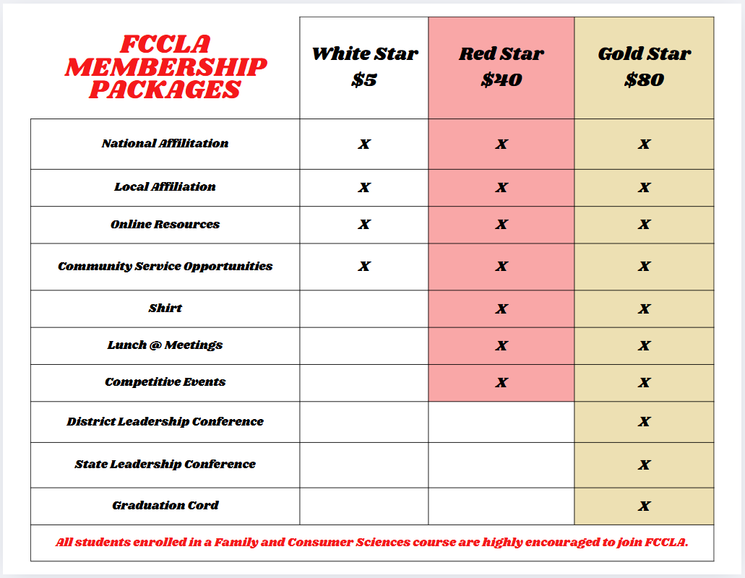

FCCLA Fall membership flyer

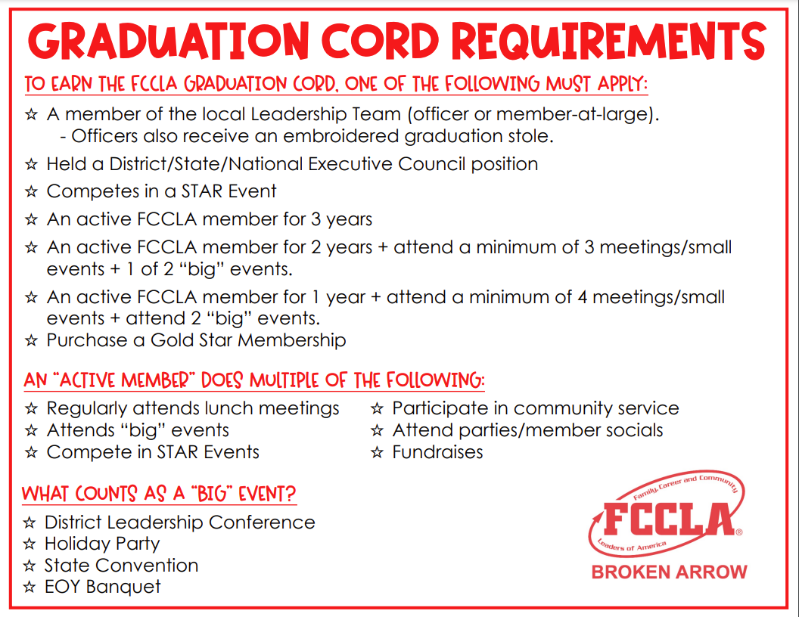

FCCLA Graduation Cord Requirements

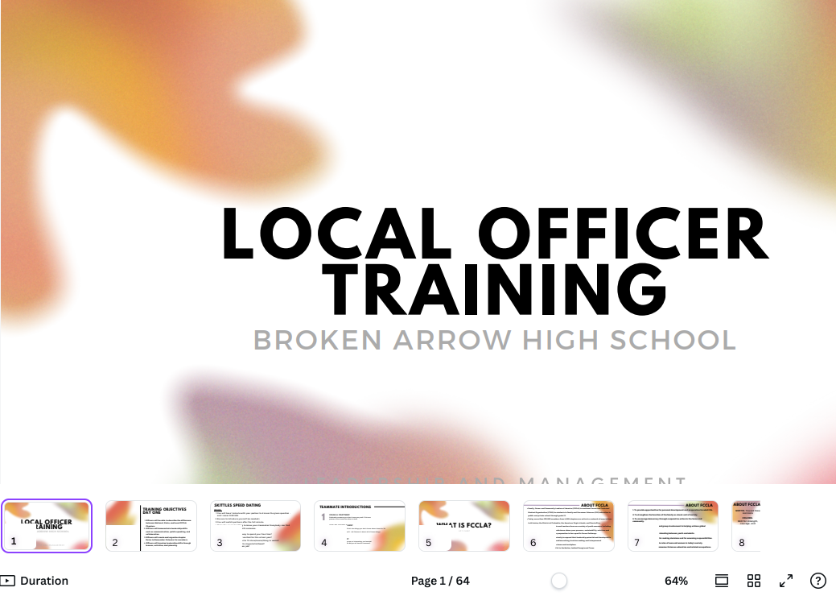

Broken Arrow High School local officer training

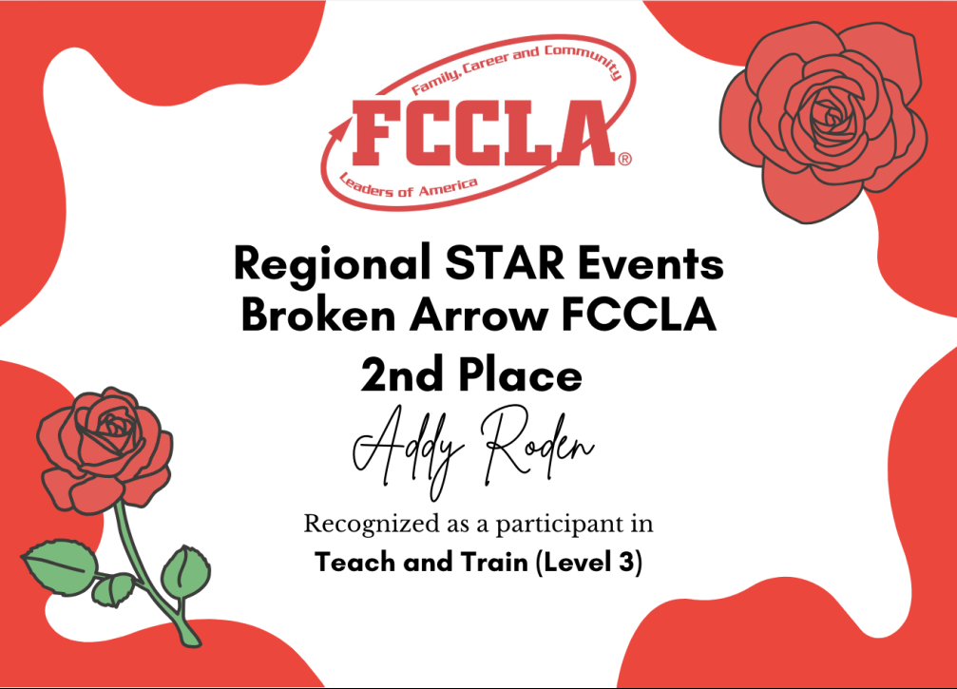

Plaque given at end of year awards banquet

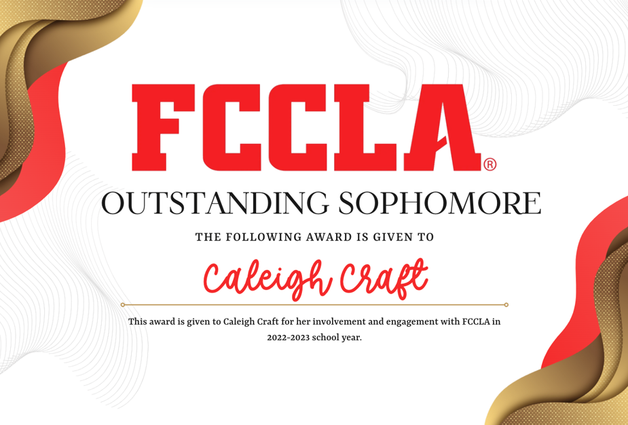

Plaque given at end of year awards banquet

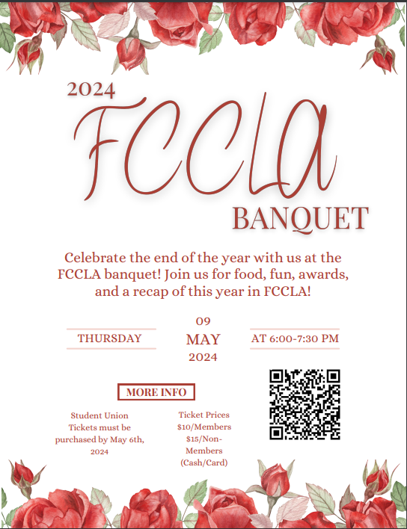

End of year banquet flyer

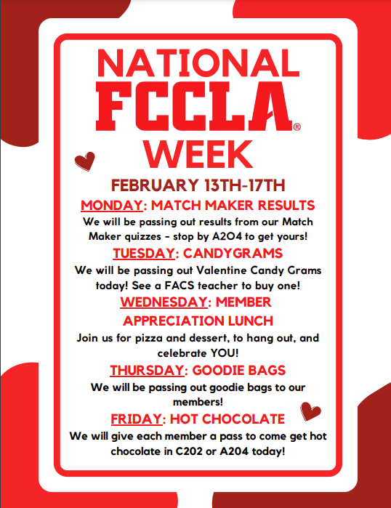

FCCLA Week Flyer

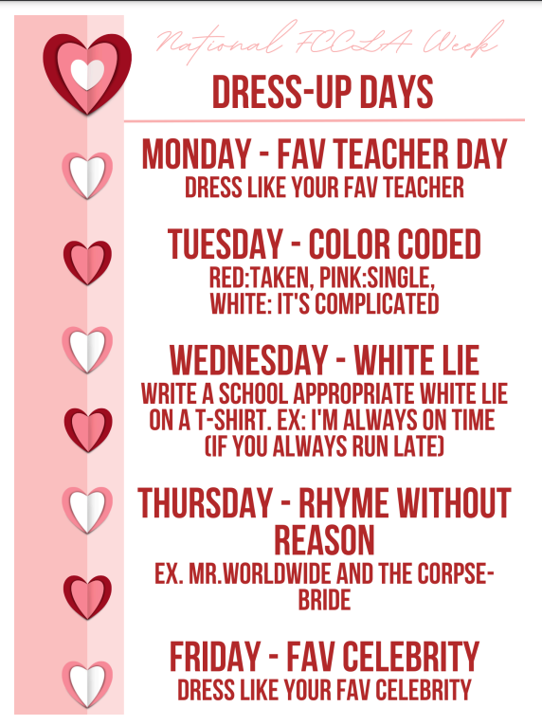

FCCLA Dress up days