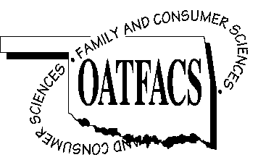

OATFACS Officers Meeting Agenda
OKACTE Headquarters
Oklahoma City, OK
January 21, 2016

- Call to Order Brooke Kusch

- Minutes of Last Meeting Laura Head

- Treasurer's Report LeElla Lee

- Committee Reports

  - Financial Growth LeElla Lee
  - Legislative Laura Head/Andrea Brice
  - Membership Stephanie Stonecipher
  - Nominating Jeanine Clark
  - Scholarship Berneta Haddox
  - Public Information Keri Laxton/Trina Renfrow
  - Awards Karin Davis

- Old Business

  - FACS Day at the Capitol
  - Review OATFACS Committees/Officer Committee Assignments
  - OATFACS T-shirts (Scholarship Fund Raiser)
  - Sponsors for August Conf.

- New Business
  - Curriculum Showcase Winner
  - Summer Conference Breakfast vs. Lunch
  - Reception in honor of Lori Carlile (ACTE President)
  - Opportunity Fund Application Review
  - OATFACS Officer Application Review and date due
  - Career-Tech Staff Update

- New Teacher Meeting Date

VII. Adjournment Brooke Kusch

