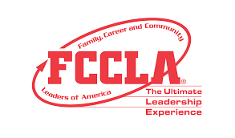
September 26, 2025
Enid High School
Chapter Fee $75
Each student $5.00
School Name:
Advisor Name:
School Address:
City, State, Zip:
BILLED TO:
Oklahoma North 2 FCCLA District Leadership Meeting
INVOICE

Description (Student Name) | Unit | Price | Amount Due
Total

Please Make
Payments to
North 2 FCCLA (Rita Hartwick)
c/o of Enid High School
611 West Wabash
Enid, OK 73703

