Mustang Mid-High

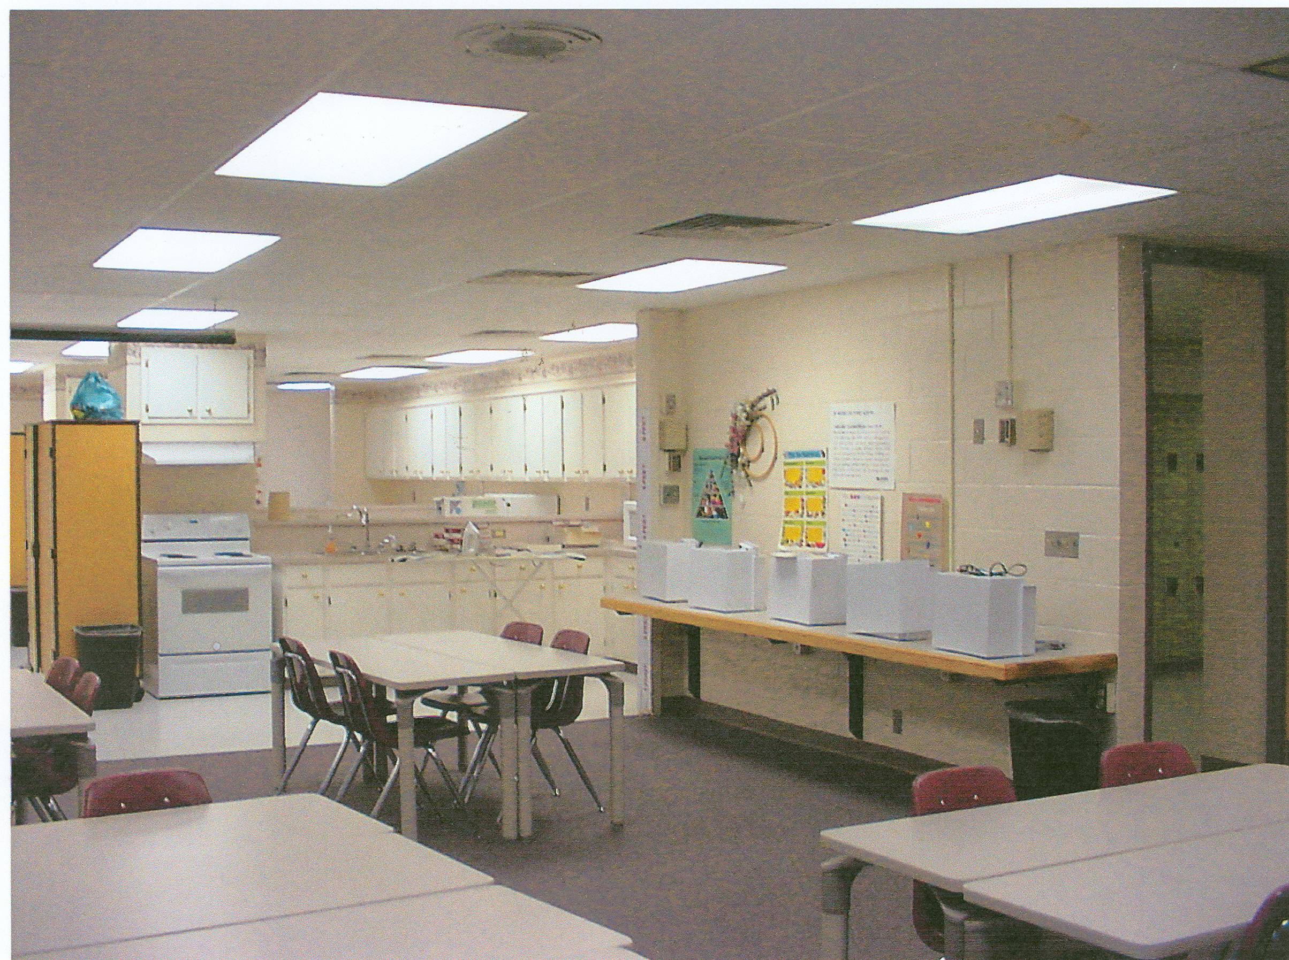
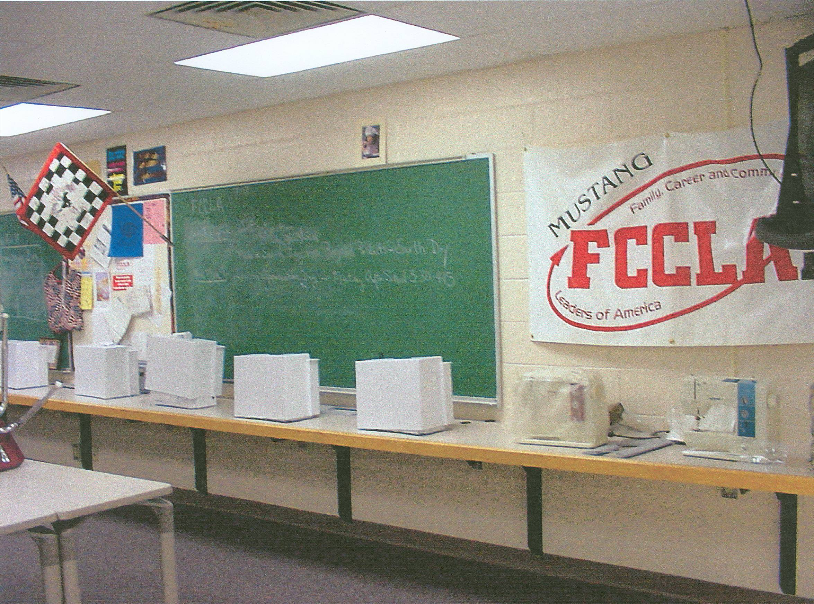
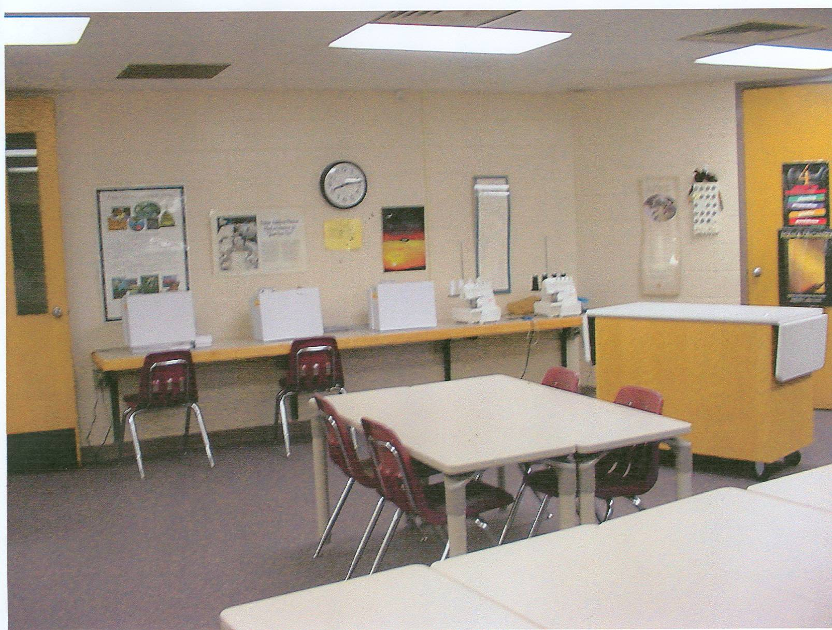

A multi-purpose counter attached to wall for portable sewing machines, computers, and/or classroom projects is space saving and economical.

Note classroom tables are lightweight and height adjustable to meet varying student needs. When raised, these tables make excellent project and fabric cutting tables. They are available in light or dark colors, as well as various widths and lengths.

