6 Career Fields
The career fields are the six large groups. They include all of the occupations in the United States, and their titles tell you something about the focus of work in that group of occupations.
This page may be photocopied or printed from the resource website at https://ctyou.org/course/view.php?id=4552
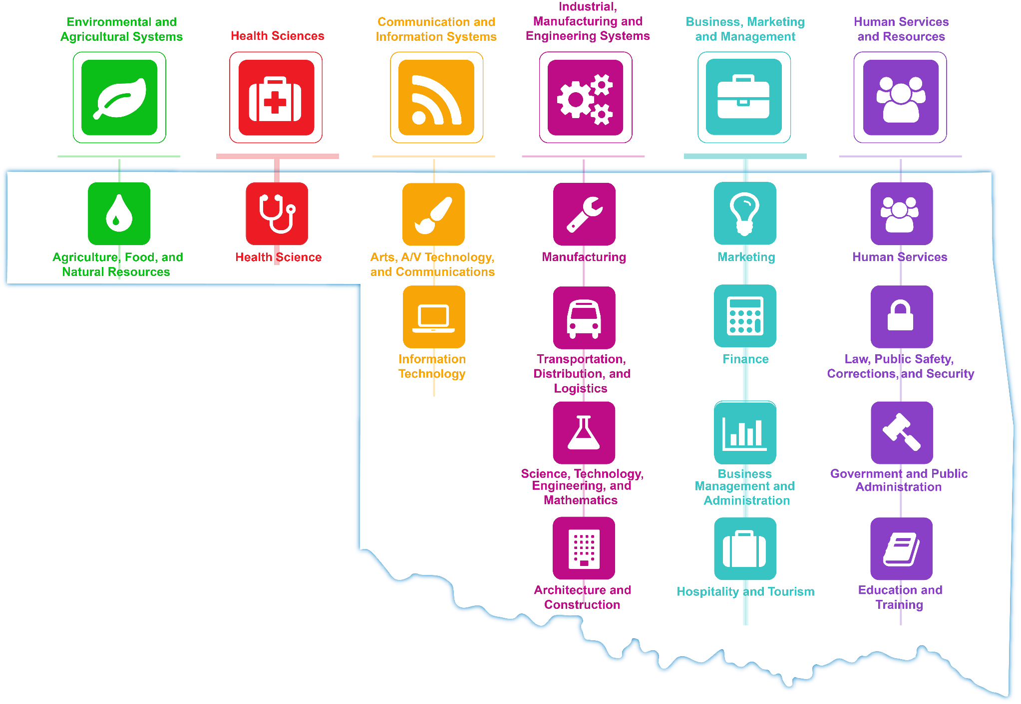


Oklahoma Wealth Generating Ecosystems
Driver Systems  - Aerospace and Defense  - Agriculture and Biosciences  - Energy– oil and wind  - Information and Financial Services  - Transportation and Distribution | Complementary Systems  - Construction  - Health Care  - Education  - Creative Industries

The Oklahoma Department of Career and Technology Education does not discriminate on the basis of race, color, religion, national origin, sex/gender, age, disability, or veteran status. Inquiries concerning application of this policy may be referred to ODCTE, Compliance Coordinator, 1500 West Seventh Avenue, Stillwater, OK 74074-4364, 1-800-522-5810 or (405) 377-2000.
This publication is printed and issued by the Oklahoma Department of Career and Technology Education as authorized by 70 O.S. 1981, Sec. 14-104, as amended. 1,000 copies have been prepared and distributed at a cost of $348.00. Copies have been deposited with the Publications Clearinghouse of the Oklahoma Department of Libraries. 17-35662

16 National Career Clusters
Each o the six career fields is divided into 1 to 4 sub-groups, called clusters. Each cluster is made up of a number of occupations and postsecondary majors related to the specialty of that cluster. The results of your OKCareerGuide interest and skills assessments are linked to these same clusters.

