Create an OKCareerGuide.org Account

Steps to create an OK Career Guide Student account.
Go to www.OkCareerGuide.org.


Click on Create an Account (grey button).


Choose “I am a middle or high school student.” Remember, you are creating a student account. Complete the questions that follow as if you were a student.
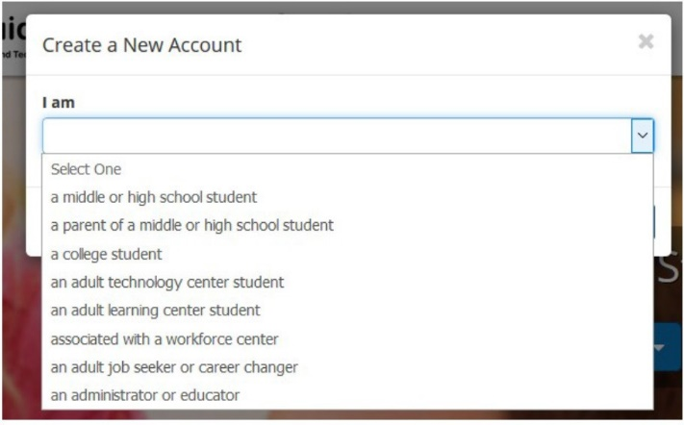

Click Next Steps and begin the four-step registration process.
- Step 1: School Information
  - Current Grade Level: Choose the grade level you work with the most.
  - High School Graduation Year
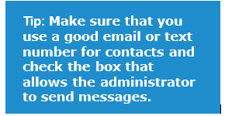
  - School, Center, Org or Oklahoma Resident: Type “ODCTE training” as your school. This is our training school. This will allow your school to maintain the integrity of student data on OK Career Guide.
- Step 2: Personal Information
  - First Name
  - Last Name
  - ZIP Code
  - Birth Date
  - Gender
  - Please contact me by: Please choose email.
  - Email Address: Enter an email to which you will have access.
- Step 3: Create a Username
  - Create desired username: It may help to add the word “student” to your username so you can remember that this is your student account. Later you will have an educator account.
  - Choose password.
  - Confirm password.
  - Pick a security question and answer it.
  - Please document your username and password for future use.
    - Username:
    - Password:
- Step 4: Demographics
  - After you fill in your demographic information, click “Sign Me Up to” complete the process.

Please document this for future use.

Username: Password: _____________________
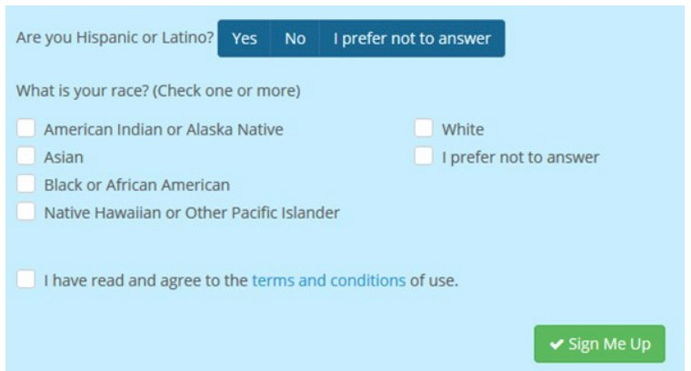
Tip: Completing the race and ethnicity demographics will allow administration to contact you about opportunities, grants, camps, and scholarships. It will offer equity driven services based on your community needs. This allows you to be contacted as a group of students through the system based on race and ethnicity when specific scholarships or opportunities arise.

