Parent Account Codes

Account Settings
After students create accounts, you should have them invite their guardians/parents to create accounts.
- Go to “Welcome (Student Name)” on the top right.
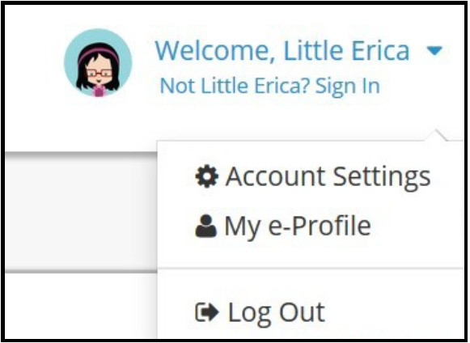

- Click on the down arrow next to your name to open the drop-down menu. Click on Account Settings.
- Scroll to the bottom of the account settings to My Parent Account(s) and click the pencil.

- Fill out the information. The system will generate a code and send a message to the parent to view the student account.

- Click on the pencil on My Current Grade Level, which is right above My Parent Account(s).
Students will need to change the grade level each year.



Parent View Account Instructions

Parent View Account
Parents have to have their student invite them to create an account. The student can choose to send a text or an email with a code that will allow a parent to create an account. They can also copy the code and take it to their parents to create the account. Click on “I need to create an account” and choose “I am a parent/guardian” and then follow these steps to create a parent account.

Step 1: Education and Student Information
- Choose the level of education that you as a parent have completed.
- Enter the access code supplied by your student.
- Enter your student’s full name.
- Select your child’s school.
- Enter your student’s birth date.
- Select your relationship to your student.
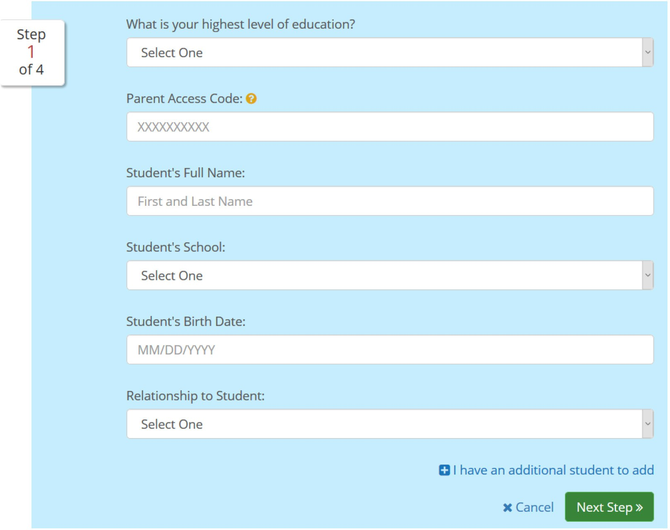

Step 2: Personal information
- First Name
- Last Name
- ZIP Code
- Gender
- Preferred method of contact
- Email address or cellphone number

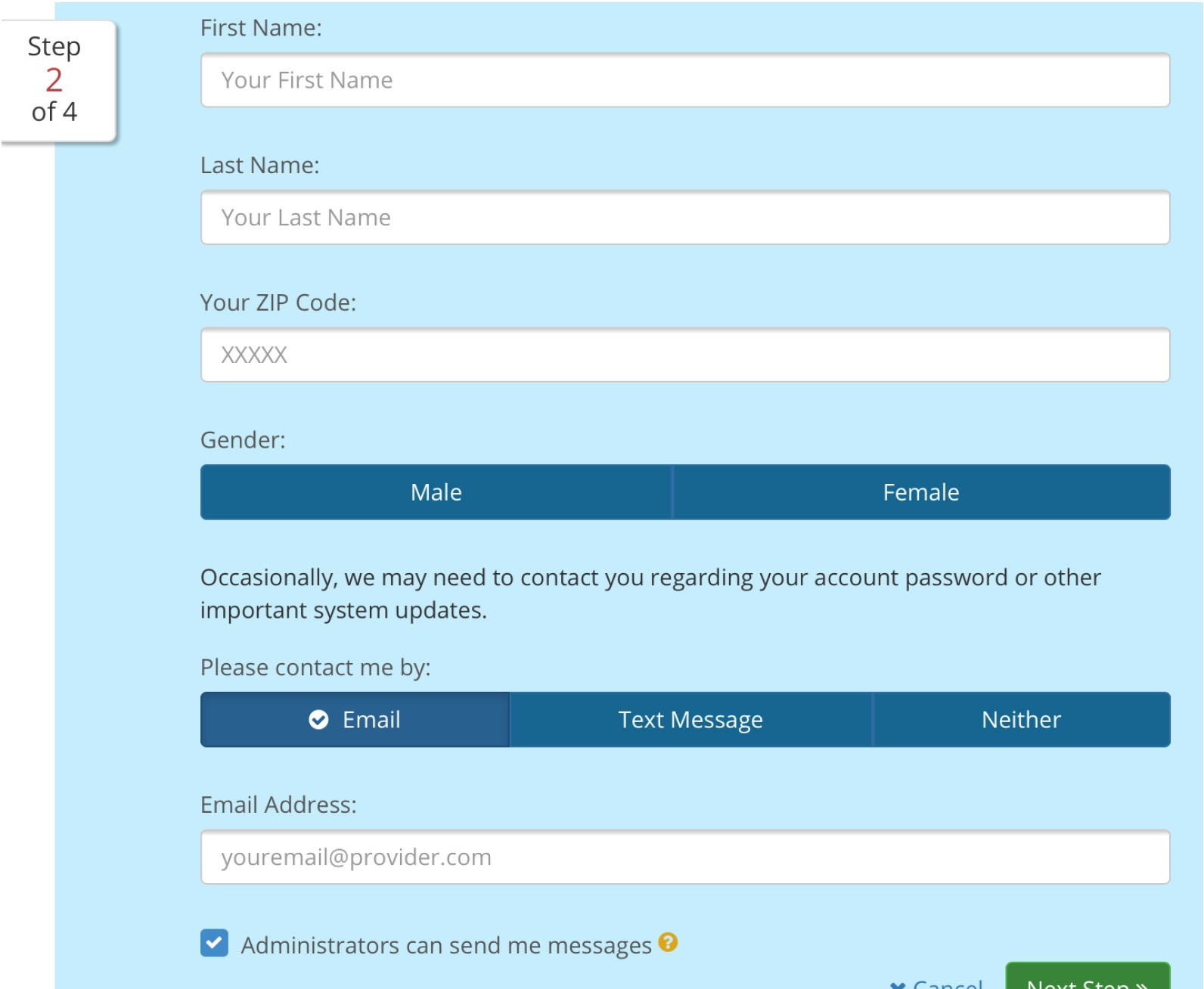

Step 3: Create a User Name
- Choose desired user name.
- Create password.
- Confirm password.
- Pick a security question and answer it.
- Please document your user name and password for future use.
  - User name:
  - Password:

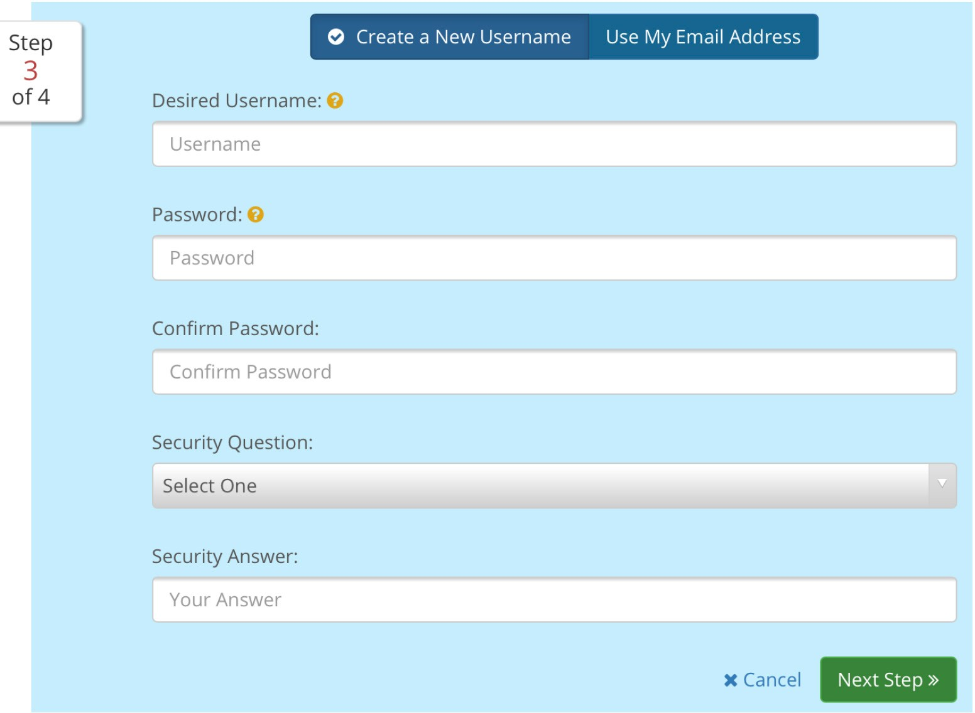

Step 4: Demographics
a. You may select “I prefer not to answer,” but answering allows counselors to offer selected opportunities for training and scholarships. After you have selected your answer, click the box to agree to the terms and conditions and click Sign Me Up to complete the process.
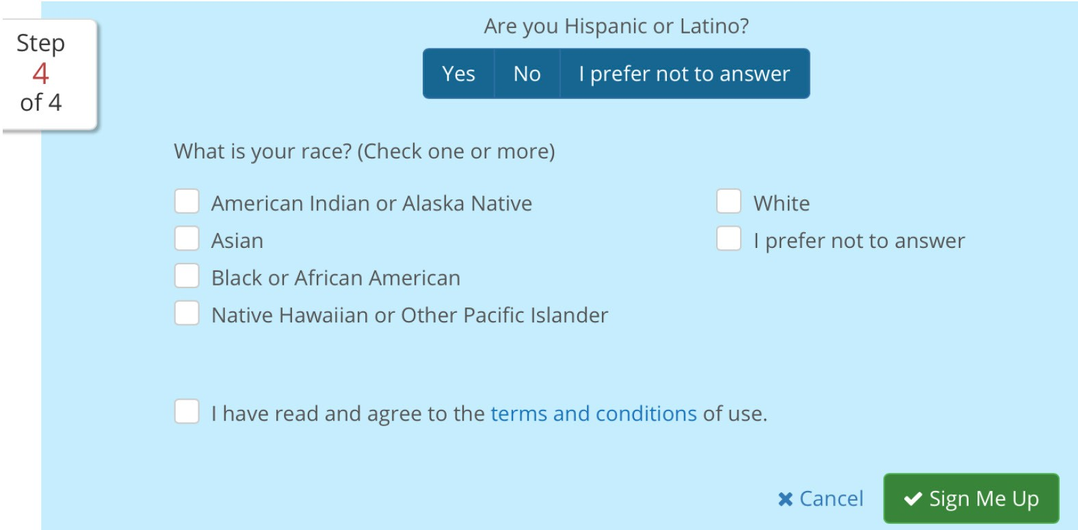

OKCareerGuid Site Map Parent View Menu Options
Below is the map of the parent site, along with screen shots of the menus.
