Planet R questions
- Pick the four healthy foods for today’s lunch menu.
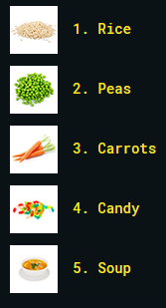

Planet I questions
All questions will choose between the following:
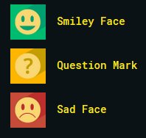
- Do you like to think about how far away stars might be?
- Do you like to collect rocks?
- Do you like to mix different foods to see what happens?
- Do you like to study how bugs move?
- Do you like to read books?
The game will give them a summary of smiley faces such as below:

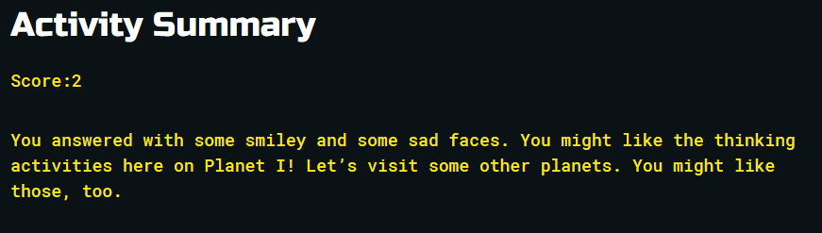

Planet A questions
All questions will choose between the following:
- Do you like to color drawings?
- Do you like to tell stories using dolls or toys?
- Do you like to make up dances to go with music?
- Do you like to take pictures using a camera?
- Do you like to design new shapes using toy-building bricks?
The game will give them a summary of smiley faces such as below:
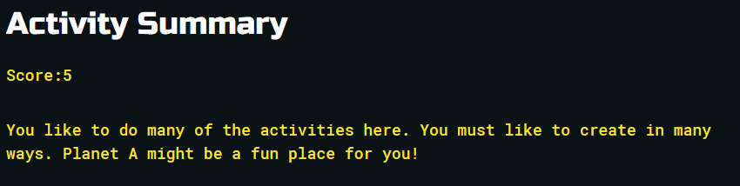

Planet S questions
All questions will choose between the following:
- Would you like helping to set the dinner table at home?
- Would you like to be part of a team with your friends and classmates?
- Would you like to provide care for a classroom pet?
- Would you like to help your classmates with a schoolwork?
- Would you like to hold a door open for classmates when traveling as a group?
The game will give them a summary of smiley faces such as below:
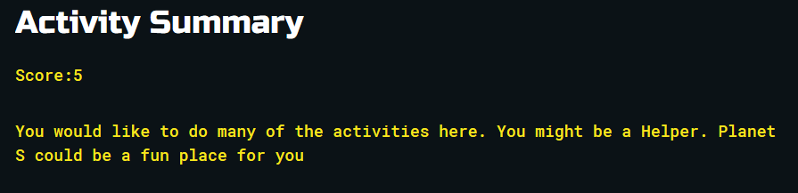

Planet E questions
All questions will choose between the following:
- Would you like to give the directions when playing the “Simon Says” game?
- Would you like to persuade someone to buy you a new toy?
- Would you enjoy making decisions about what to eat for lunch?
- Would you like to be the line leader in school?
- Would you enjoy convincing your friends to play a new game?

The game will give them a summary of smiley faces such as below:
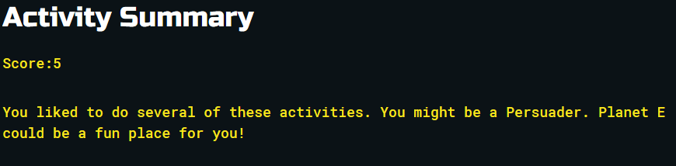

Planet C questions
All questions will choose between the following:
- Would you like to organize the dolls on a shelf?
- Would you like to know exactly what is going to happen during your day?
- Would you like to count toy money?
- Would you like to sort building blocks by shape and color?
- Would you like to play a game by the rules?

The game will give them a summary of smiley faces such as below:
