Grade 3 Planet R Questions
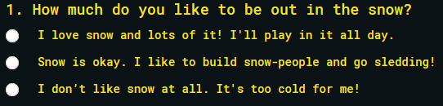
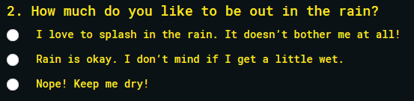
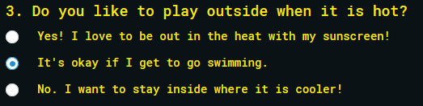
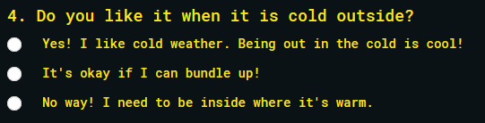
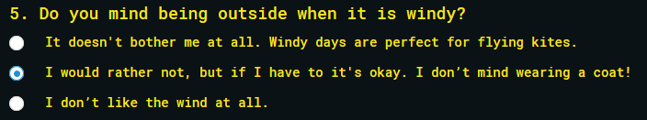
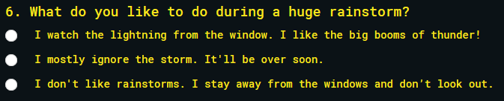
Planet I Questions
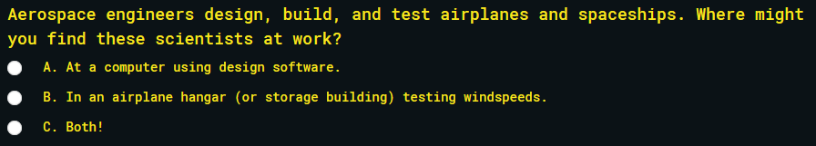
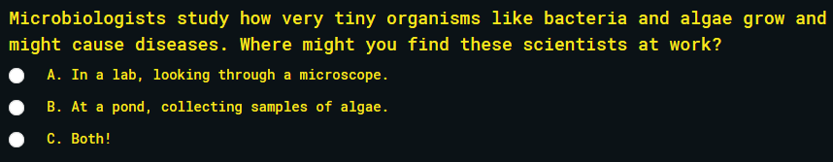
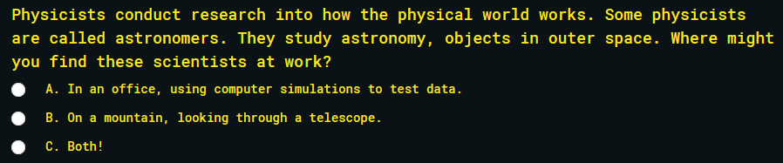
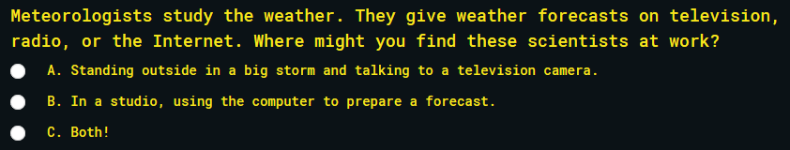
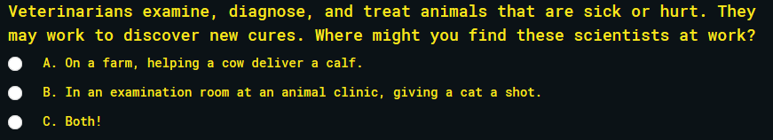
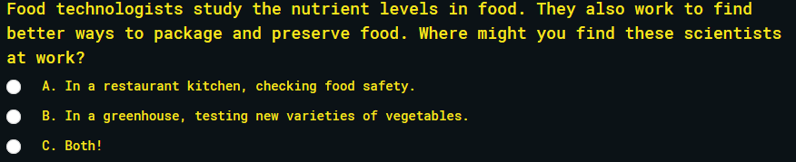
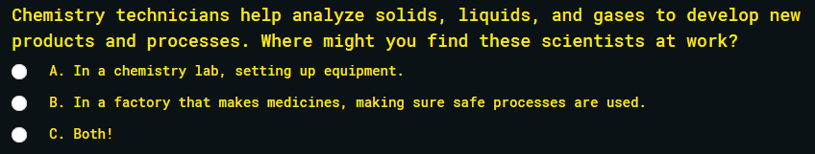
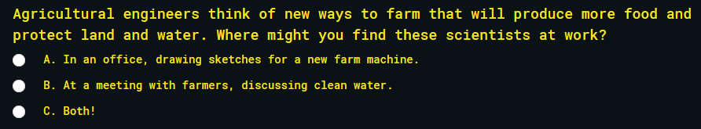
Planet A Questions

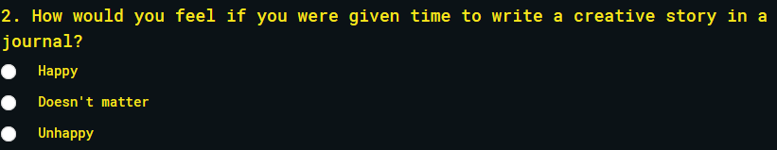


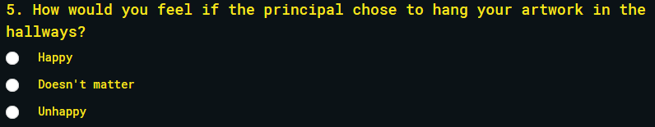
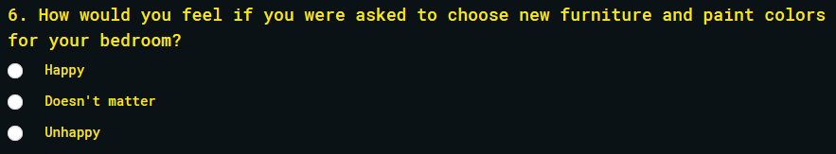
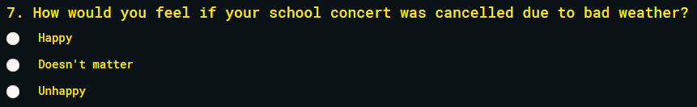

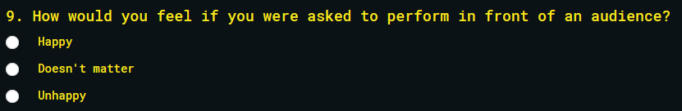

Planet S Questions
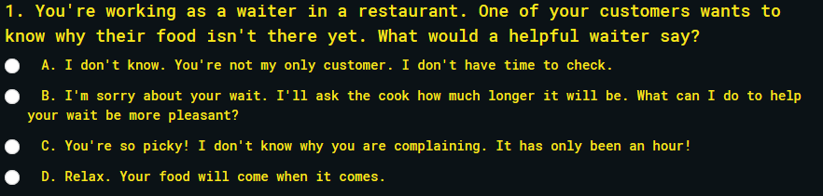
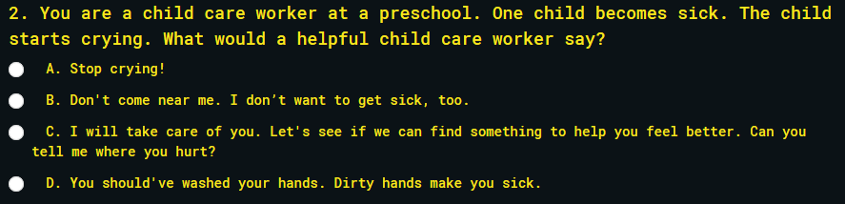
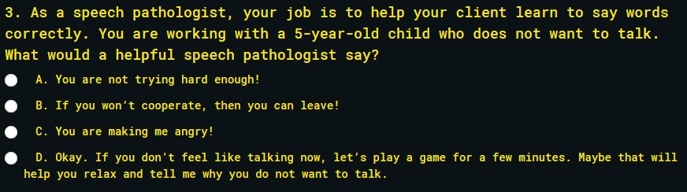
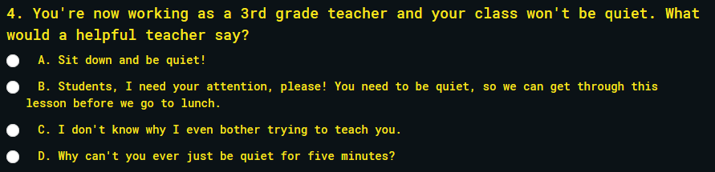
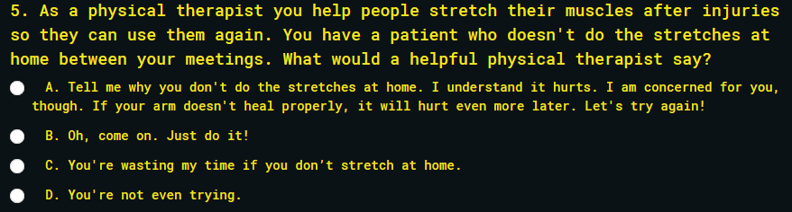

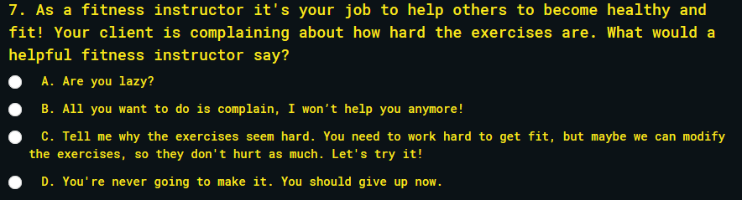
Planet E Questions
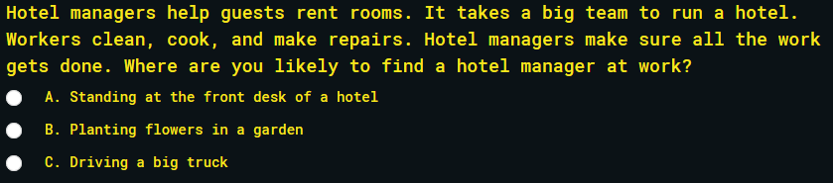
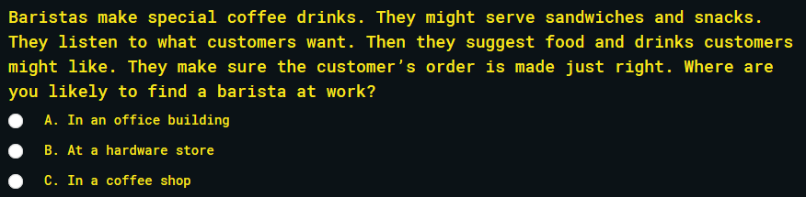
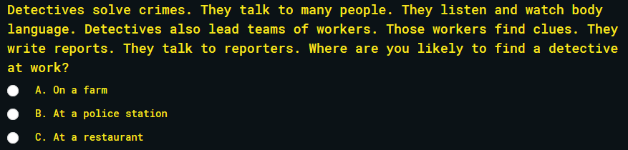

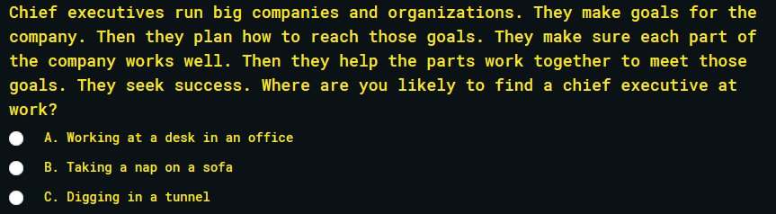
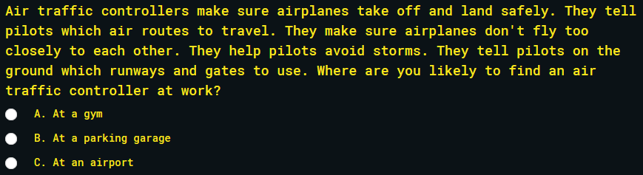
Planet C Questions
