YouTube training videos

https://www.youtube.com/channel/UCPDSJmY1piKBLp9KxTZdPGw

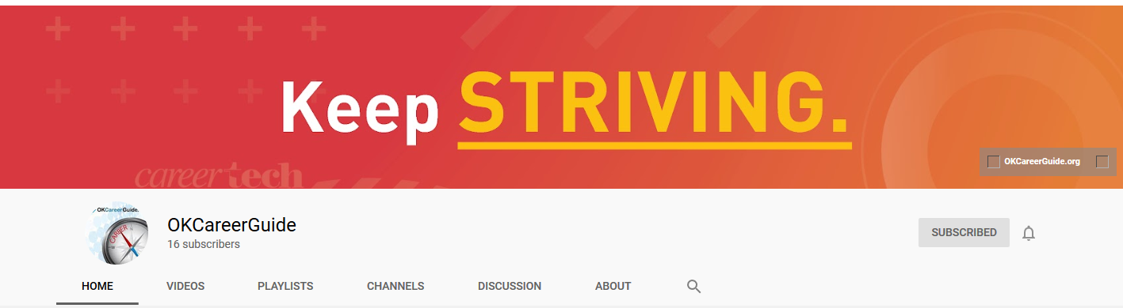

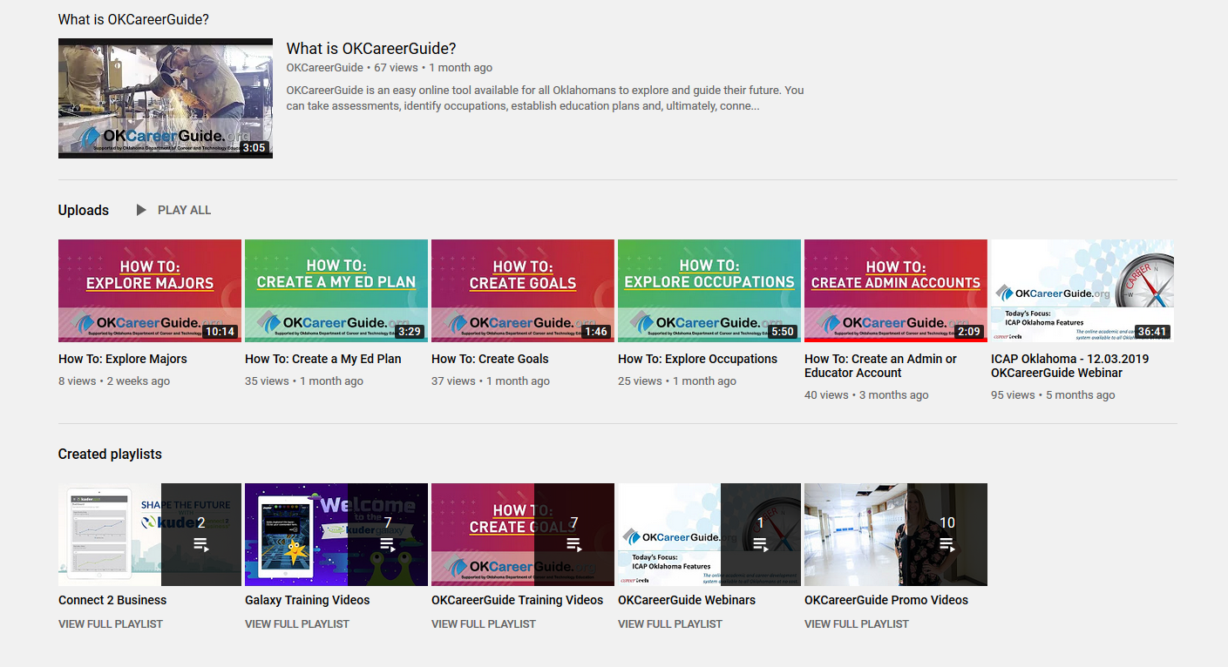

Introducing Kuder Galaxy - For Counselors Only Conference 2019 Training

https://www.youtube.com/watch?v=NLoeGl-1_mM

Launch Kids Into Career Possibilities with Kuder Galaxy®
https://www.youtube.com/watch?v=3hQx_RPg9Ro

A Look Inside Kuder Galaxy
https://www.youtube.com/watch?v=vDewGJhbkIQ&t=4s

Kuder Galaxy® Student Setup Tutorial
https://www.youtube.com/watch?v=6IMccVVoZZU

How to Add Classrooms in Kuder Galaxy®
https://www.youtube.com/watch?v=uCqLcYaLq_o

How to Create "I" Statements in Kuder Galaxy®
https://www.youtube.com/watch?v=Dj6EivWygJk

How to Add Students In Kuder Galaxy®
https://www.youtube.com/watch?v=c6yGnTa1nY0

How to Add Admins in Kuder Galaxy®
https://www.youtube.com/watch?v=XQH6_9-I0NE
Galaxy – Counselor Training for Moore Public Schools https://youtu.be/bCF_ImXOCP0

