CCR Champion Spotlight: Championing Community Engagement for Early Hands-On Career Exposure in Stillwater, Oklahoma
In many communities, career exploration stays within a school community.
In Stillwater, Oklahoma, career exploration became the spark for something larger.
Through coordinated community engagement led by Stillwater Public Schools, the Stillwater Chamber of Commerce, and Oklahoma CareerTech, career exploration did not stay within classrooms. The data from OKCareerGuide, a career exploration and planning platform, became the design framework for a district-wide career day where every 5th grader interacted with real people, real industries, and real career simulations connected to their own assessed interests.
This is what it means to bring assessments and online career exploration to life and it is what defines a CCR Champion.

Community Engagement as the Catalyst for Hands-On Career Exposure
Career assessments matter most when the community around the student responds to them.
The Stillwater experience began when the Stillwater Chamber of Commerce proposed a 5th-grade event, and Oklahoma CareerTech offered the use of virtual reality career-simulation headsets. Stillwater Public Schools connected those community resources to the career exploration work already happening with Kuder Galaxy in its elementary buildings.
That decision turned a fun day into a fully aligned career exposure event.
Community engagement became the catalyst. Without the Chamber’s outreach to local businesses, there would not have been a critical mass of industries represented. Without CareerTech’s VR contribution, students could not have stepped inside the work. And without local businesses showing up prepared with artifacts, demonstrations, and conversations, the day would not have felt different from any other career day.
The community decided 5th graders deserved its best and showed up accordingly.

Bringing Career Assessments and Online Career Exploration to Life
Stillwater Public Schools has used Galaxy for years across its elementary buildings. Galaxy is an age-appropriate, gamified online career exploration platform built on the Holland work environment framework, sorting career interests across six “planets” that correspond to Holland environments: Realistic, Investigative, Artistic, Social, Enterprising, and Conventional.
For 5th graders, Galaxy is an introduction to a vocabulary about themselves.
A few weeks before the event, every 5th grader across the district’s six elementary schools completed Galaxy planets and identified their top two planets that resonated with them and were recommended through research-based assessments.
Then, the planning team built the event around those results.
Every participating business and organization was mapped to one of the six Holland work environments. The Artistic planet was anchored by Meridian Technology Center’s cosmetology program. The Conventional planet hosted banks and loan officers walking students through investment plans. Construction trades anchored the Realistic planet.
That is how online career exploration becomes lived experience.
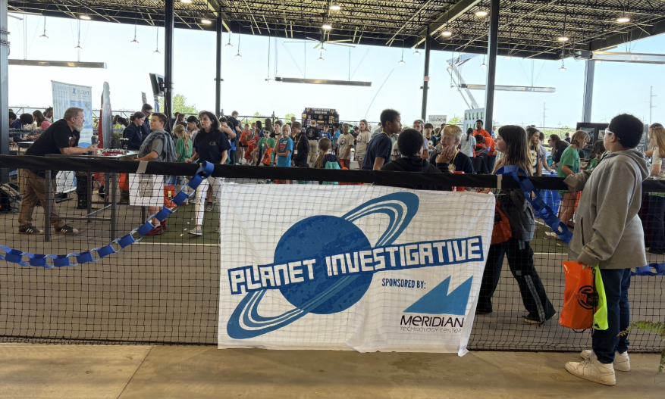

Hands-On Career Exposure Aligned to Student Interests
Each planet station offered two layers of engagement:
- A real person doing real work
- A VR simulation tied to that same planet.
Construction tradespeople brought hands-on projects. The hair salon brought in hair tinsel, which became one of the day’s most popular items. The all-female firefighter team brought their gear and let students try it on. Local trades and businesses came prepared not with a banner and candy, but with artifacts, demonstrations, and direct conversation.
Students were encouraged to begin at their top two planets, then explore the rest. The intentionality of that design created a moment that captured the day’s entire purpose.
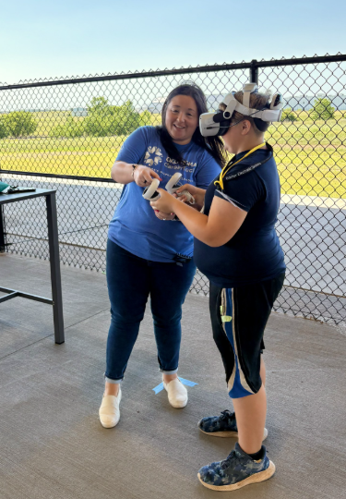
A student walked over to a Conventional-planet station where OKCareerTech was hosting a VR simulation on creating an investment plan. She asked him why he chose that simulation.
“Earlier in the morning, he had gone to a planet that had a local banker on it who was talking about investment plans as part of his work, and he wanted to see what that looked like in-depth.”
— Brittany Crane, OKCareerTech
A 10-year-old, exposed to a real adult talking about real work, became curious enough to seek out the deeper version of the idea on his own. He did not need to be prompted. The community engagement made the curiosity inevitable. The VR simulation gave him a way to act on it.
Hands-on exposure delivered value because it was aligned to student interest data and reinforced by community partners who came prepared to engage.

A Coordinated Community Strategy
The career day was made possible by a coordinated set of partners, each contributing distinct value:
- Stillwater Chamber of Commerce recruited the businesses, anchoring the event in the local economic community.
- Oklahoma CareerTech provided OKCareerGuide featuring Galaxy, along with VR career simulation headsets, expanding what a 5th-grade career experience could feel like.
- Stillwater Public Schools provided the guided career exploration and conversations with students, aligning students to planets before the event.
- Community businesses showed up with hands-on demonstrations, artifacts, and direct interaction.
All six of Stillwater’s elementary schools came together. The scale mattered. Career readiness, in Stillwater, is not a building-level activity. It is a district priority reinforced by a community-wide commitment.

In Their Own Words
Counselors across the district point to the structure of the day as the reason it worked.
“Richmond students benefited from the knowledge they learned from Galaxy. They better understand how their interests and favorite subjects can shape their future careers. We appreciate the support and partnership between Career Tech, the Chamber of Commerce, and SPS to make this event possible for our students.”
— Leslie McSpadden, School Counselor, Richmond Elementary
“I am passionate about opening doors for students through early career exploration. My absolute favorite lessons to teach are career-based lessons, and I love getting to see careers through my students’ eyes at our annual career day. It is a privilege to live in Stillwater and have so many different career examples for our students to learn from. The Galaxy platform, along with the Career Tech VR headsets, was an interactive way for our 5th graders to explore the six career clusters, helping them visualize their own paths in the workforce. It is such an honor to have support in our community to encourage career exploration from an early age.”
— Emily Deason, School Counselor, Sangre Ridge Elementary
And from the 5th graders themselves:
“I really liked the Career Day. It was fun to visit the tables and learn about the careers. I really liked making the pen at Eskimo Joe’s table.”
— 5th grade student, Richmond Elementary
“There was one station that I used marshmallows, spaghetti, and tape to build the tallest tower. I didn’t think I would like building before that but it was really fun!”
— 5th grade student, Richmond Elementary

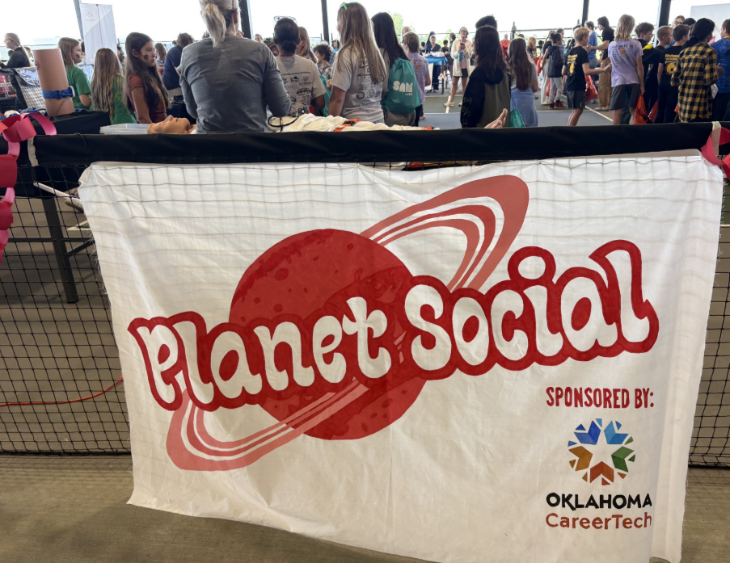

Championing College & Career Readiness
Career and College Readiness is most effective when community engagement and online career exploration work together to expose students to the world of work in tangible ways.
In Stillwater:
- Community engagement led the design with the Chamber, CareerTech, and local businesses showing up as partners.
- Career assessments and online career exploration through Galaxy gave the day its framework and personalized every student’s path.
- Hands-on career exposure paired real people with VR simulations at every Holland Code planet.
- All six elementary schools came together as a single coordinated experience.
Stillwater Public Schools demonstrates how community engagement can take career assessments and online career exploration off the screen and bring them into a 5th grader’s hands.
From classrooms to community, the connection is built in person.
And that is what defines a CCR Champion.
These solutions were made available through OKCareerGuide, a tailored CCR solution built by Kuder and provided in partnership with the Oklahoma Department of CareerTech.

