
Dear Principals and Instructional Leaders,
Welcome to the new school year! We are excited to introduce “Teacher Tips,” a valuable resource designed to support the retention of new teachers.
“Teacher Tips” offers weekly insights specifically tailored for new educators, aligning with their school year to highlight professional development opportunities. As instructional leaders and principals, you can utilize these tips to engage in meaningful discussions with new teachers, fostering stronger relationships and understanding their unique needs.
To kickstart these conversations, there is a Back-to-School Checklist that can be utilized with any teacher. These tips will not only help reinforce school policies but also provide you with insights into how new teachers plan to manage their classrooms. This proactive approach aims to alleviate the “sink or swim” mentality often faced by first-year educators.
Feel free to share these tips with any teachers who may benefit from additional support.
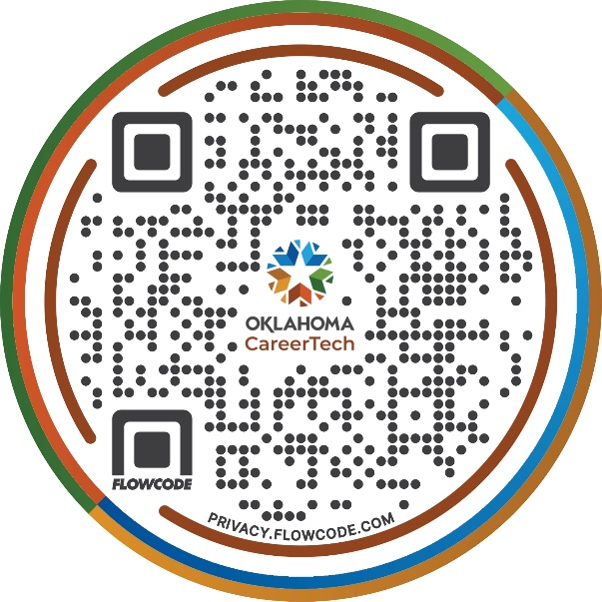
For easy access, all “Teacher Tips” will be archived at ctyou.org, where you can find further resources. Simply scan the QR code provided to access the “Teacher Tips” directly.

Thank you for your commitment to supporting our new teachers!

