
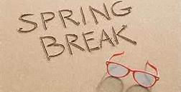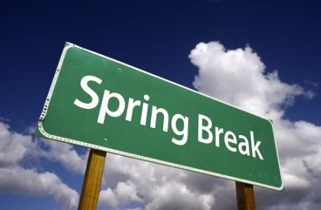
It is spring break and time to walk away and just let it go for a few days. Remember some of the tips about stress, and take advantage of this time off and allow yourself time to rest before the last quarter of the year.

If you have ever wondered what other teachers do for break, watch this video and start relaxing:

https://www.youtube.com/watch?v=2LpH33DfxmY

Join Teacher Tips after spring break as we look at planning for engagement.

