Creating an OKCareerGuide Account
OK Career Guide will help you explore a world of possibilities, make decisions about your future, and prepare for the next step in your education and career planning journey.
Steps to Create an OKCareerGuide Account

- Go to https://okcareerguide.kuder.com

2. Click on Create a New Account (Gray Button)
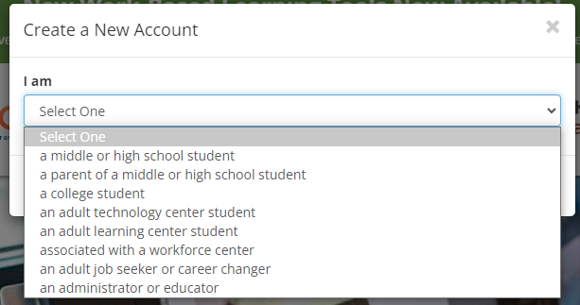

Tip:
Each user type is unique and will populate recommended resources based on your stage of life!

3. Choose the user type that you identify with.

4. Click Next Steps and begin the four-step registration process

Student Navigator Accounts
Step 1: School Information
- Current Grade Level
- High School Graduation Year
- School, Center, Organization or Oklahoma Resident
Step 2: Personal Information
- First Name
- Last Name
- Zip Code
- Birth Date
- Gender
- Contact Preference
- Email Address
Step 3: Create a Username and Password
- Desired Username
- Choose Password
- Confirm Password
- Security Questions
Step 4: Demographics
- After checking the demographics that you identify with and indicate that you have read and agreed to the terms and conditions, click

Sign Me Up

Adult Journey Accounts
Step 1: User Type Information
- I Most Closely Identity With
- Years of Work Experience
- School, Center, Organization or Oklahoma Resident (use if you are an adult who is not associated with an educational institution)
Step 2: Personal Information
- First Name
- Last Name
- Zip Code
- Birth Date
- Gender
- Contact Preference
- Email Address
Step 3: Create a Username and Password
- Desired Username
- Choose Password
- Confirm Password
- Security Questions
Step 4: Demographics
- After checking the demographics that you identify with and indicate that you have read and agreed to the terms and conditions, click
Sign Me Up

