
This is it for this year. This week, I would like to look back at some of the things you have learned in your first year.
- Change is an opportunity for growth. This has been a year of growth for you. What you know now is way more than what you knew when you started.
- Teaching is hard work. Those on the outside of education always talk about teachers having it easy. That is only because they have never been in a classroom.
- Teachers clarify purpose. You give purpose to many students who had none when they started your class. Now they see connections not only to the real world, but to their other subjects.
- You give voice to your students. While you are the expert in the classroom, you know that sometimes you have to step aside and let the students discuss and learn from each other.
- You are constantly giving feedback. Even though that feedback can be a simple as thumbs up or a smile, students are always looking to you for feedback.
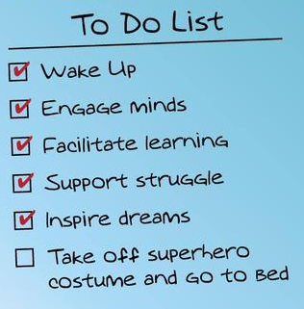
- Collaboration is a powerful thing. Teachers are a unique group and when they get together, they produce great learning situations. Oklahoma has some of the best teachers in the country. Take advantage of every chance you have to brainstorm with your colleagues.
Have a great summer and send that superhero costume out to the cleaners.

