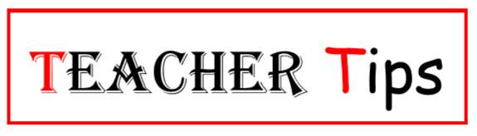
Do you remember the last time you used a maps program or app to get to a specific location? Both provide the direction to travel. In your class you also need a direction you will travel for the day or the week. It is essential that the students have a direction to start the class each day. You can give direction with a lesson plan that is a part of the bigger plans called unit plan and curriculum map, which we will discuss later.
Lesson plans can be as simple as the PPAE (preparation, presentation, application and evaluation). A little more detailed is the 5E Lesson Plan (engagement, exploration, explanation, elaboration, and evaluation). Plans can also be of various size and detail, as with the CTE Lesson Plan. Many schools use LAPs (learning activity packets), which are like lesson plans for the student, but your lesson plan needs more and different information. Over the next couple of weeks, we will look at parts of the lesson plan and strategies for each section.
Do not be upset with yourself if your lesson plans do not look like those of your peers. Most lesson plans that you look at are tailored to fit the personalities of the teachers and their teaching styles. Your style and personality will start showing up in your lesson plans more and more as you continue to teach and work with students.
Do not be afraid, however, to beg, borrow or use any other teacher’s lesson plans as you start building your own lessons. Just keep in mind you will have to make the plans work for you and your classroom.
We begin this week with the end or destination of the lesson in mind by looking at what you need to prepare for the students reach their destination or succeed. You do this with planning. Many of you have curriculum that is very well laid out and may even be broken down into lessons for you. Even so, you will still need to locate some specific things so you know when you have reached your destination. Below is a list of things to look for in the curriculum or create yourself from the resources at hand.
- Subject and grade levels.
- Lesson objective and CTE/technical objectives.
- Academic and 21st century skills.
- Materials: PowerPoints, handouts, any technology you or the students need, any manipulatives the students or you will need to complete the lesson.
- Duration: one hour, three hours or more.
- Instructional strategies.
We have already mentioned one way start a lesson is with a bell ringer to get the students started thinking about what they are going to learn.
Next week, we’ll look at ideas for moving your lesson forward.

