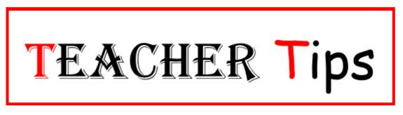
Last week we mentioned starting your lesson with a bell ringer. Whether you call it getting started, engaging or a hook, there are several strategies for starting a lesson. This is your first chance for you to help the students make a connection with the topic to be covered and to find out what they already know about the topic before presenting new information. Listed below are some strategies for starting a lesson:
- Bell ringers.
- Pictures with questions.
- Vocabulary.
- Teaser Questions.
- Anticipation Guide.
Once you have started and made some connections with the students then it is time to transition into the lesson itself. The delivery or strategies that you will use will depend on what needs to be covered or presented. There are several ways for you to present material to the students, many newer curriculums have prepared the presentation that is ready for you to use. Some times that will be necessary however; if the students can have an active part in the learning process they will take ownership of the knowledge faster than if it is just given to them.
While I could spend the rest of the year just talking about instructional strategies, I would suggest you follow the imbedded link and check with your peers as to which strategies work best for them. Keep in mind what you know about your students and the way they like to learn.
Another way to learn about instructional strategies is to attend the different conferences that are offered to you as a teacher. While they may not be presenting on strategies you may experience many strategies during the conference and those presenters will be happy to share the technique.
Next week, we’ll look at closing the lesson.

