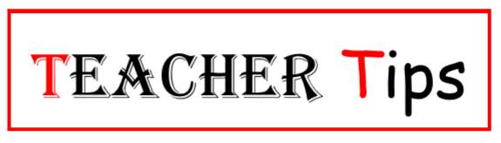
While lessons may extend over one or more days at some point they must come to an end. In most teaching cultures this is known as a closure. Closure for a teacher can include the following actions:
- Check for understanding and upcoming instruction.
- Emphasize key information.
- Tie up loose ends and bring it back to objectives.
- Correct misunderstandings.
Many teachers think checking for understanding must include some sort of formal assessment at the end of a lesson. Good questioning and allowing students to take part in their own learning, such as in the “Think Pair Share” strategy, allows you to do informal evaluation and feedback throughout the lesson, however.
Students on the other hand find closure helpful for taking the following actions:
- Demonstrating their understanding with summarization and review activities.
- Internalizing key information.
- Connecting the lesson to previously learned knowledge.
- Realizing information in new and current situations.
Students want to make every lesson real to themselves; some foundational concepts, however, are hard to connect until additional lessons have been covered. Sometimes the only closing you have is to introduce the next piece of the puzzle in a much bigger picture.
There are many ways to close a lesson, and they all depend on what you need to know before you can proceed with future lessons or labs. Do not beat yourself up if you run out of time and do not get to a closing, though. You can either start with a review or combine closing with the next lesson.
I am attaching a rubric for self-evaluation of your lesson plans. Do not be upset if your lessons do not meet all the categories or you rank low in the assessment. The rubric is only offered as a tool or a map to help your lessons get better.

